ASSIGNMENT NO-1

Create the following tables with the given structures and insert sample dta as specified
A)SALESPEOPLE
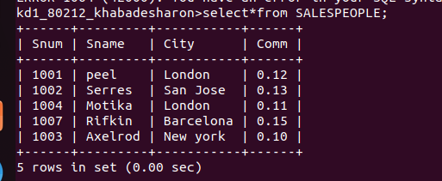

B) CUSTOMERS
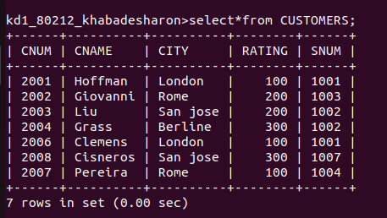

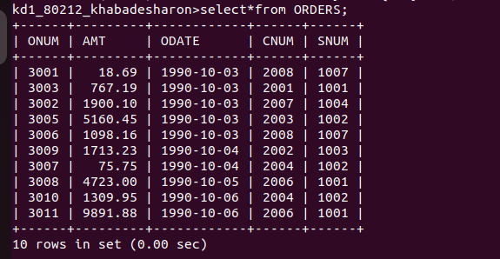
C) ORDERS

