ASSIGNMENT NO -6

Q1) Write two different queries that would produce all orders taken on october 3rd
or 4th ,1990.

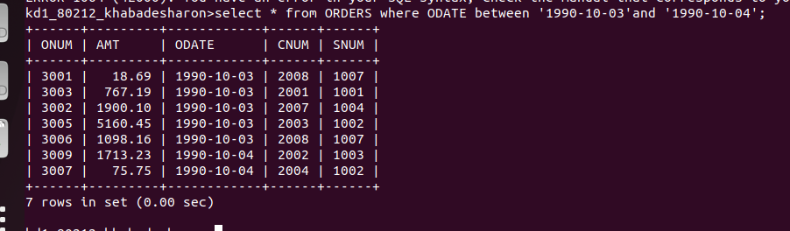
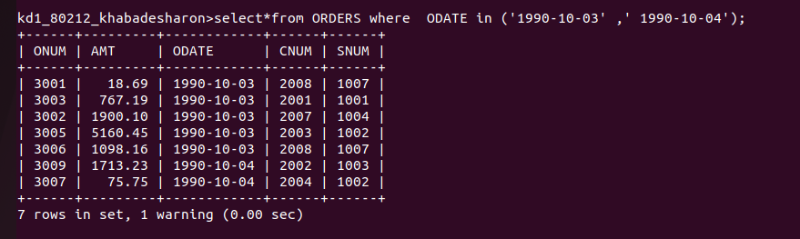

Q2 ) Write a query that selects all the of the customers serviced by peel or peel or motika.
(Hint: the SNUM field relates the two tables to one another).
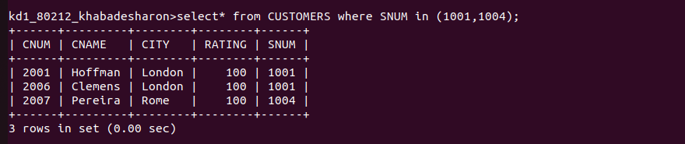

Q3.)Write a query that will produce all the customers whose names begin with letter from ‘A’ to ‘G’.

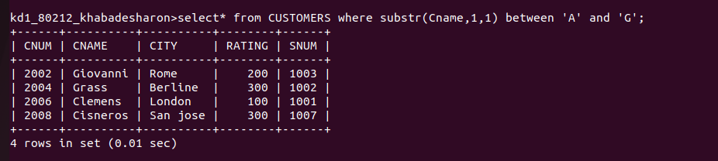
Q4.)4. Write a query that selects all customers whose names being with the letter ‘C’.

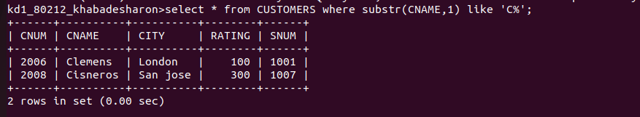
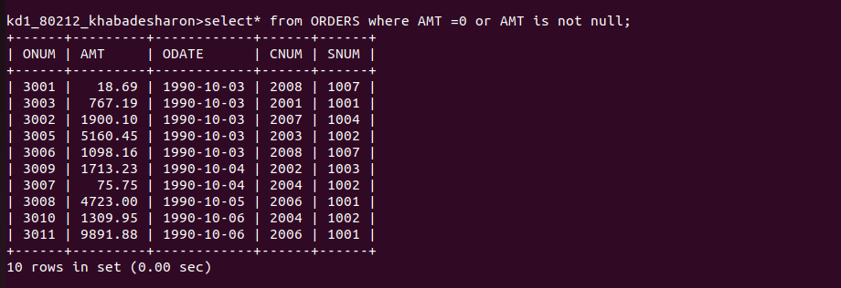
5. Write a query that selects all orders except those with zeroes or NULLS in the amt field.

