Assignment 1

***Q1.***

***Salespeople_Table:***

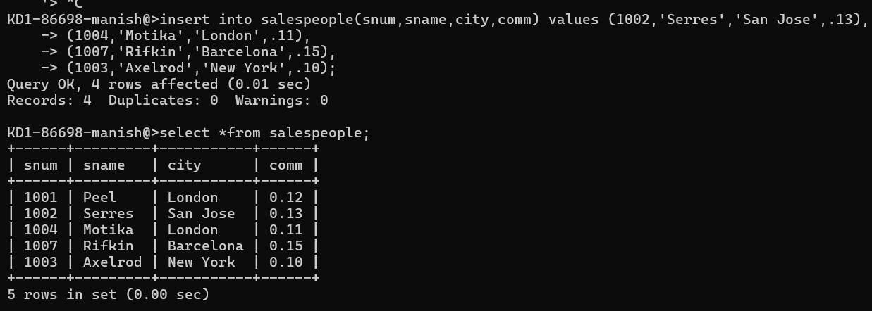

***Q2.***

***Customer Table:***

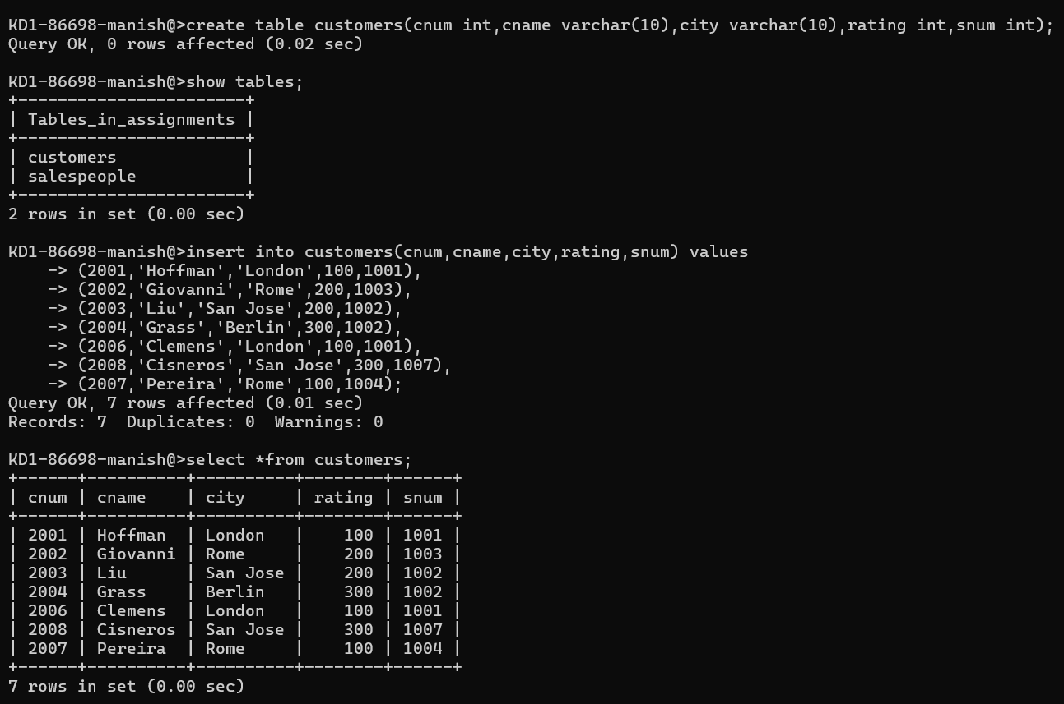

***Q3.***

***Orders_Table :***

