**Assignment 12**

***1) Write a query that selects all customers whose ratings are equal to or greater than ANY of Serres’.***

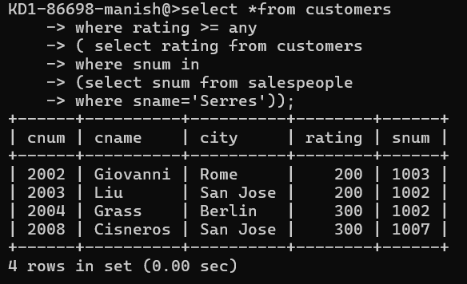

***2) Write a query using ANY or ALL that will find all salespeople who have no customers located in their city.***

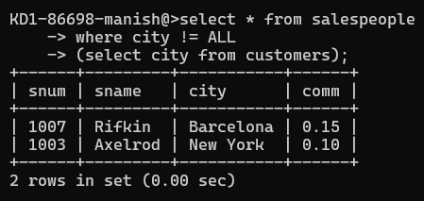

***3) Write a query that selects all orders for amounts greater than any for the customers in London.***

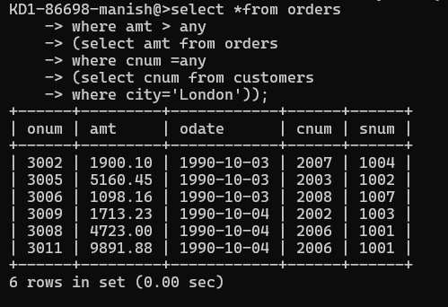

***4) Write the above query using MIN or MAX.***

