**Assignment 14**

***1) Write a command that puts the following values, in their given order, into the salespeople table: city – San Jose, name – Blanco, comm – NULL, cnum – 1100.***

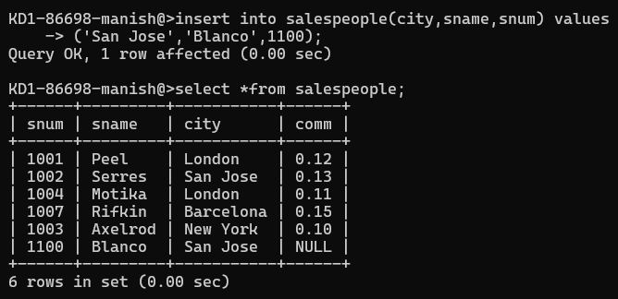

***2) Write a command that removes all orders from customer Clemens from the Orders table.***

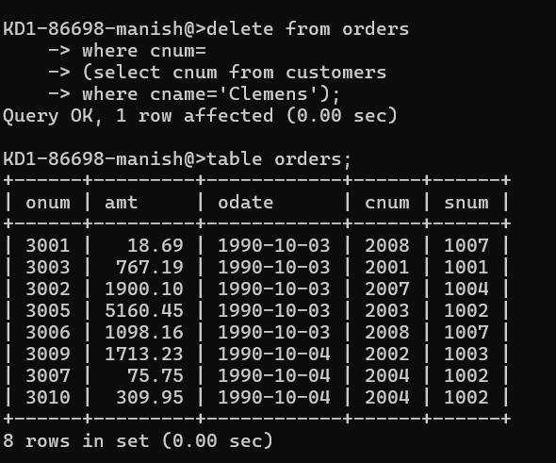

***3) Write a command that increases the rating of all customers in Rome by 100.***

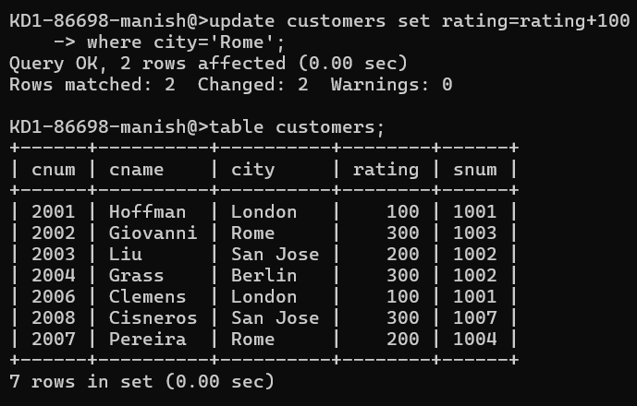

***4) Salesperson Serres has left the company. Assign her customers to Motika.***

***­­­­­­­--­­­­­­***