**Assignment 4**

***1) Write a select command that produces the order number, amount, and date for all rows in the Orders table. Salespeople_Table :***

***KD1-86698-manish@>select onum,amt,odate from orders;***

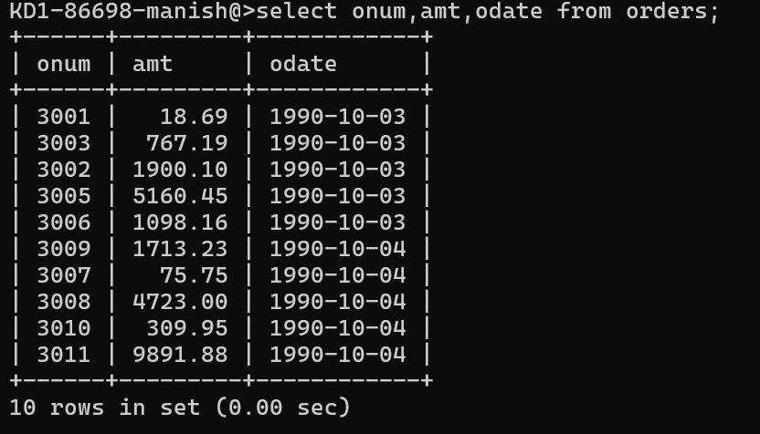

***2) Write a query that produces all rows from the Customers table for which the salesperson’s number is 1001. Customer Table :***

***KD1-86698-manish@>select *from customers where snum=1001;***

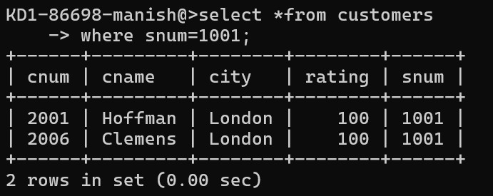

***3) Write a query that displays the Salespeople table with the columns in the***

***KD1-86698-manish@>select *from salespeople;***

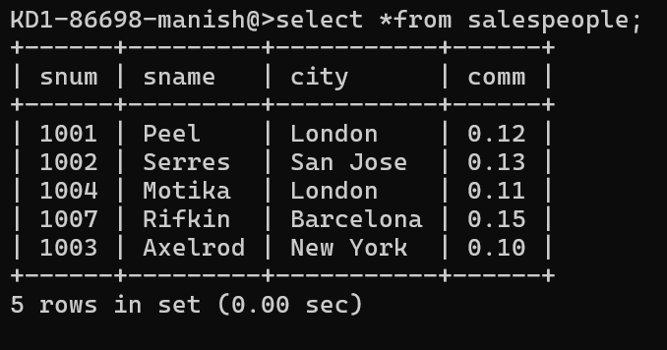

***4) Write a select command that produces the rating followed by the name of each customer in San Jose.***

***KD1-86698-manish@>select rating from customers where city='San Jose';***

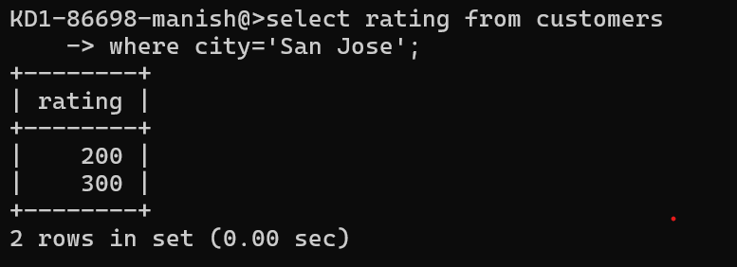

***5) Write a query that will produce the snum values of all salespeople (suppress the duplicates) with orders in the Orders table.***

***KD1-86698-manish@>select distinct snum from orders;***

