**Assignment 5**

***1) Write a query that will give you all orders for more than Rs. 1,000.***

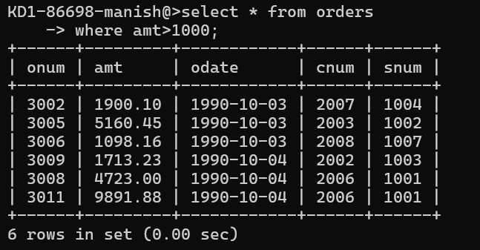

***2) Write a query that will give you the names and cities of all salespeople in***

***London with a commission above .10.***

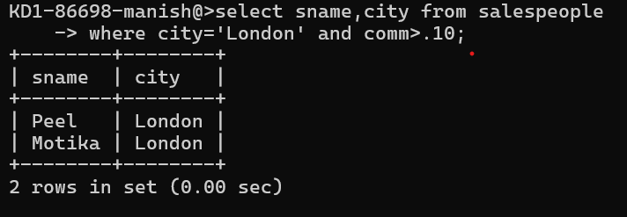

***3) Write a query on the Customers table whose output will exclude all customers***

***with a rating <= 100, unless they are located in Rome.***

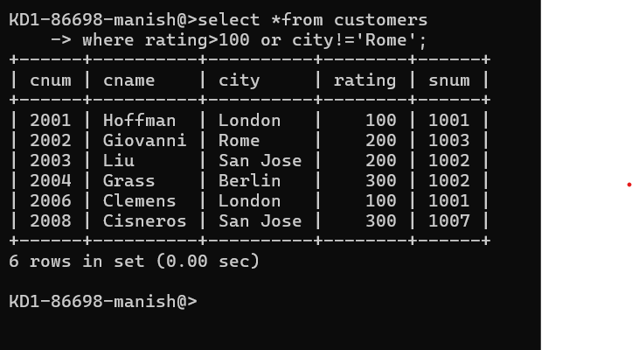

***4) What will be the output from the following query?***

***Select * from Orders where (amt < 1000 OR NOT (odate = ‘1990-10-03’ AND cnum > 2003));***

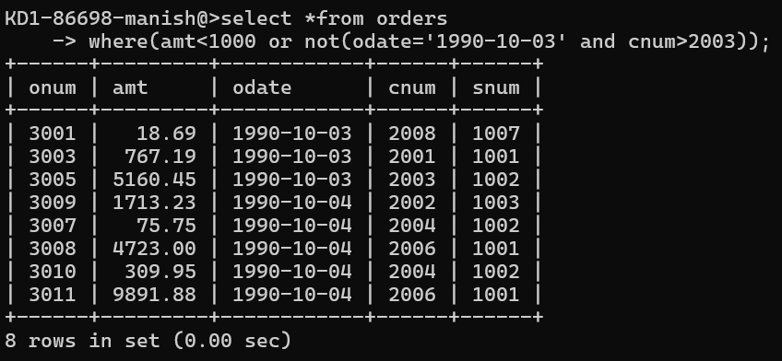

***5) What will be the output of the following query?***

***Select * from Orders where NOT ((odate = ‘1990-10-03’ OR snum >1006) AND amt >= 1500);***

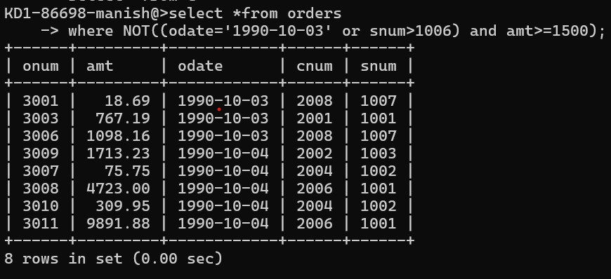

***6) What is a simpler way to write this query?***

***Select snum, sname, city, comm From Salespeople where (comm > .12 OR comm <.14);***

