**Assignment 6**

1. ***Write two different queries that would produce all orders taken on October 3rd or 4th, 1990.***

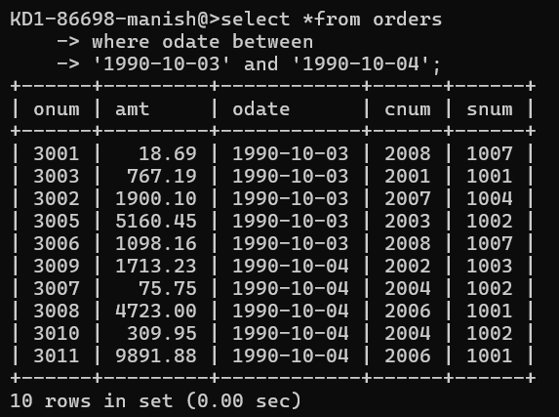

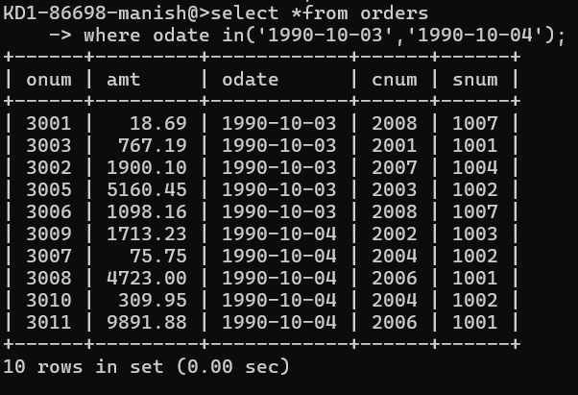

***2) Write a query that selects all of the customers serviced by Peel or Motika.***

***(Hint: the snum field relates the two tables to one another).***

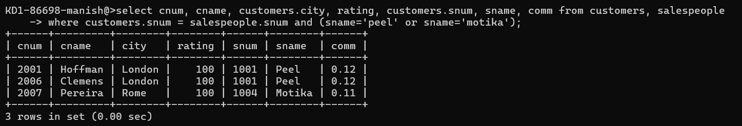

***3) Write a query that will produce all the customers whose names begin with a letter from ‘A’ to ‘G’.***

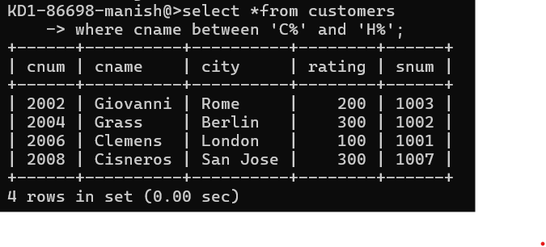

***4) Write a query that selects all customers whose names begin with the letter‘C’.***

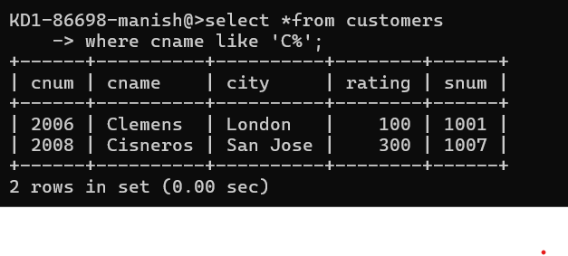

***5) Write a query that selects all orders except those with zeroes or NULLs in the amt field.***

