**Assignment 7**

***1) Write a query that counts all orders for October 3.***

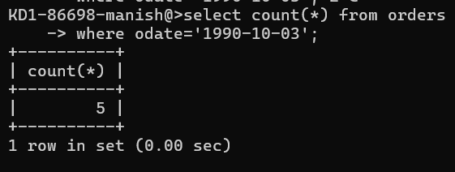

***2) Write a query that counts the number of different non-NULL city values in the Customers table.***

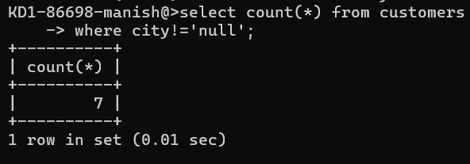

***3) Write a query that selects each customer’s smallest order.***

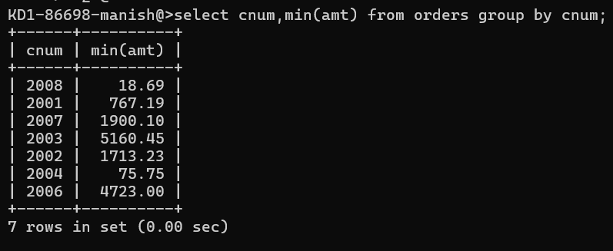

***4) Write a query that selects the first customer, in alphabetical order, whose name begins with G.***

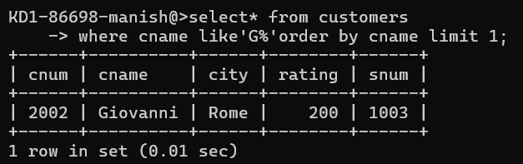

***5) Write a query that selects the highest rating in each city.***

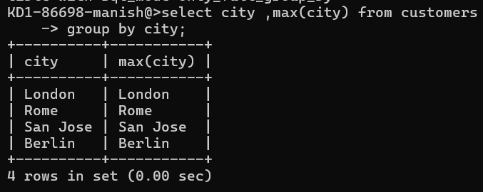

***6) Write a query that counts the number of salespeople registering orders for each day. (If a salesperson has more than one order on a given day, he or she should be counted only once.)***

