**Assignment No – 02**

*Command 1-3*

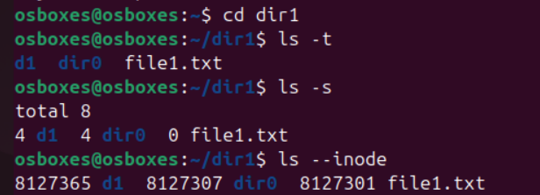

*4. List the contents of the subdirectory*

**

*5. Create a file, write your surname and name in it and save.*

*i. now open the same file and add your address in it and save.*

*ii. reopen the same file and check your name and address in it.*

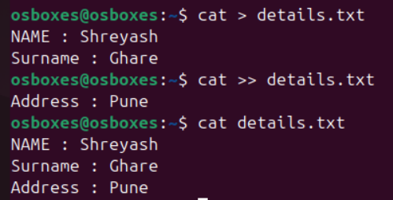

*6. how to change the time stamp of file (man touch)*

**

*7. Create directory structure :*

*Give following commands ,*

*-> mkdir one*

*-> cd one*

*-> touch 1.txt 11.txt 111.txt*

*-> mkdir two*

*-> cd two*

*-> touch 2.txt 22.txt 222.txt*

*-> mkdir three*

*-> cd three*

*-> touch 3.txt 33.txt 333.txt*

*-> mkdir four*

*-> cd four*

*-> touch 4.txt 44.txt 444.txt*

*-> mkdir five*

*-> cd five*

*-> touch 5.txt 55.txt 555.txt*

*-> cd ~ (i.e. go to your home directory)*

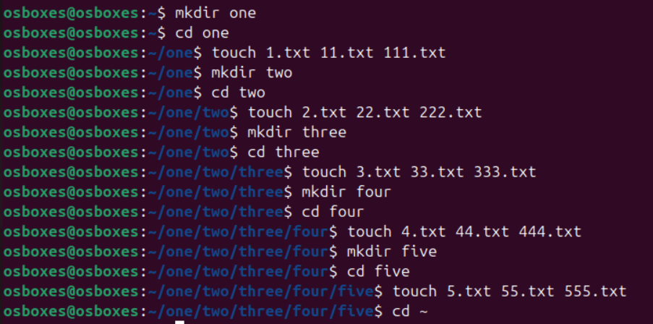

*8. Considering above directory structure , Do following operations :*

*i. list the directory contents of directory named "five" from current directory (i.e. home directory).*

**

*ii. write your name in a file named "44.txt" of directory "four" from current directory.*

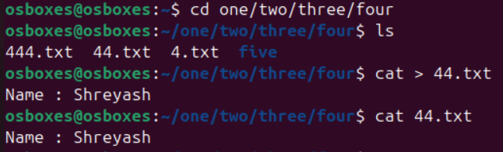

*iii. remove the file named "555.txt" from directory "five" from current directory.*

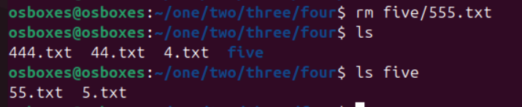

*iv. change directory to five ( i.e. cd one/two/three/four/five/ ).*

**

*v. write your course name in file named "3.txt" which resides in directory "three" from current directory (i.e. five).also read the same file.*

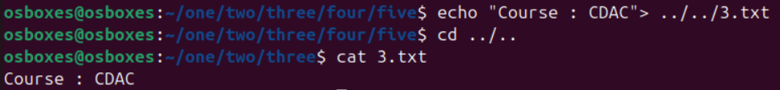

*vi. list the contents of directory "two" from current directory (i.e. five).*

**

*vii. remove file named "222.txt" which belongs to directory "two" from current directory (i.e. five)*

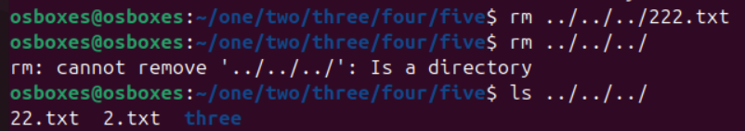

*viii. now change the directory to "one"*

**

*ix. remove all files only from directory named "five" from current directory (i.e. one)*

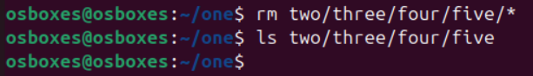

*x. remove directory named "five" from current directory (i.e. one)*

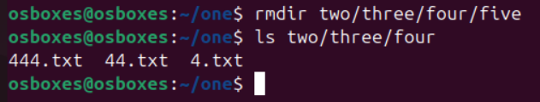

*xi. remove whole directory named "four" from current directory (i.e. one)*

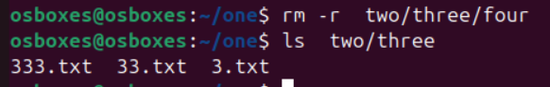

*xii. change to your home directory.*

**

*9. change the time stamp of file named "3.txt" which resides in directory named "three".(man touch)*

