Assign 3 : Linux Commands

1. Ls



1. Rename



1. Ln-s

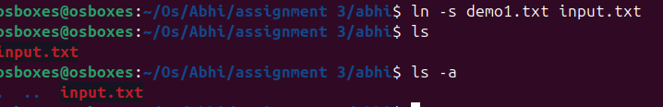

1. Ln



1. Stat

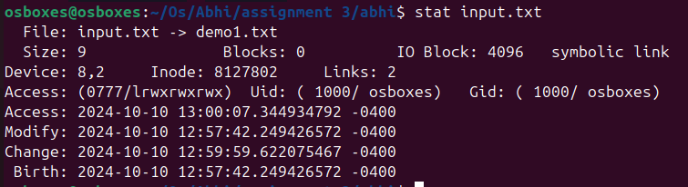

1. Touch



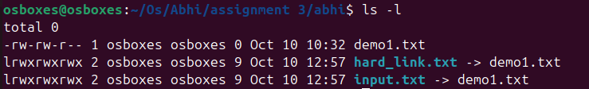

1. Touch



1. Tail

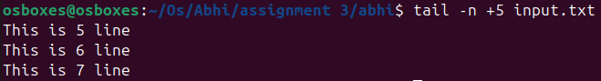

1. Init 0

* Poweroff

1. Init 6

* Reboot

1. Whoami



1. Tty



1. who am i

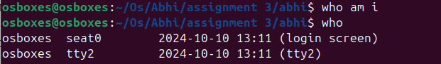

1. users



1. who



1. grep, egrep, fgrep

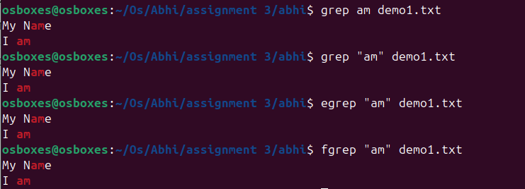

1. chmod



1. chmod



1. wc



1. who



1. head, tail

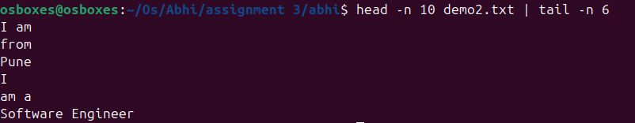

1. sort

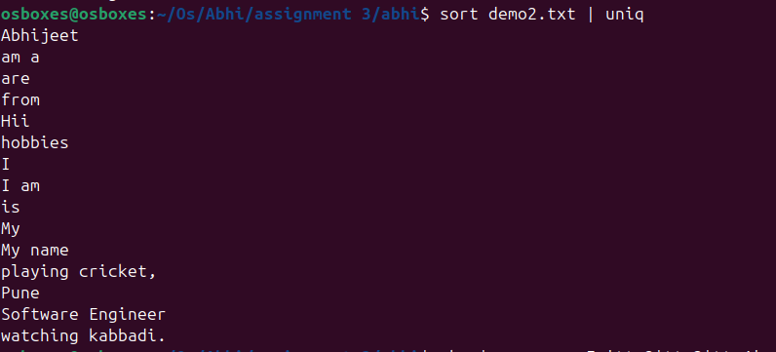

1. who, grep



1. is

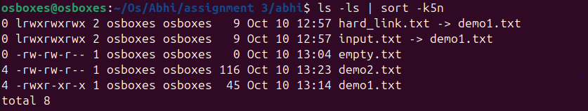

1. is,grep



1. ls, grep



1. tr

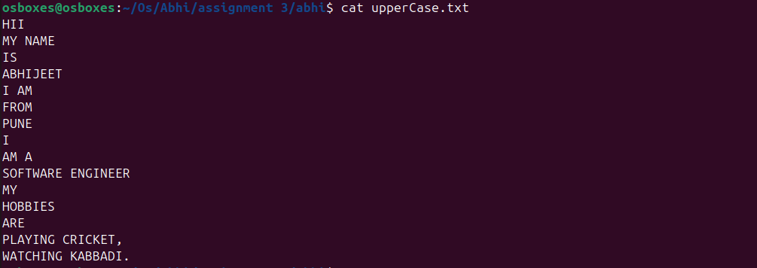

1. cut

