***Assignment No – 04***

*Create a file named "data.txt" and write the following lines in it(write as it is).*

*Linux is open source. In Linux everything is file*

*files have permissions.*

*files have inode no.*

*files have size.*

*there are several types of files*

*compose the commands fulfilled following requirement*

*i) count the no. of words ,characters and lines from above 2 file.(man wc)*

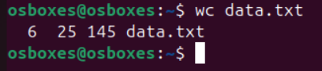

*ii) list the lines having word "files" (man grep)*

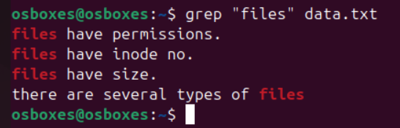

*iii) list the lines having word "file" (man grep)*

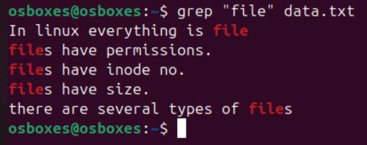

*iv) list the lines which don't have word "files" (man grep)*

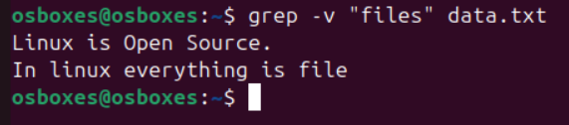

*v) list the lines having word "have" . (man grep)*

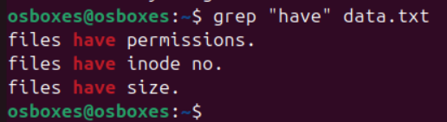

*vi) list the lines starts with letter "f" (man grep)*

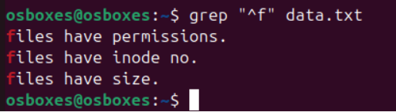

*vii) list the lines ends with "." (man grep)*

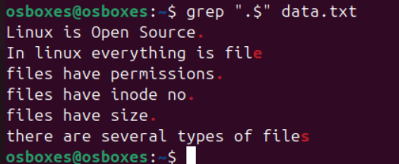

*viii) list only first two lines.(man head)*

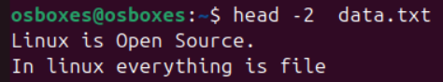

*ix) list only last three lines.(man tail)*

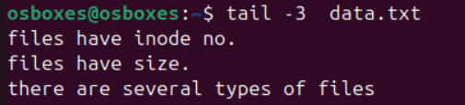

*x) list line no.3,4 and 5 . (man head and tail)*

