***Assignment No – 10***

*1) Write a query that produces all pairs of salespeople who are living in the same city. Exclude combinations of salespeople with themselves as well as duplicate rows with the order reversed.*

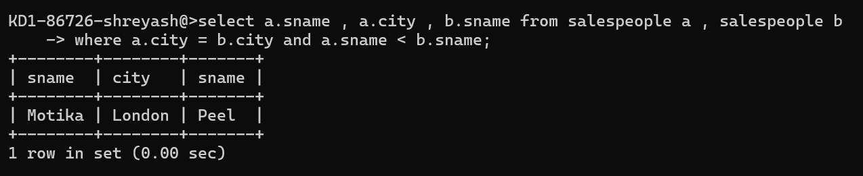

*2) Write a query that produces the names and cities of all customers with the same rating as Hoffman.*

