***Assignment No – 11***

*1) Write a query that uses a subquery to obtain all orders for the customer named Cisneros. Assume you do not know his customer number (cnum).*

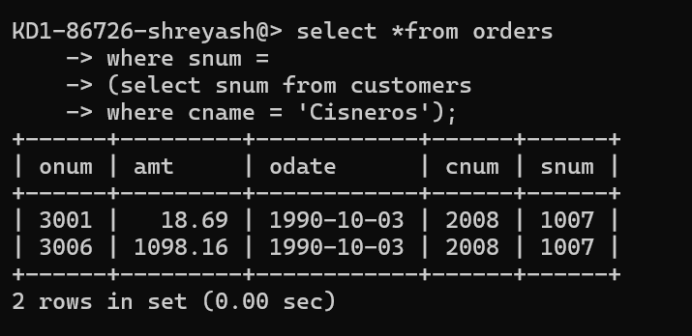

*2) Write a query that produces the names and ratings of all customers who have above-average orders.*

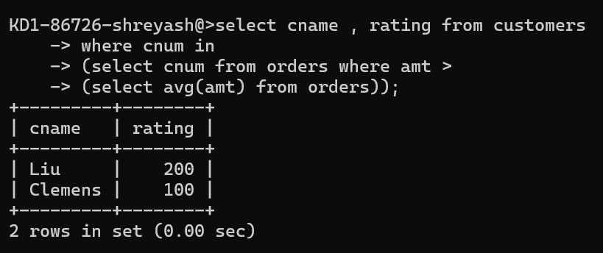

*3) Write a query that selects the total amount in orders for each salesperson for whom this total is greater than the amount of the largest order in the table.*

