***Assignment No – 12***

*1) Write a query that selects all customers whose ratings are equal to or greater than ANY of Serres’.*

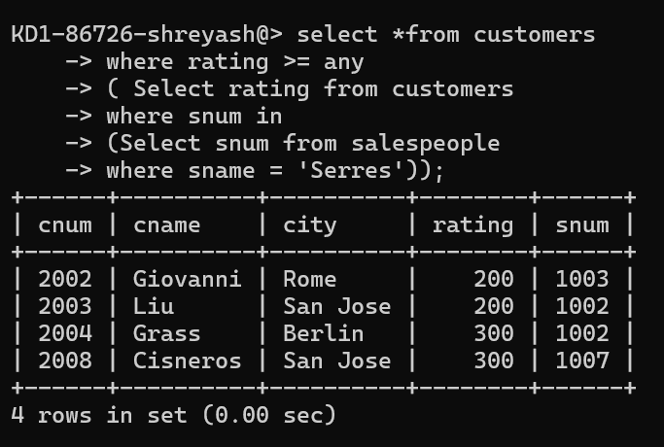

*2) Write a query using ANY or ALL that will find all salespeople who have no customers located in their city.*

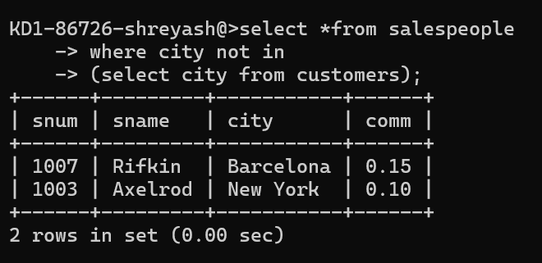

*3) Write a query that selects all orders for amounts greater than any for the customers in London.*

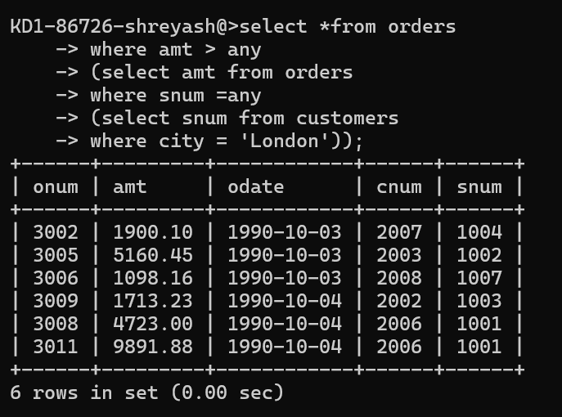

*4) Write the above query using MIN or MAX.*

