***Assignment No = 14***

*1) Write a command that puts the following values, in their given order, into the salespeople table: city – San Jose, name – Blanco, comm – NULL, cnum – 1100.*

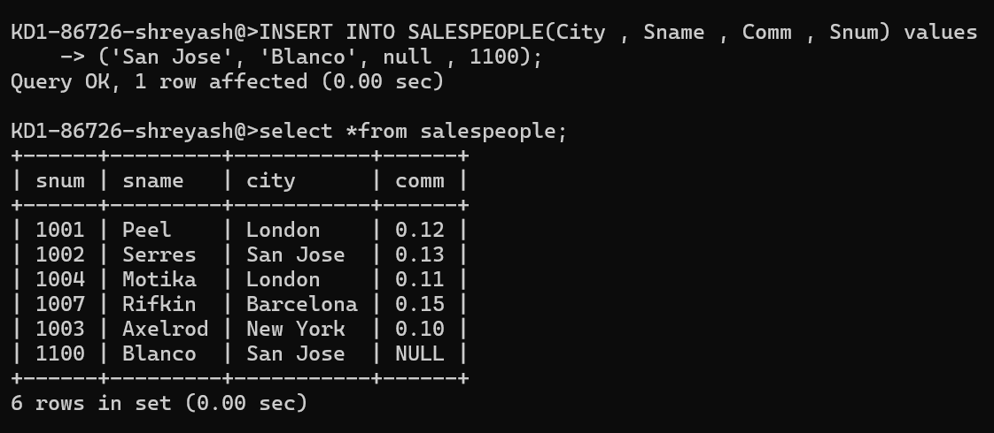

*2) Write a command that removes all orders from customer Clemens from the Orders table.*

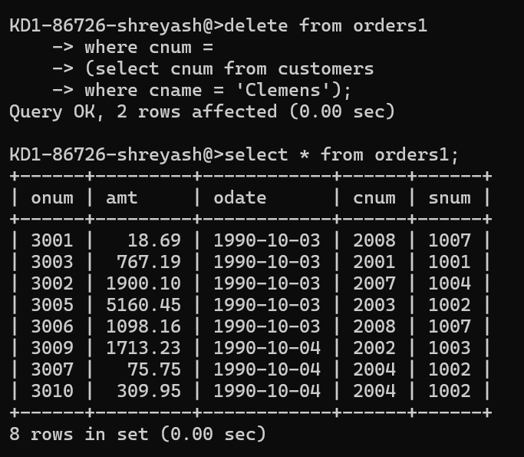

*3) Write a command that increases the rating of all customers in Rome by 100.*

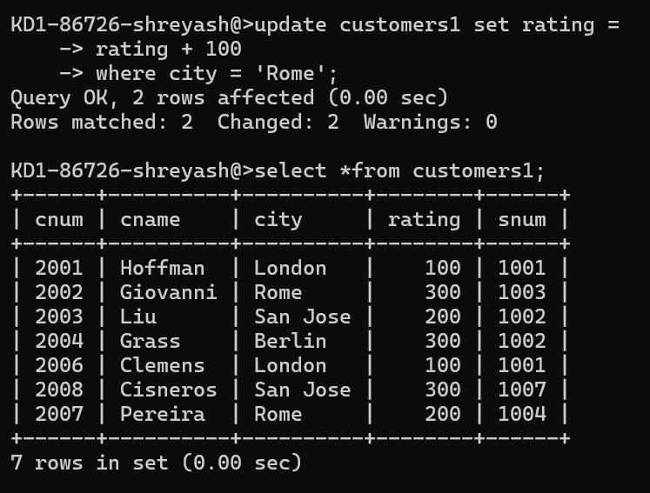

*4) Salesperson Serres has left the company. Assign her customers to Motika.*

