***Assignment N0 – 05***

1. *Write a query that will give you all orders for more than Rs. 1,000.*

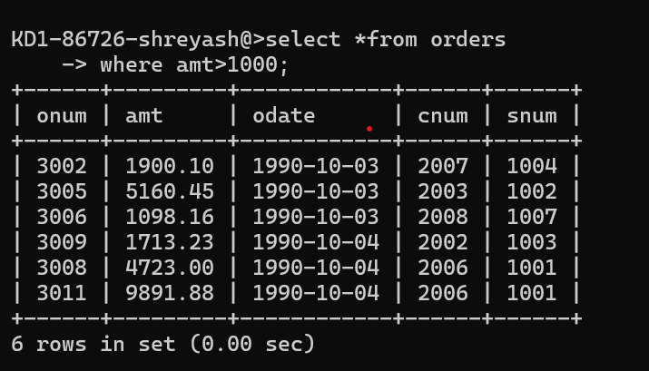

1. *Write a query that will give you the names and cities of all salespeople in London with a commission above .10*

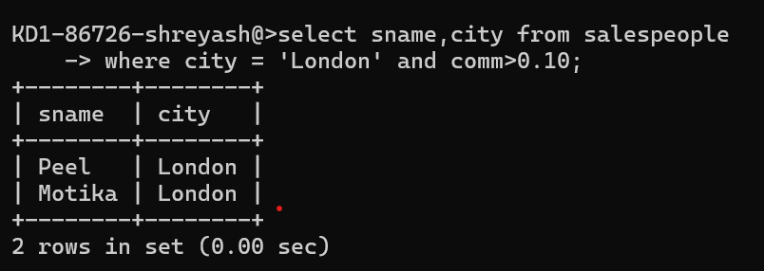

1. *Write a query on the Customers table whose output will exclude all customers with a rating <= 100, unless they are located in Rome.*

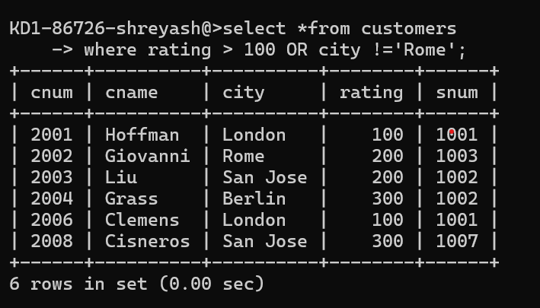

4*) What will be the output from the following query?*

*Select * from Orders where (amt < 1000 OR NOT (odate = ‘1990-10-03’ AND cnum > 2003));*

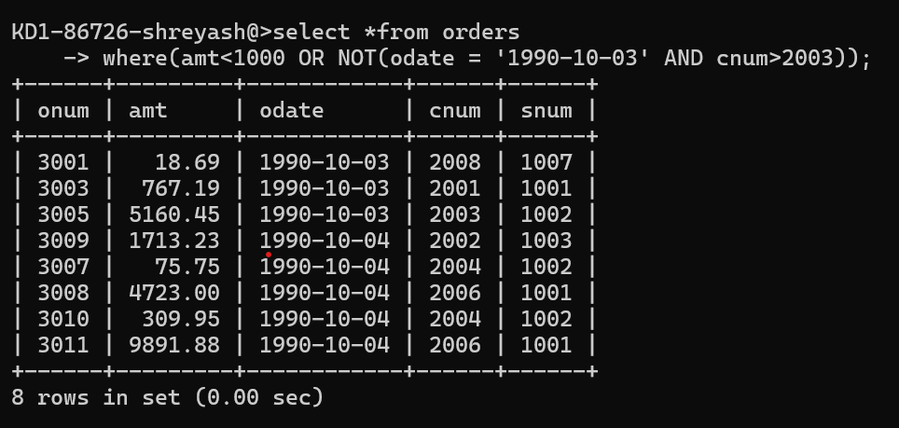

5) *What will be the output of the following query?*

*Select * from Orders where NOT ((odate = ‘1990-10-03’ OR snum >1006) AND amt >= 1500);*

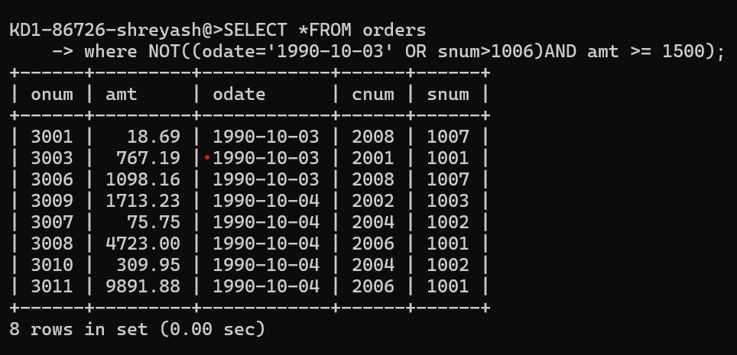

6) *What is a simpler way to write this query?*

*Select snum, sname, city, comm From Salespeople where (comm > .12 OR comm)*

