***Assignment No – 06***

1. *Write two different queries that would produce all orders taken on October 3rd or 4th, 1990.*

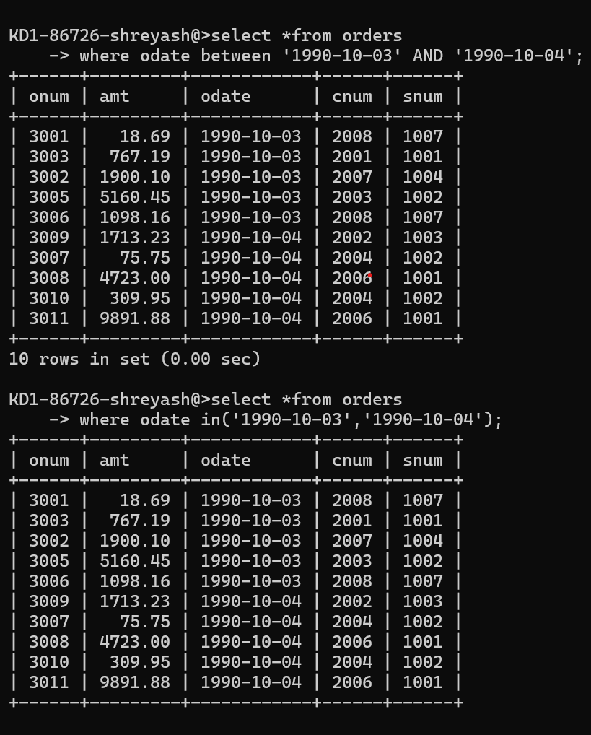

1. *Write a query that selects all of the customers serviced by Peel or Motika. (Hint: the snum field relates the two tables to one another).*

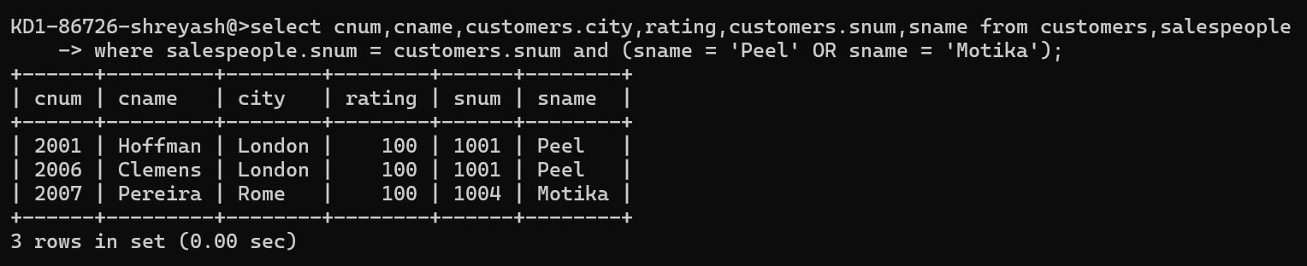

1. *Write a query that will produce all the customers whose names begin with a letter from ‘A’ to ‘G’.*

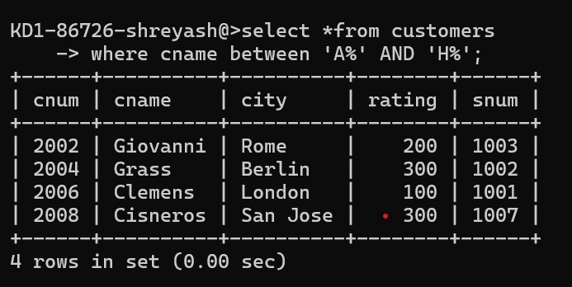

1. *Write a query that selects all customers whose names begin with the letter ‘C’.*

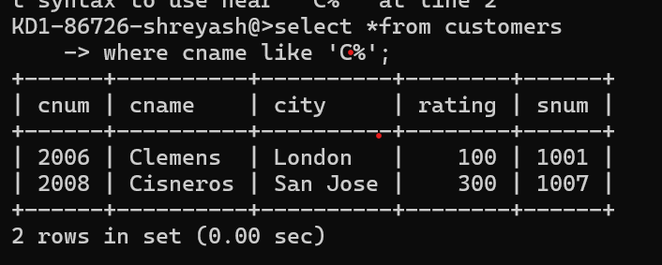

1. *Write a query that selects all orders except those with zeroes or NULLs in the amt fields*

