**Assignment_III : Linux_Commands**

1. Display hidden files



1. Rename all *.txt files to *.htm



1. Create symbolic link (shortcut) for a file

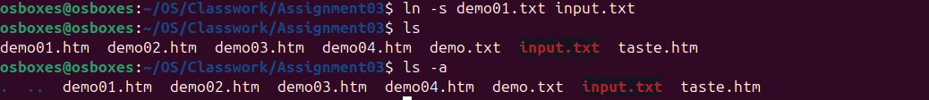

1. Create hard link for a file



1. Display time stamp of the file

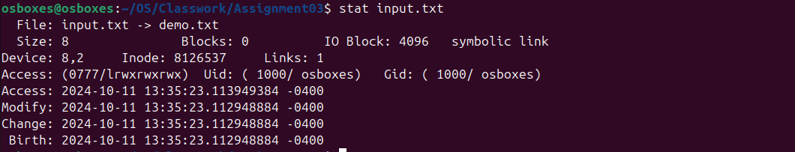

1. Change the time stamp of the file

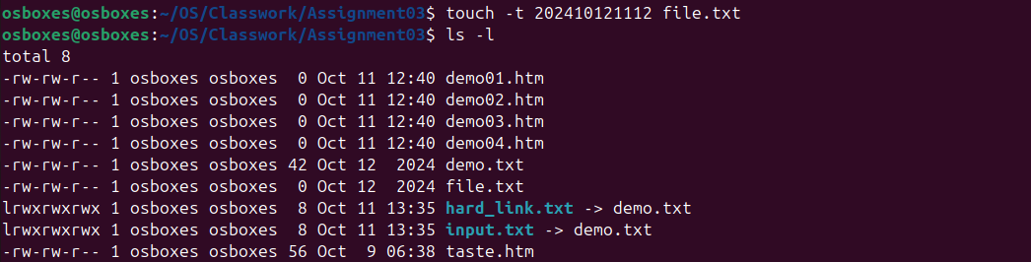

1. Create empty file



1. Print all lines in a file from fifth line onwards

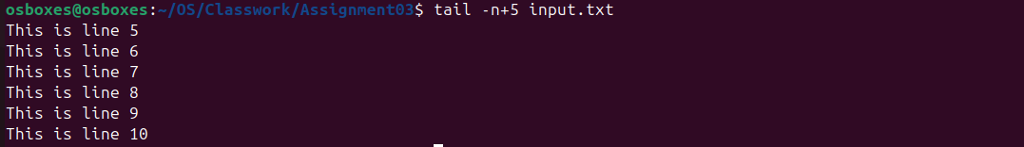

1. Shutdown (Only for super-user)

* Poweroff

1. Reboot (Only for super-user)

* Reboot

1. Find current user



1. Find current terminal



1. Find current user and terminal



1. Find all users logged into the system



1. Find all users logged in and terminals in use



1. Find a given word/pattern from the file

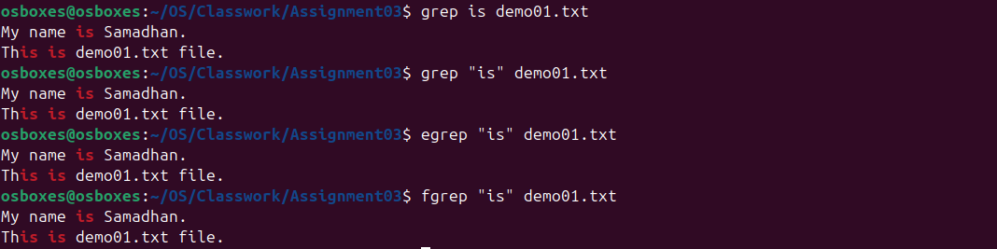

1. Make a file as read-only



1. Make a file as write, read and execute



1. Take input from the file, count words and store output to other file



1. Count words in output of “who” command



1. Print lines 5 to 10 from the given file

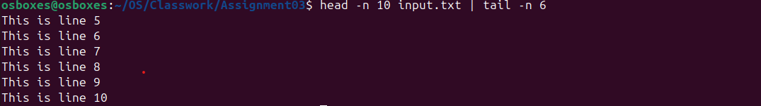

1. Print the uniq values from the unsorted file

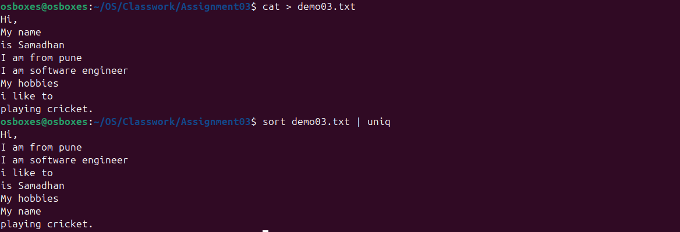

1. Display all users not using tty2, tty3, tty4



1. Display all files in ascending order of their file size

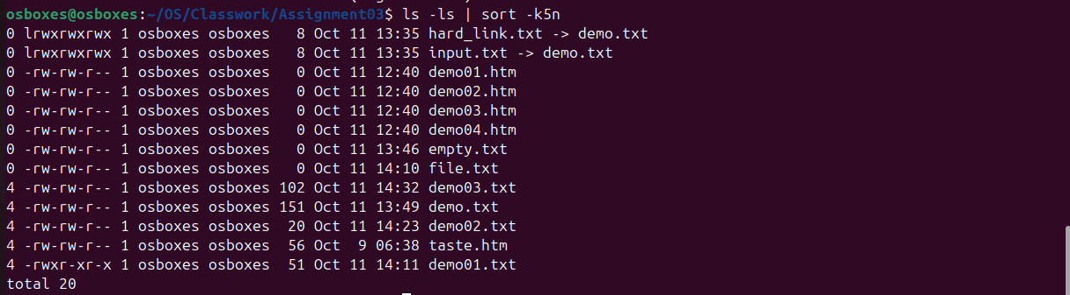

1. Count number of files and directories from current directory



1. Display only hidden files in a directory
2. Convert file contents into uppercase , also learn "-s" option of this command
3. Split the file contents using delimiter and print required fields