Create the following tables with the given structures and insert sample data as specified: -

1. SALESPEOPLE Snum int(4) Sname varchar(10) City varchar(10) Comm float(3,2)



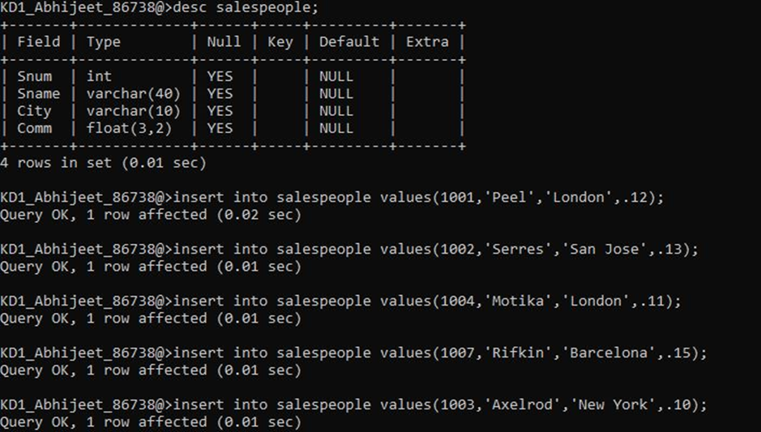

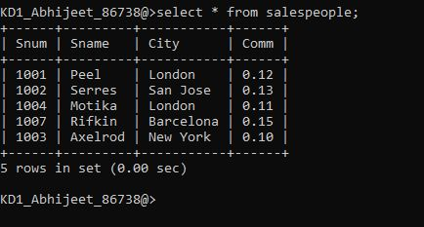

1. CUSTOMERS Cnum int(4) Cname varchar(10) City varchar(10) Rating int(4) Snum int(4)

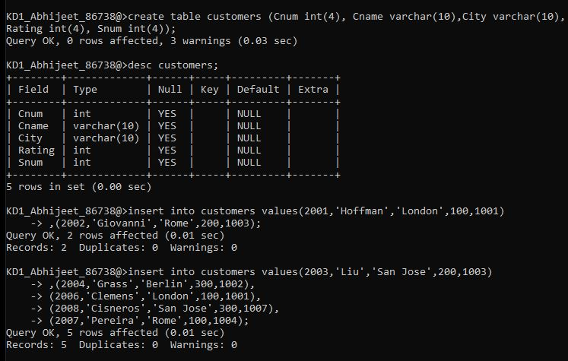

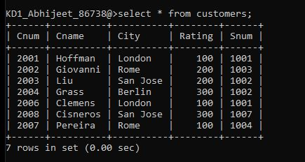

1. ORDERS Onum int(4) Amt float(7,2) Odate date Cnum int(4) Snum int(4)

