1. Write a query that selects all customers whose ratings are equal to or greater than ANY of ‘Serres’.

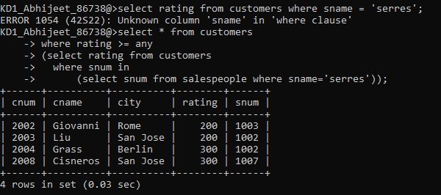

1. Write a query using ANY or ALL that will find all salespeople who have no customers located in their city.

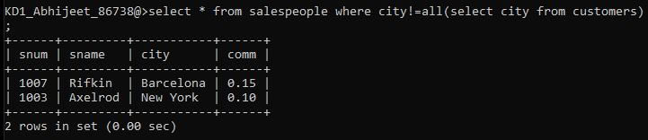

1. Write a query that selects all orders for amounts greater than any for the customers in London.

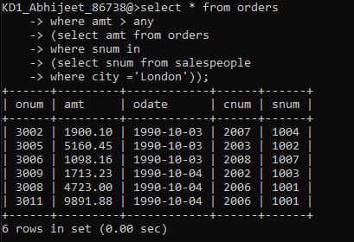

OR

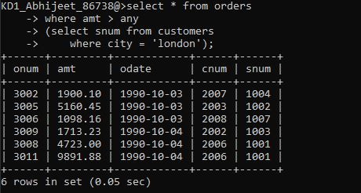

1. Write the above query using MIN or MAX.

