Assisgment-1

1. An audio signal is recorded using the following format.

FS = 8 kHz, encoded with16 bit and recorded in MONO

Calculate the memory requirement to store 100 ms signal in PCM WAV format.

1. Determine the F0 of the following signal if the signal is sampled at 22050Hz

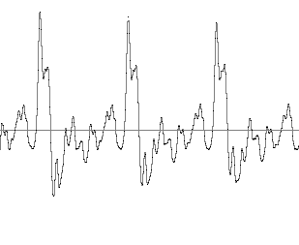

90 Samples

1. A Low-pass digital FIR filter is designed using the following specification.

Transition bandwidth =100 KHz, Cut off frequency =2 kHz, sampling frequency of the input signal is 8 kHz and the filter is implemented using HAMMING window.

Determine the order of the FIR filter?

1. Determine the period of the discrete-time signal *x[n].* where



1. Using frequency domain method (based on DFT and IDFT) determine the response of the FIR filter with impulse response *h[n]* to an input sequence *x[n].*



1. Figure-2 represents the magnitude of the discrete-time Fourier transform of a steady-state vowel segment. The envelope of the spectral magnitude is sketched with a dashed line. Suppose that the sampling rate is 12 kHz meet the Nyquist rate. Determine the value of the first formant frequency.

