**Assungment-2**

1. Describe the state of the Glottis during the pronunciation of the following phoneme?

(i) /k/, (ii) /b/, (iii) /a/, (iv) /l/, (v) /ʃ/

2. Draw a schematic diagram of the upper palate and mark the place of articulation of the following phonemes

(i) /gh/, (ii) /p/ (iii) /s/, (iv) /gh/, (v)/ɖ/

3. A voiced based telephone dialing system is designed using the following words

[DIAL; STOP; ONE; TWO; THREE; FOUR; FIVE; SIX; SEVEN; EIGHT;NINE;ZERO]

Following figure shows the spectrographic representation of the any of the above words. Using your knowledge of acoustic phonetics, determine the possible word.

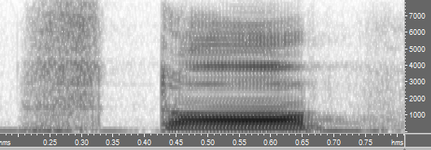

1. Following figure is the time domain representation of a consonant acoustic signal. Write the possible manner of articulation of the consonant

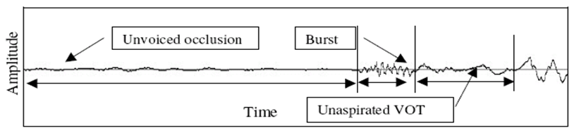

1. Draw the Schematic representation of the physiological mechanism of speech production and describe the production of the phoneme /k/ and /u/