Indian Institute of Technology, Kharagpur

Centre for Educational Technology

**Mid Semester Examination 2015**

Subject**: INTRODUCTION TO DIGITAL SPEECH PROCESSING** Code: ET60007

**Time: 2:00 Hours** PART-A:-10*2=20; PART-B:-5*6=30 **Full Marks =50**

***Answer all the questions of PART-A and PART-B***

*(Please enclose the Annexure-1 along with the answer script)*

**PART-A**

1. Two source of speech signal producing a vowel /a/. The overall intensity of one source is 20dB and other is 21dm. If a human being perceives the two sounds as same intensity sound explains why this happen?
2. What is equal loudness curve or phone curve? Draw an equal loudness curve for ***5 dB***.
3. Suppose an electric fan produces a noise intensity of 40 dB. How many times more intense is the sound of a conversation if it produces an intensity of 60 dB?
4. Draw the directivity pattern of an unidirectional microphone
5. What are the perceptual parameters of speech?
6. If cross section area of a uniform tube is A, and average atmospheric density is ρ what will be value of acoustic inductance.
7. If figure-1 represent the Frequency response of Uniform tube in no loss condition. Draw the Frequency response of Uniform tube if Effect of wall vibration is considered

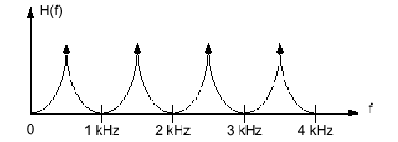

Figure-1

1. Time varying glottal resistance and inductance-both functions of glottal opening *AG(t). I*f the glottis is completely closed what will be the value of glottal impedance and volume velocity
2. The frequency response of a uniform tube is as given as figure-2. How many poles will be in the tube transfer function?

**F7**

**F6**

**F5**

**F4**

**F3**

**F2**

**F1**

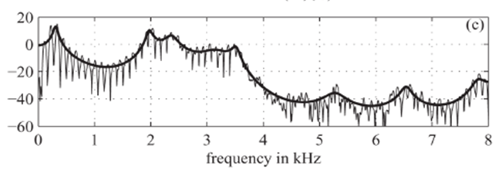

1. Prove that the velocity of sound is dependent only on the type of gas and the temperature and it does not depend on pressure.

**PART-B**

1. (a) Draw a schematic diagram of the upper palate and mark the place of articulation of the following phonemes
2. /p/, (B) /n/, (C) /s/, (D) /gh/, (E)/ɖ/

(b) Draw the Schematic representation of the physiological mechanism of speech production and describe the production of the phoneme /k/ and /u/

1. A voiced based telephone dialing system is designed using the following words

[DIAL; STOP; ONE; TWO; THREE; FOUR; FIVE;SIX;SEVEN;EIGHT;NINE;ZERO]

Annexure-1 shows spectrograms of one version of each of these words. Using your knowledge of acoustic phonetics, determine which spectrogram corresponds to which word.

1. A voiced speech sound /u/ is produce by two tube lossless vocal tract model. If the terminations at the glottis and lips are completely lossless. Derive the transfer function of the model in z domain. Draw the digital equivalent circuit diagram of the above voiced speech sound production Model
2. A speech production system is model using Uniform Tube Modeling and it produces a voice sound. Figure -1 shows the spectrum of the above voice sound along with the formant frequency and formant bandwidth with sampling frequency FS = 10 kHz. Derive the transfer function of the above Uniform Tube Model. General equation of the Uniform Tube Model is given in equation (1). Draw the digital implementation diagram of the model.

 (1)

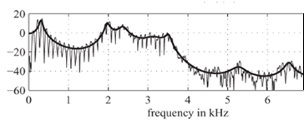

F1=4200 Hz

BW=140 Hz

F1= 5000 Hz

BW=112 Hz

F1=740 Hz

BW=68 Hz

F1=350 Hz

BW=98 Hz

F1=3100 Hz

BW= 55 Hz

F1= 2200 Hz

BW=65 Hz

1. (a) What is the perceived pitch (in Mels) for the following tones?

I) 250 Hz; II)1.5kHz III) 3.3 kHz

(b) Intensity of a voice conversation is 60dB and intensity of noise generated by an electric machine is 62 dB which one will be perceive louder and why?

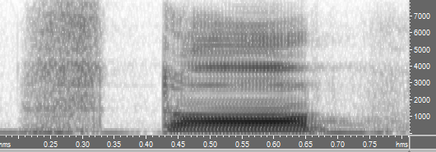 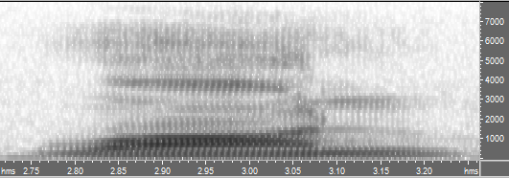

(A)………………….stop (B)…..one

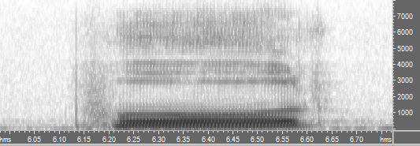 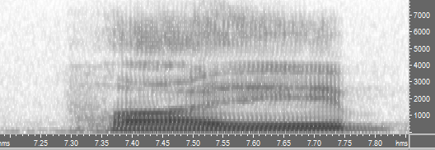

(C)……four (D)……Five

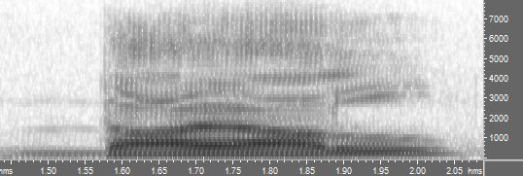 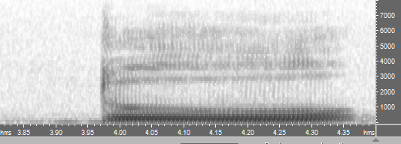

(F)….. Dial (G) …. Two

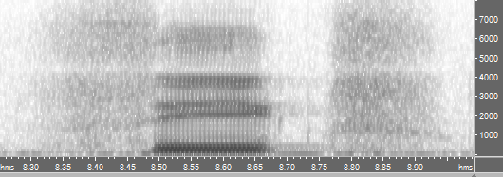 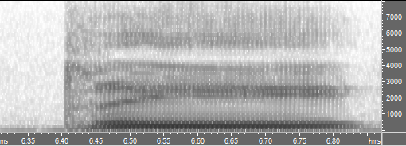

(H)….six (I) ……Three

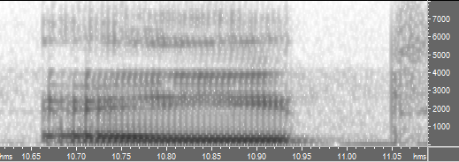 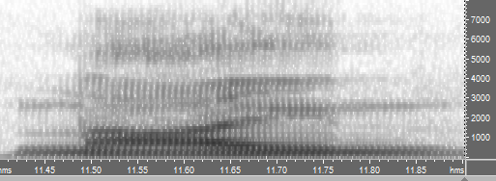

(J)…………eight (K)……Nine

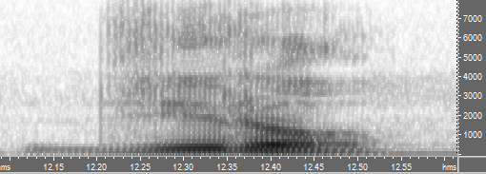 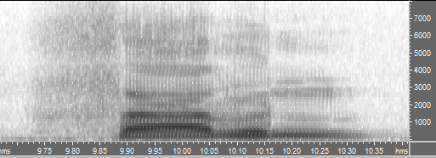

(L)….Zero (M)……seven