Indian Institute of Technology, Kharagpur

Centre for Educational Technology

**Mid Semester Examination 2019**

Subject**: INTRODUCTION TO DIGITAL SPEECH PROCESSING** Code: ET60007

**Time: 2:00 Hours** PART-A:-10*2=20; PART-B:-5*6=30 **Full Marks =50**

***Answer all the questions of PART-A and PART-B***

*(Please enclosed the Annexure-1 along with the answer script)*

**PART-A**

1. Two source of speech signal producing a vowel ***/e/***. The overall intensity of one source is ***20dB*** and other is ***21dB***. If a human being perceives the two sounds as same intensity sounds describes the reason.
2. Acoustic intensity of an audio system is ***5W/m2***. Represent it in dB and find out the Loudness (L) in Sones.



1. Write the speech perceptual parameters name.
2. If figure-1 represent the frequency response of uniform tube in no loss condition. Draw the frequency response of the uniform tube if effect of wall vibration is considered

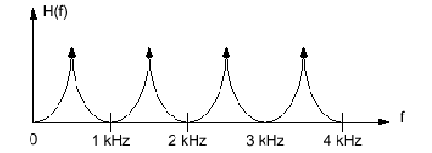

Figure-1

1. Time varying glottal resistance and inductance-both functions of glottal opening ***AG(t)****. I*f the glottis is completely closed what will be the value of glottal impedance and volume velocity
2. First formant frequency of a steady state vowel is ***F1=250Hz***. Consider that the vowel is produced using a single lossless acoustic tube. How long is the impulse response of the tube? Where the speed of sound ***c=350m/s***.
3. Figure-2 represents the production of a consonant write the **manner** and **place** of articulation of the consonant

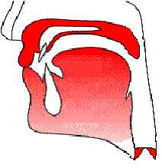

Figure-2

1. Write the place of articulation of the following phonemes?

/bh/, /t/, /k/, /ɖ/

1. 2 sec. speech segment is encoded using LPC coefficient and the LPC coefficient are extracted for each frame with a frame rate ***100 frame/s***. Calculate numbers of LPC coefficient frames can be extract from the above speech signal? Where sampling frequency ***Fs=16 kHz***
2. An audio signal is recorded using the following format. To store ***200ms*** signal in PCM WAV format how much memory is required?

***FS = 44.1 KHz***, encoded with **16 bit** and recoded in MONO

**PART-B**

1. A speech production system is model using Uniform Tube Modeling and it produces a voice sound. Figure -3 shows the spectrum of the above voice sound along with the formant frequency and formant bandwidth with sampling frequency ***FS = 10 kHz***. Derive the transfer function of the above Uniform Tube Model. General equation of the Uniform Tube Model is given in equation (1). Draw the digital implementation diagram of the model.

 (1)

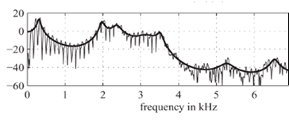

F1= 2200 Hz

BW=65 Hz

F1=740 Hz

BW=68 Hz

F1=350 Hz

BW=98 Hz

F1=3100 Hz

BW= 55 Hz

F1= 5000 Hz

BW=112 Hz

F1=4200 Hz

BW=140 Hz

Figure -3

1. A causal LTI system has system function is given in equation-1. Equation 2 represents the expression of prediction error filter ***A(z)***. Lattice Formulations of Linear Prediction as given in equation 3(a) and 3(b)

Where ***e[m]*** represents the forward prediction error, ***b[m]*** represents the backward prediction error and ***ki*** is the PARCOR coefficient



3(b)



If the signal ***s[n] = {1,-2, 2}*** applied in the design error filter ***A(z)*** (as in question no. 2) where ***p=3,*** calculate the value of the forward prediction error at the output of the ***2nd*** lattice.

1. A speech signal is sampled at ***16 KHz, 16 bit***; determine the required order of the LPC analysis. If each of the LPC coefficients is encoded with ***2 byte***, ***Gain in 2 byte***. Voiced Unvoiced and F0 information is encoded using ***2 byte***. Calculate the compression ratio if frame rate is ***100 frame /sec***.
2. If the order of the LPC analysis is ***3*** and LPC coefficients are {α1, α2, α3} compute the model gain for a signal ***x[n] = {1, 2, 1,-1,2}***



1. A voiced based speed dialing system of a mobile phone is design for the following words. Figure-4(I) to (VI) in **Annexure-1** shows spectrograms of one version of each of the words. Using your knowledge of acoustic phonetics, determine which spectrogram corresponds to which word.

(I) Home, (II) DIAL, (III) office, (IV) doctor, (V) School, (VI) Disconnect

Annexure-1

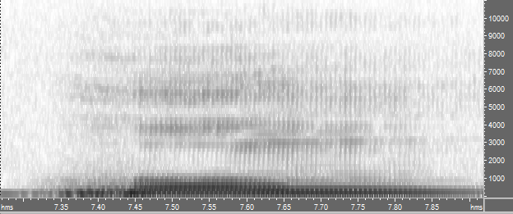 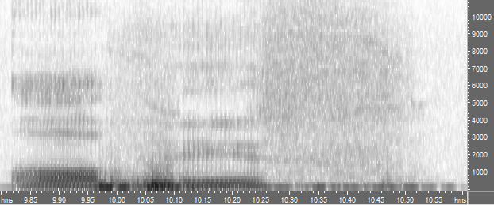

(I) ……………………… (II) ……………………………..

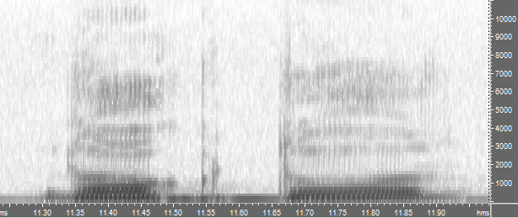 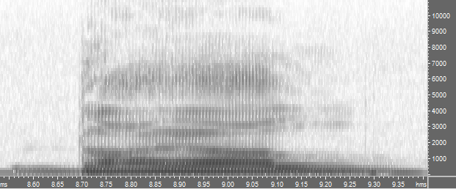

(III)………………………………….. (IV) …………………………………….

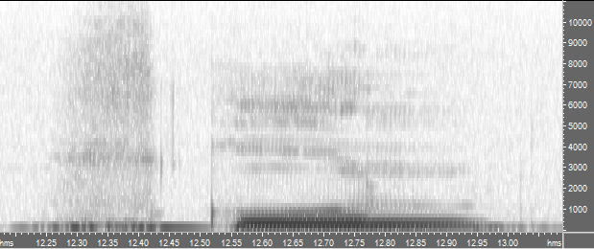 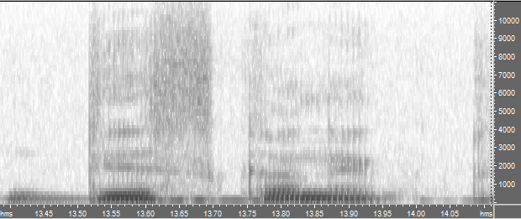

(V)……………………………… (VI) ..…………………….