Assisgment-1
- An audio signal is recorded using the following format.
F_{S} = 8 kHz, encoded with16 bit and recorded in MONO
Calculate the memory requirement to store 100 ms signal in PCM WAV format.
- Determine the F₀ of the following signal if the signal is sampled at 22050Hz
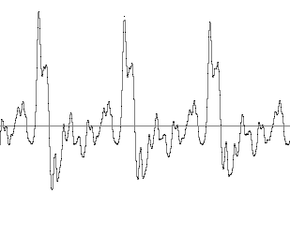
90 Samples
- A Low-pass digital FIR filter is designed using the following specification.
Transition bandwidth =100 KHz, Cut off frequency =2 kHz, sampling frequency of the input signal is 8 kHz and the filter is implemented using HAMMING window.
Determine the order of the FIR filter?
- Determine the period of the discrete-time signal x[n]. where

- Using frequency domain method (based on DFT and IDFT) determine the response of the FIR filter with impulse response h[n] to an input sequence x[n].

- Figure-2 represents the magnitude of the discrete-time Fourier transform of a steady-state vowel segment. The envelope of the spectral magnitude is sketched with a dashed line. Suppose that the sampling rate is 12 kHz meet the Nyquist rate. Determine the value of the first formant frequency.
