Assungment-2

- Describe the state of the Glottis during the pronunciation of the following phoneme?
(i) /k/, (ii) /b/, (iii) /a/, (iv) /l/, (v) /ʃ/

2. Draw a schematic diagram of the upper palate and mark the place of articulation of the following phonemes
(i) /g^{h}/, (ii) /p/ (iii) /s/, (iv) /g^{h}/, (v)/ɖ/

3. A voiced based telephone dialing system is designed using the following words
[DIAL; STOP; ONE; TWO; THREE; FOUR; FIVE; SIX; SEVEN; EIGHT;NINE;ZERO]
Following figure shows the spectrographic representation of the any of the above words. Using your knowledge of acoustic phonetics, determine the possible word.

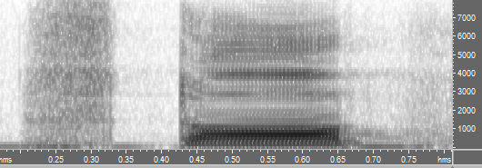

- Following figure is the time domain representation of a consonant acoustic signal. Write the possible manner of articulation of the consonant

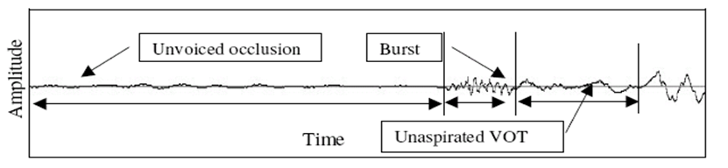

- Draw the Schematic representation of the physiological mechanism of speech production and describe the production of the phoneme /k/ and /u/

