------------------------------------------------------------------------------------------------------------------------
SQL Assignment-4
------------------------------------------------------------------------------------------------------------------------

Retrieving Information from Tables.

1) Write a select command that produces the order number, amount, and date for all rows in the Orders table.

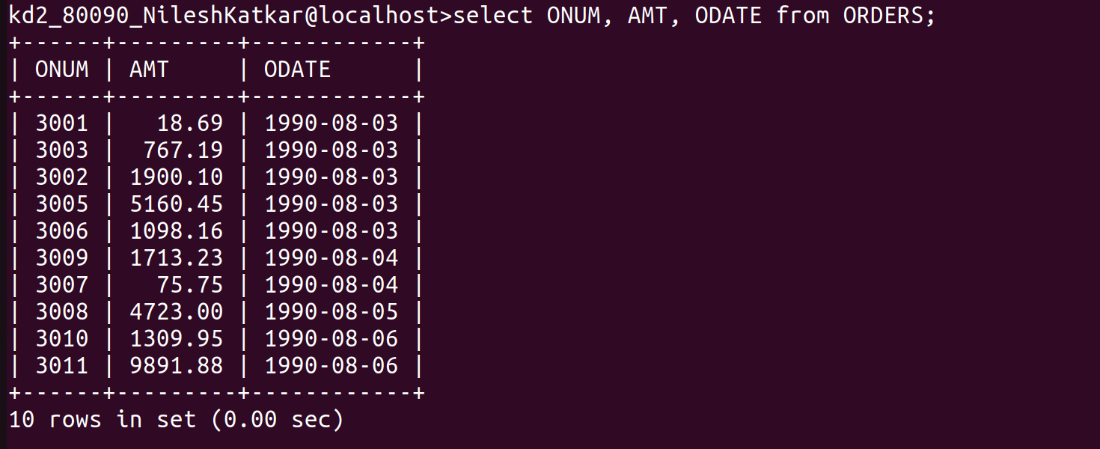

------------------------------------------------------------------------------------------------------------------------

2) Write a query that produces all rows from the Customers table for which the salesperson's number is 1001.

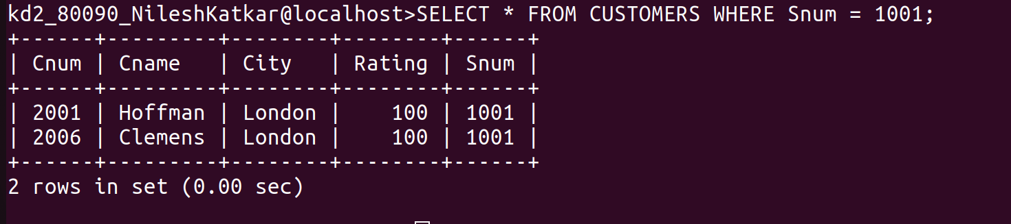

------------------------------------------------------------------------------------------------------------------------

3) Write a query that displays the Salespeople table with the columns in the following order:
city, sname, snum, comm.

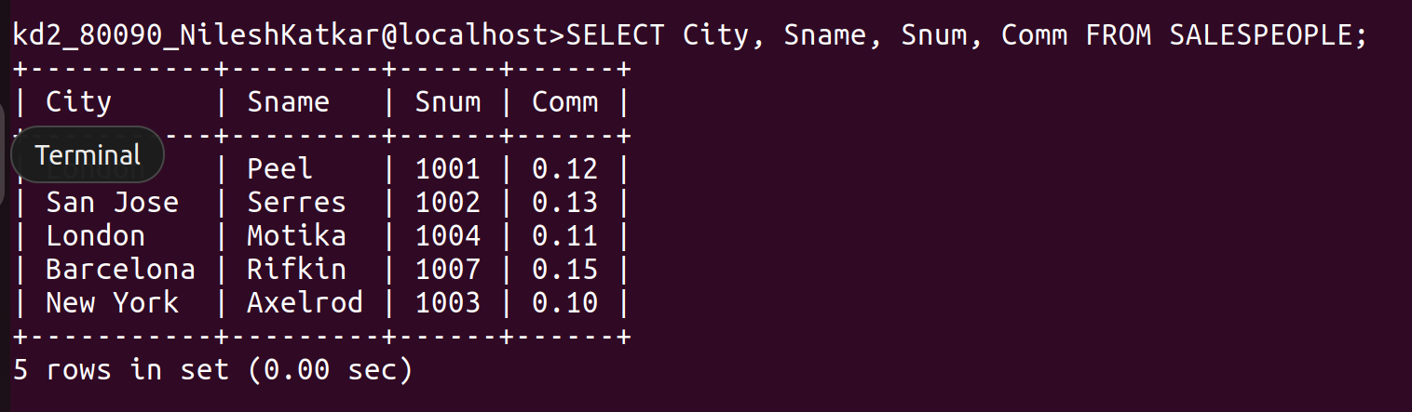

------------------------------------------------------------------------------------------------------------------------

4) Write a select command that produces the rating followed by the name of each customer in San Jose

