QUERYING MULTIPLE TABLE AT ONCE
1.Write a query that lists each order number followed by the name of the customer who made the order.
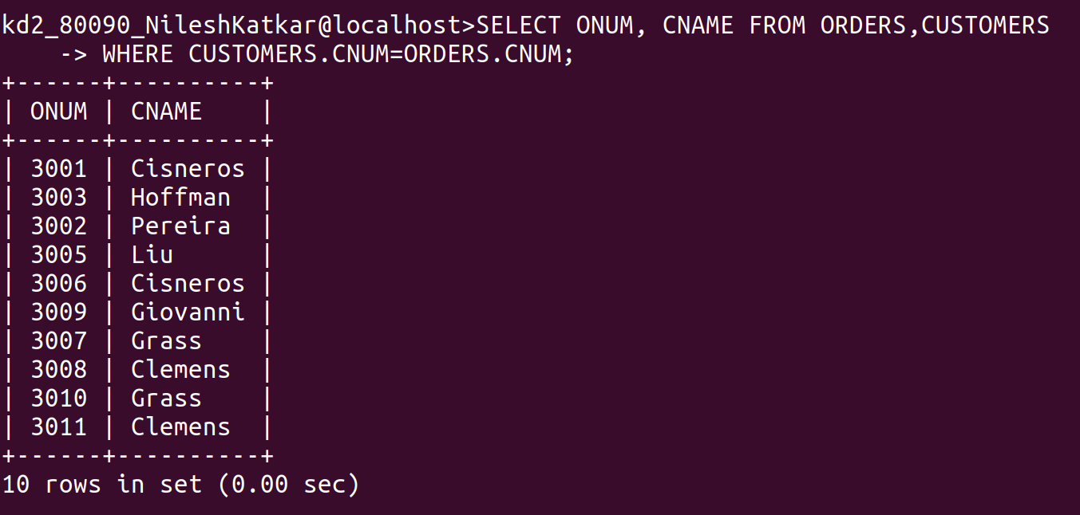
------------------------------------------------------------------------------------------------------------------------
2. Write a query that gives the names of both the salesperson and the customer for each order along with the order number.
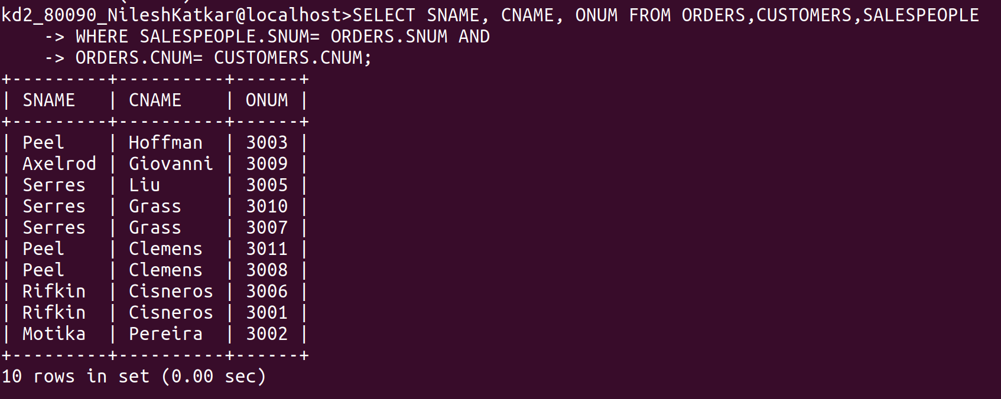
------------------------------------------------------------------------------------------------------------------------
3. Write a query that produces all customers serviced by salespeople with a commision above 12%. Output the customer’s name , the salesperson’s name, and the salesperson’s rate of commision.

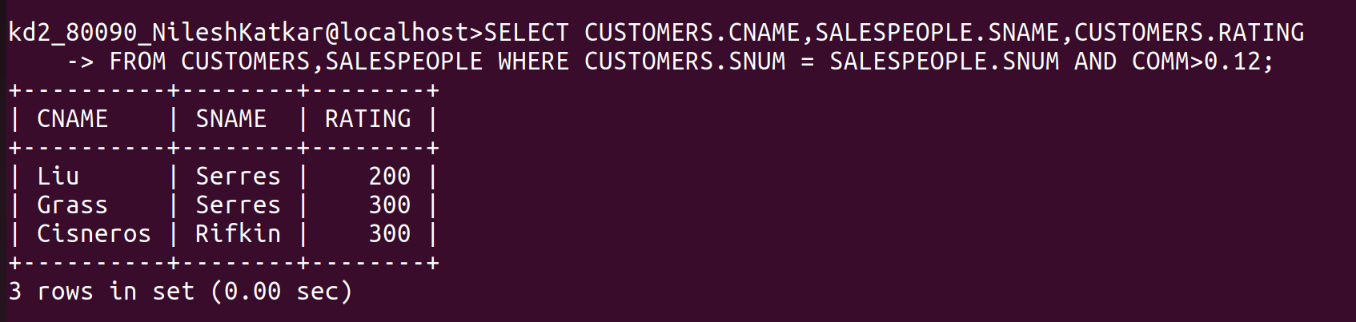
------------------------------------------------------------------------------------------------------------------------
4. Write a query that calculates the amount of the salesperson’s commision on each order by a customer with a rating above 100.




