------------------------------------------------------------------------------------------------------------------------
SQL Assignment-5
------------------------------------------------------------------------------------------------------------------------

Relational and Logical Operators.

1) Write a query that will give you all orders for more than Rs. 1,000.

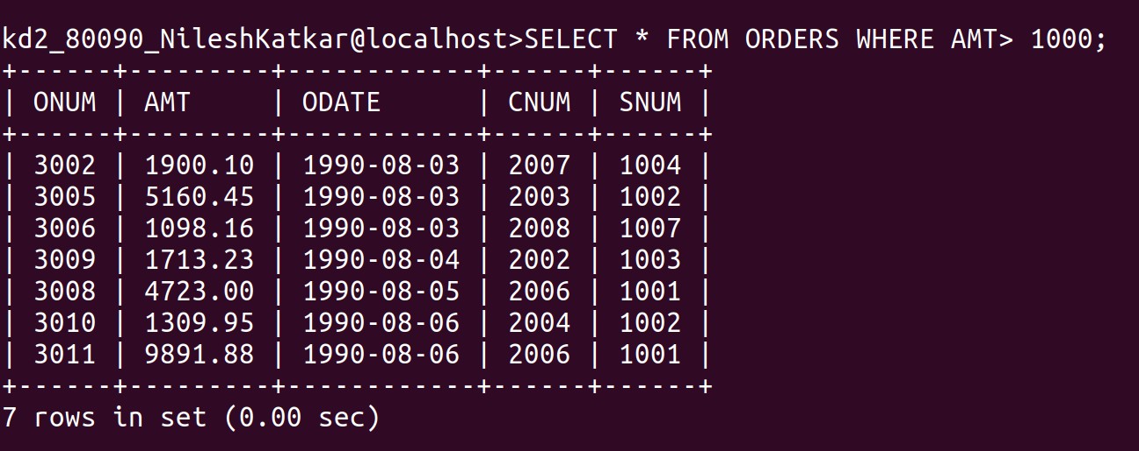
------------------------------------------------------------------------------------------------------------------------

2) Write a query that will give you the names and cities of all salespeople in London with a commission above .10

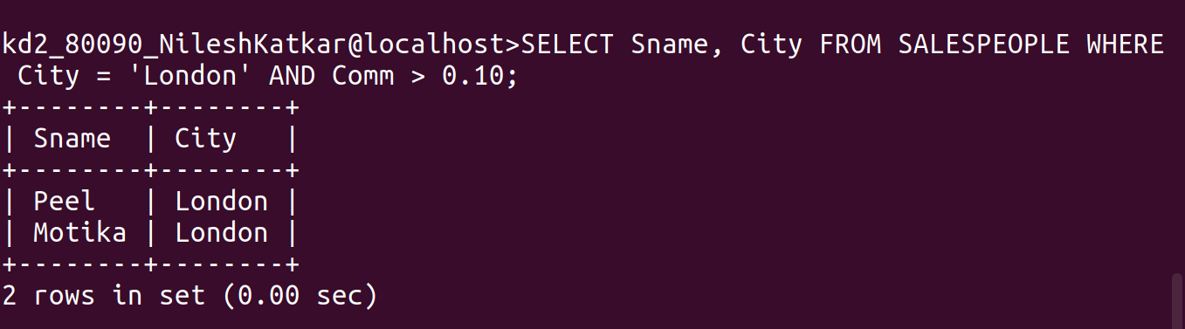
------------------------------------------------------------------------------------------------------------------------

3) Write a query on the Customers table whose output will exclude all customers with a rating <= 100, unless they are located in Rome.

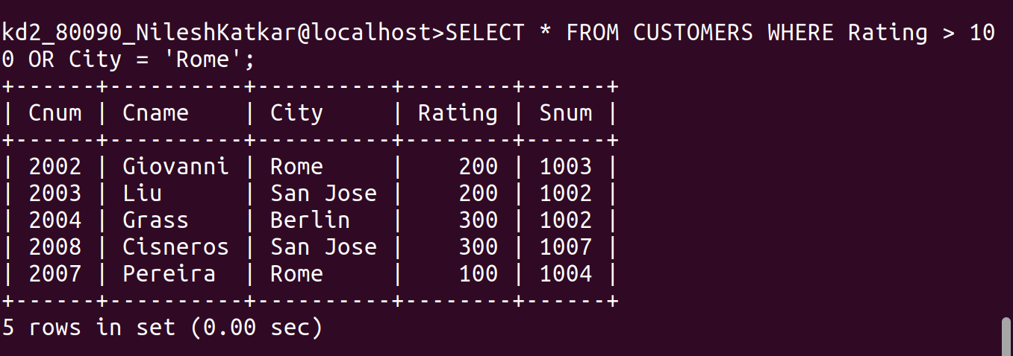
------------------------------------------------------------------------------------------------------------------------

4) What will be the output from the following query?

Select * from Orders where (amt < 1000 OR

NOT (odate = '1990-10-03'

AND cnum > 2003));

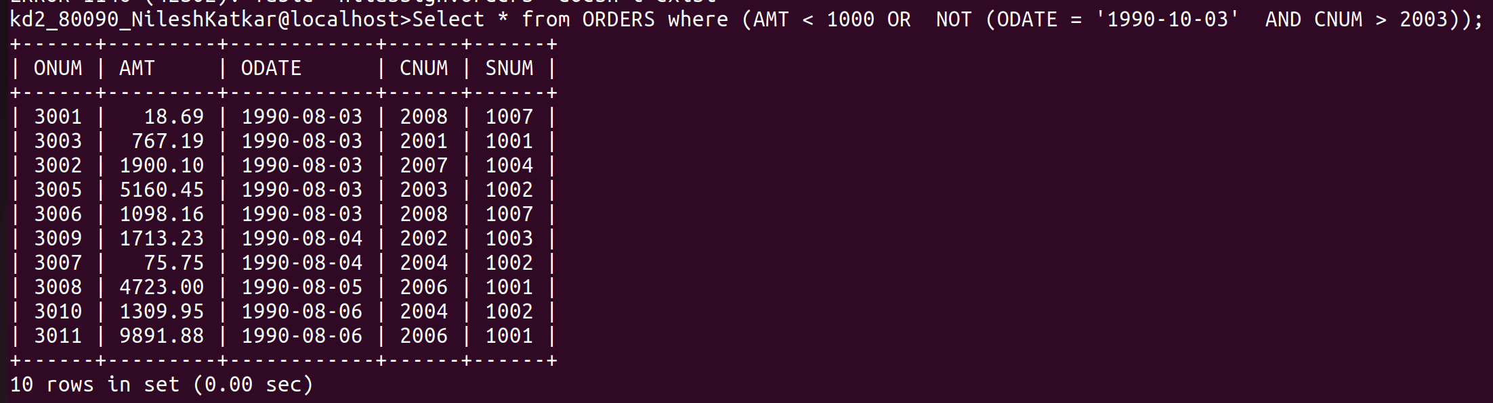
------------------------------------------------------------------------------------------------------------------------

5) What will be the output of the following query?

Select * from Orders where NOT ((odate = 1990-10-03' OR snum

>1006) AND amt >= 1500);

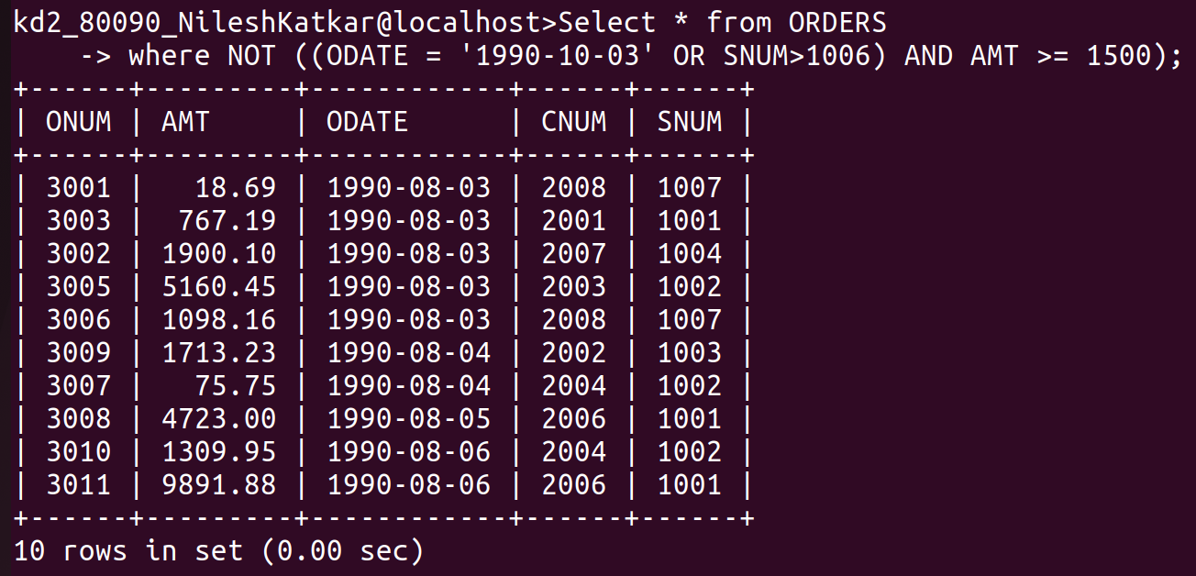

------------------------------------------------------------------------------------------------------------------------

6) What is a simpler way to write this query?

Select snum, sname, city, comm From Salespeople (comm>.12 OR comm <.14);




