SUMMARIZING DATA WITH AGGREGATE FUNCTIONS.
------------------------------------------------------------------------------------------------------------------------

QUE 1. WRITE A QUERY THAT COUNTS ALL ORDERS FOR OCTOBER 3.

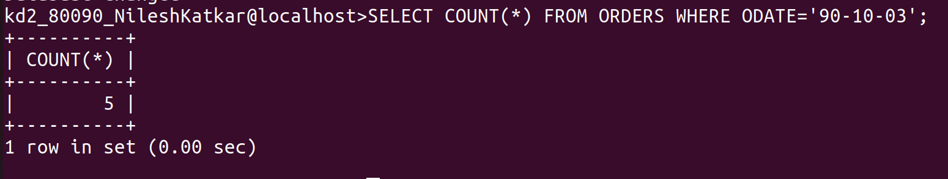

------------------------------------------------------------------------------------------------------------------------

QUE 2. WRITE A QUERY THAT COUNTS THE NUMBER OF DIFFERENT NOT-NULL CITY VALUES IN THE CUSTOMERS.

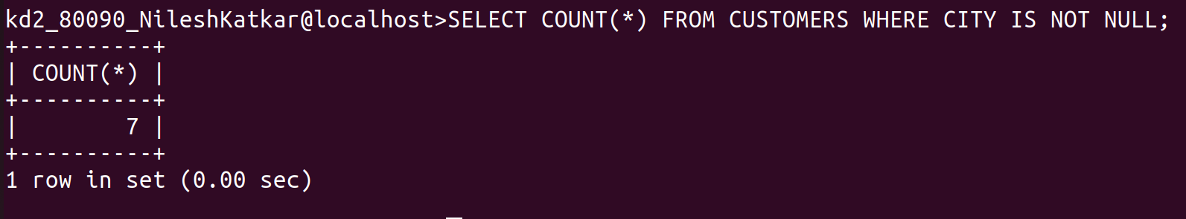

------------------------------------------------------------------------------------------------------------------------

QUE 3. WRITE A QUERY THAT SELECTS EACH CUSTOMER’S SMALLEST ORDER.

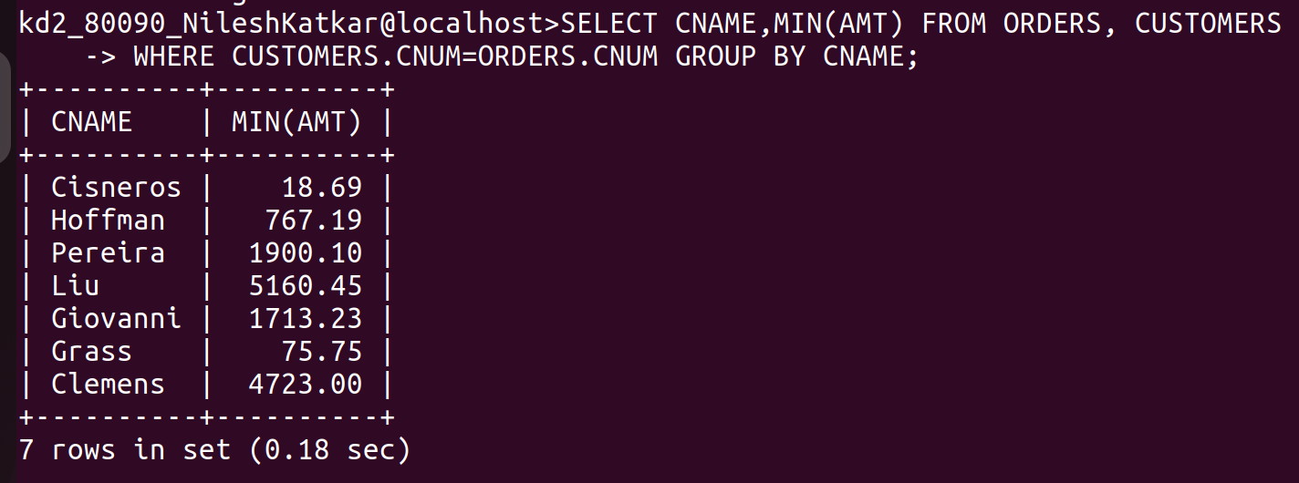

------------------------------------------------------------------------------------------------------------------------

------------------------------------------------------------------------------------------------------------------------
QUE 4. WRITE A QUERY THAT SELECTS THE FIRST CUSTOMER, IN ALPHABETICAL ORDER, WHOSE NAME BEGINS WITH G.

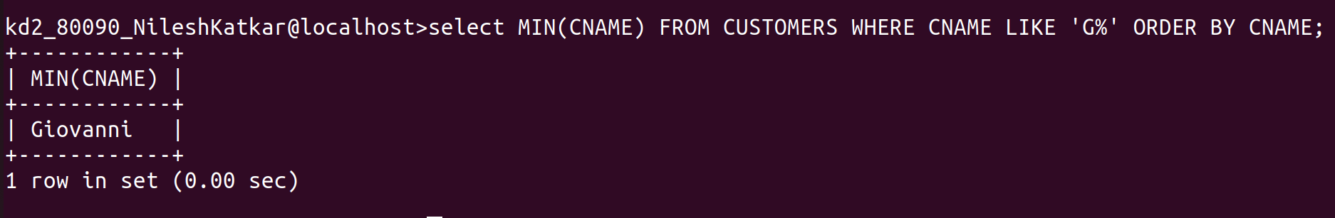
------------------------------------------------------------------------------------------------------------------------

QUE 5. WRITE A QUERY THAT SELECTS THE HIGHEST RATING IN EACH CITY.

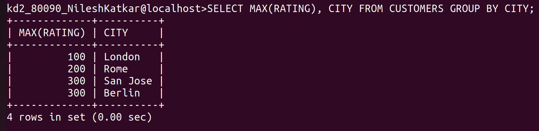
------------------------------------------------------------------------------------------------------------------------

QUE 6. WRITE A QUERY THAT COUNTS THE NUMBER OF SALESPEOPLE REGISTERING ORDERS FOR EACH DAY. (IF A SALESPERSON HAS MORE THAN ONE ORDER ON A GIVENDAY, HE OR SHE SHOULD BE COUNTED ONLY ONCE).





