JOINING A TABLE TO ITSELF

1. Write a query that produces all pairs of salespeople who are living in the same city. Exclude combination of salespeople with themselves as well as duplicate rows with the order reversed.

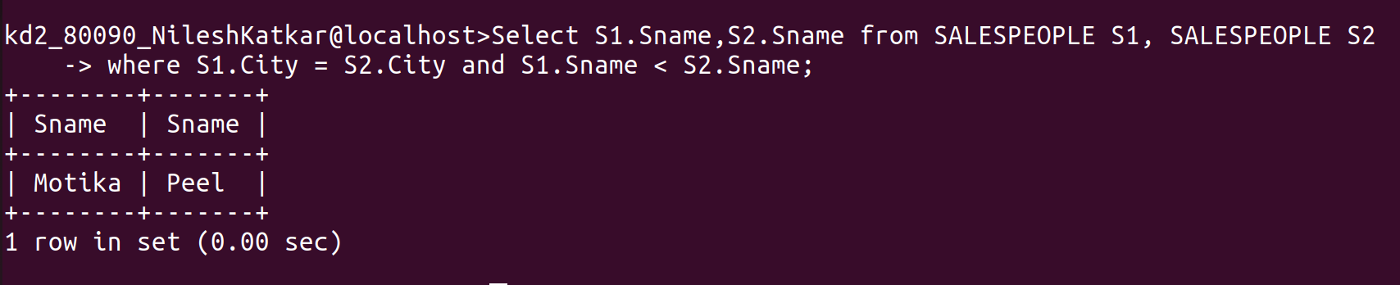
------------------------------------------------------------------------------------------------------------------------

2. Write a query that produces the names and cities of all customers with same rating as hoffman.




