SubQueries

1. Write a query that uses a subquery to obtain all orders for the customer named Cisneros. Assume you do not know his customer number(cnum).

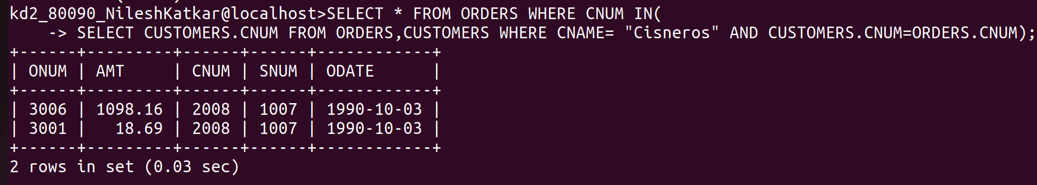
------------------------------------------------------------------------------------------------------------------------

2. Write a query that produces the names and ratings of all customers who have above – average orders.

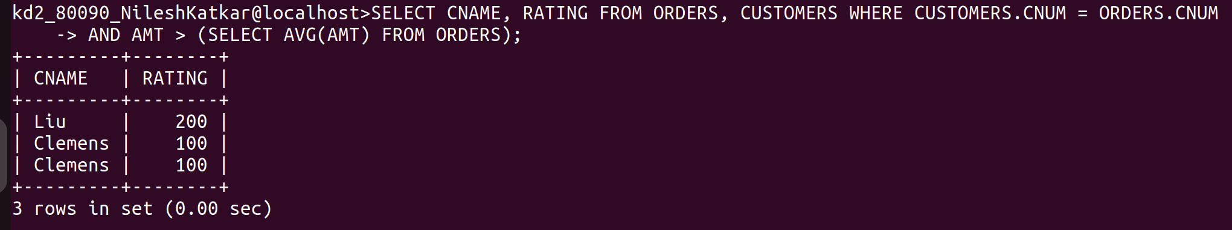
------------------------------------------------------------------------------------------------------------------------

3.Write a query that selects the total amount in orders for each salesperson for whom this total greater than the amount of the largest order of the table.




