Que . Creating sample tables and inserting values.

Que . Create the following tables with the given structures and insert sample data as specified:
------------------------------------------------------------------------------------------------------------------------
A) SALESPEOPLE
Snum int(4)
Sname varchar(10)
City varchar (10)
Comm float (3,2)
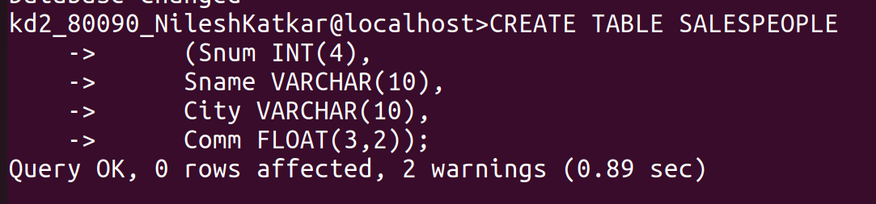

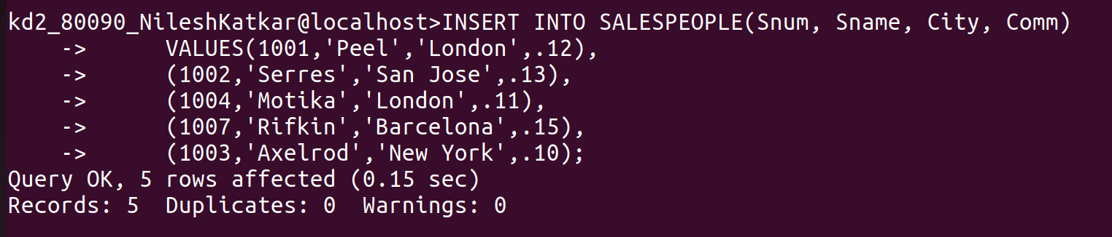

------------------------------------------------------------------------------------------------------------------------

B) CUSTOMERS
Cnum int (4)
Cname varchar (10)
City varchar (10)
Rating int (4)
Snum int (4)
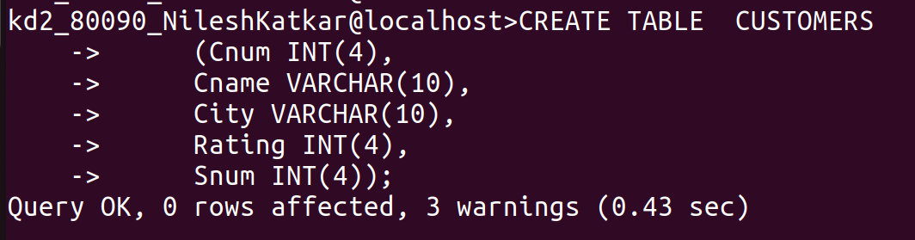

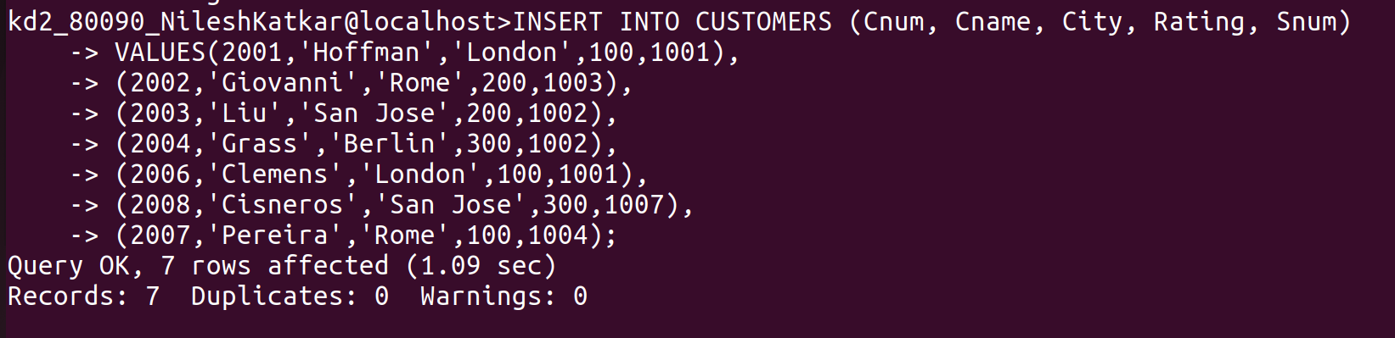
------------------------------------------------------------------------------------------------------------------------

C) ORDERS
Onum int (4)
Amt float (7,2)
Odate date
Cnum int (4)
Snum int (4)





