Entering, Deleting, and Changing Field Values.
------------------------------------------------------------------------------------------------------------------------
1. Write a command that puts the following values, on their given order, into the salespeople table:city – San Jose, name – Blanco, comm- null,cnum – 1100.

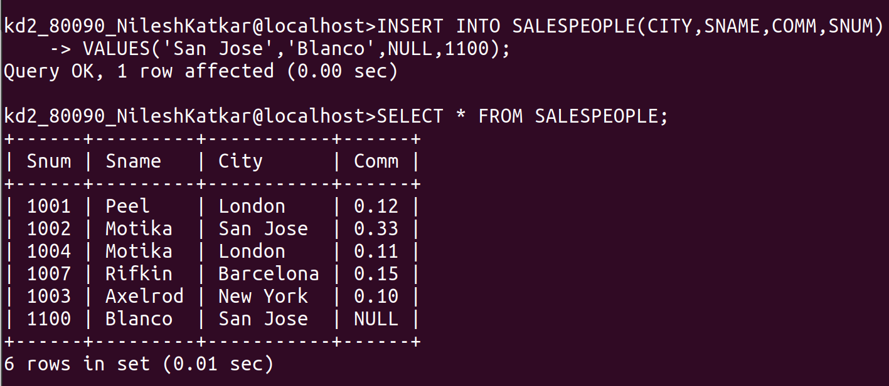
------------------------------------------------------------------------------------------------------------------------
2. Write a command that removes all orders from customer Clemens from Order table.

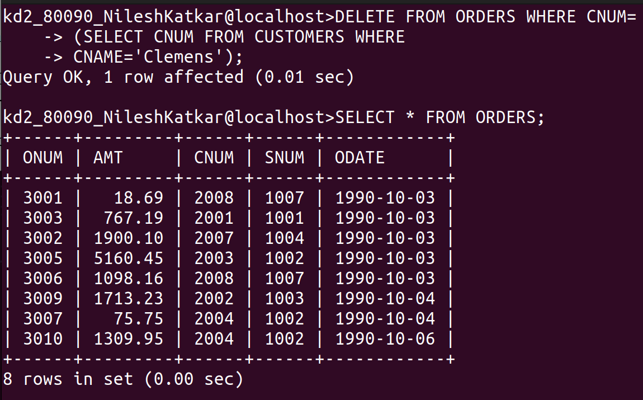
------------------------------------------------------------------------------------------------------------------------

3. Write a command that increases the rating of all customers in Rome by 100.

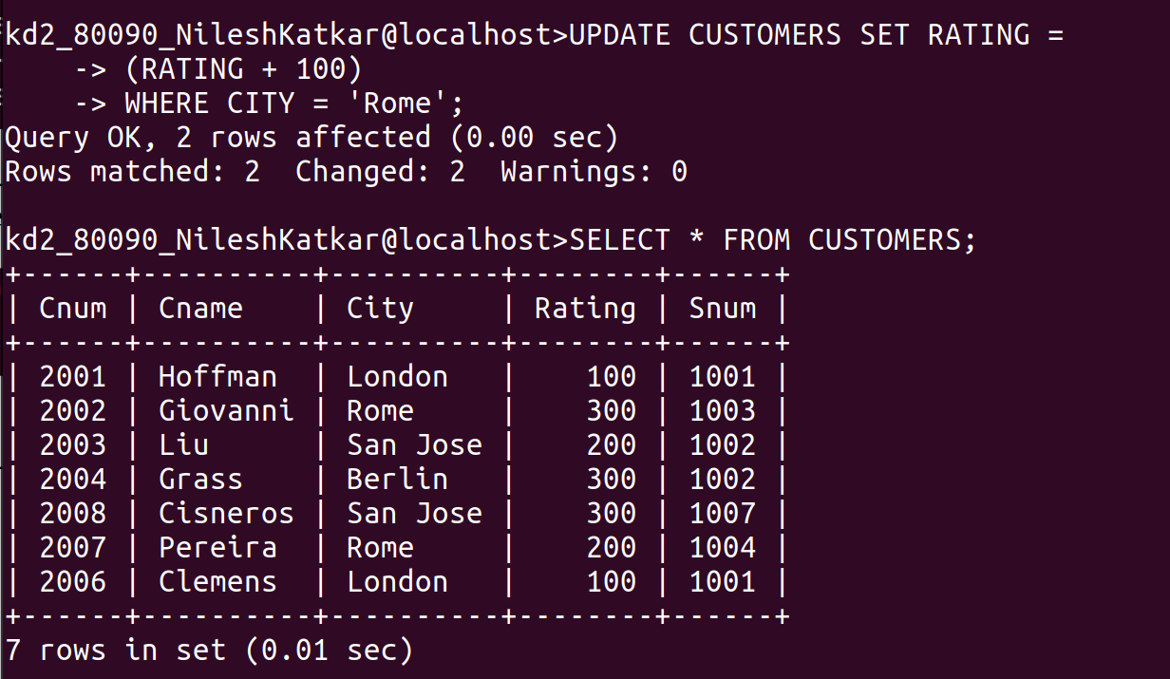
------------------------------------------------------------------------------------------------------------------------
4. Salesperson Serres has left the company. Assign her customers to Motika.





