USING THE OPERATORS IN,ANY AND ALL
------------------------------------------------------------------------------------------------------------------------
1. Write a query that selects all customers whose rating are equal to or greater than any of ‘Serres’.

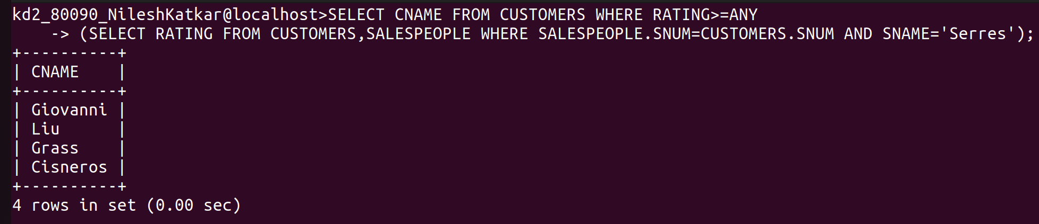
------------------------------------------------------------------------------------------------------------------------
2.

3

4

