------------------------------------------------------------------------------------------------------------------------
SQL Assignment-6
------------------------------------------------------------------------------------------------------------------------

1) Write two different queries that would produce all orders taken on October 3rd or 4th 1990.

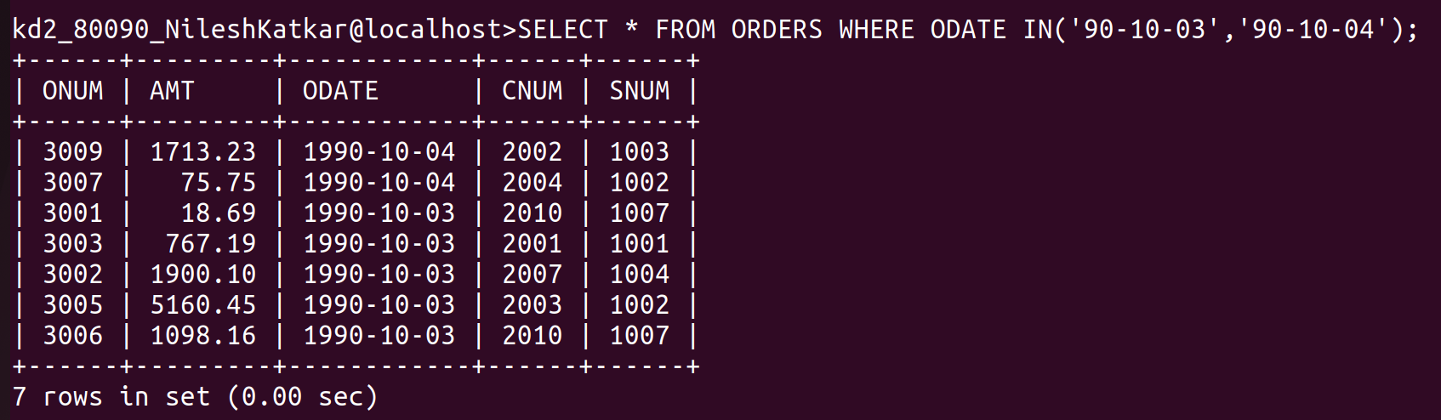
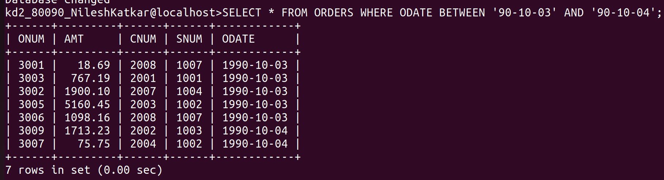
------------------------------------------------------------------------------------------------------------------------

2)Write a query that selects all of the customers serviced by Peel or Monika.
(Hint : the snum field relates the two tables to one another)

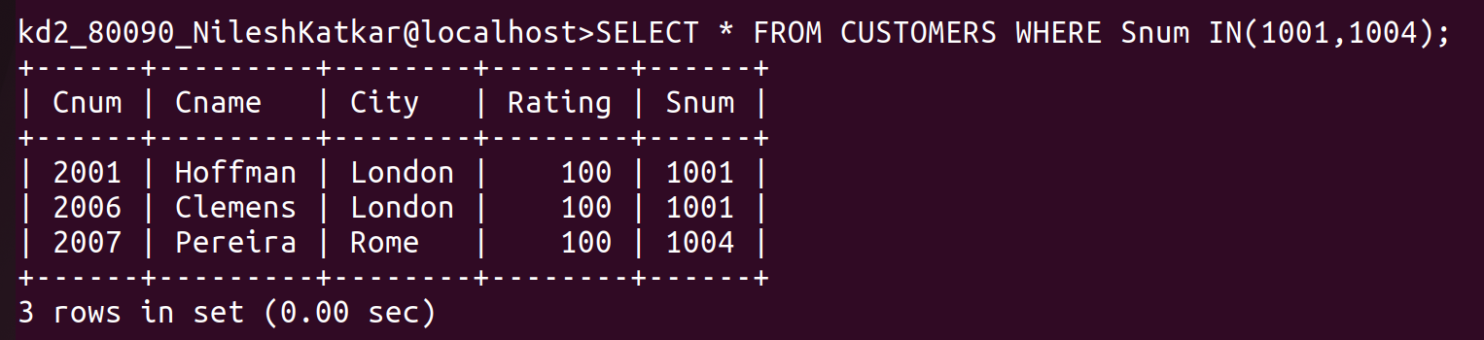

------------------------------------------------------------------------------------------------------------------------

3)Write A query that will produce all the customers whose names begin with a letter from ‘A’ to ‘G’.
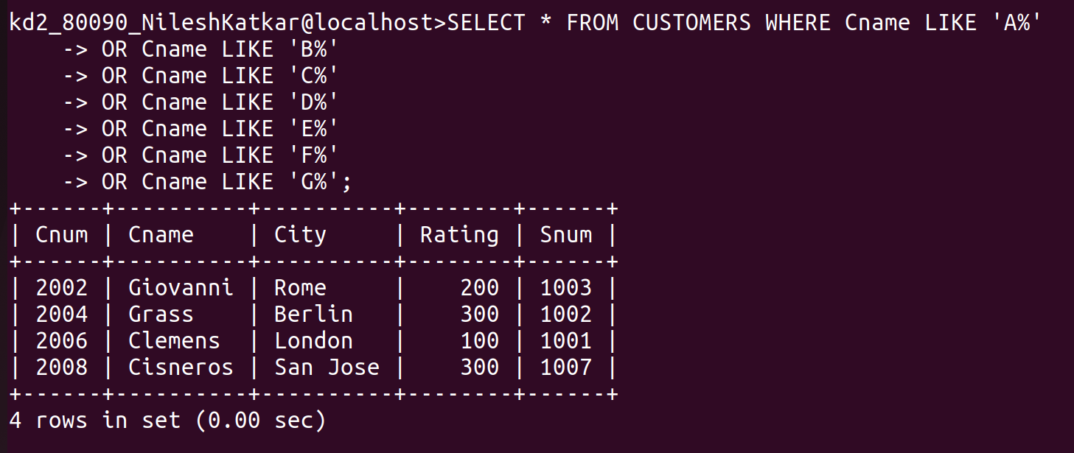

------------------------------------------------------------------------------------------------------------------------

4)Write a query that selects all customers whose names begin with letter ‘C’.

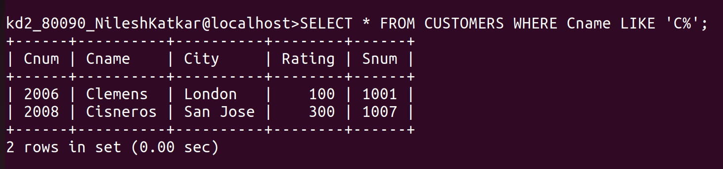
------------------------------------------------------------------------------------------------------------------------

5)Write a query that selects all orders except those with zeroes or NULLs in the amt field.




