1. Write a shell script to display your LOGIN NAME and HOME directory.
--------------------------------------------------------------------
#!/bin/bash
echo "Login Name: $LOGNAME"
echo "Home Directory: $HOME"

=======================================================================
2. Write a shell script to display menu like “1. Date, 2. Cal, 3. Ls, 4. Pwd, 5. Exit” and
execute the commands depending on user choice.

--------------------------------------------------------------------
#!/bin/bash
while true; do
echo "Menu: 1. Date, 2. Cal, 3. Ls, 4. Pwd, 5. Exit"
read -p "Enter your choice: " choice
case $choice in
1) date ;;
2) cal ;;
3) ls ;;
4) pwd ;;
5) exit ;;
*) echo "Invalid choice";;
esac
done
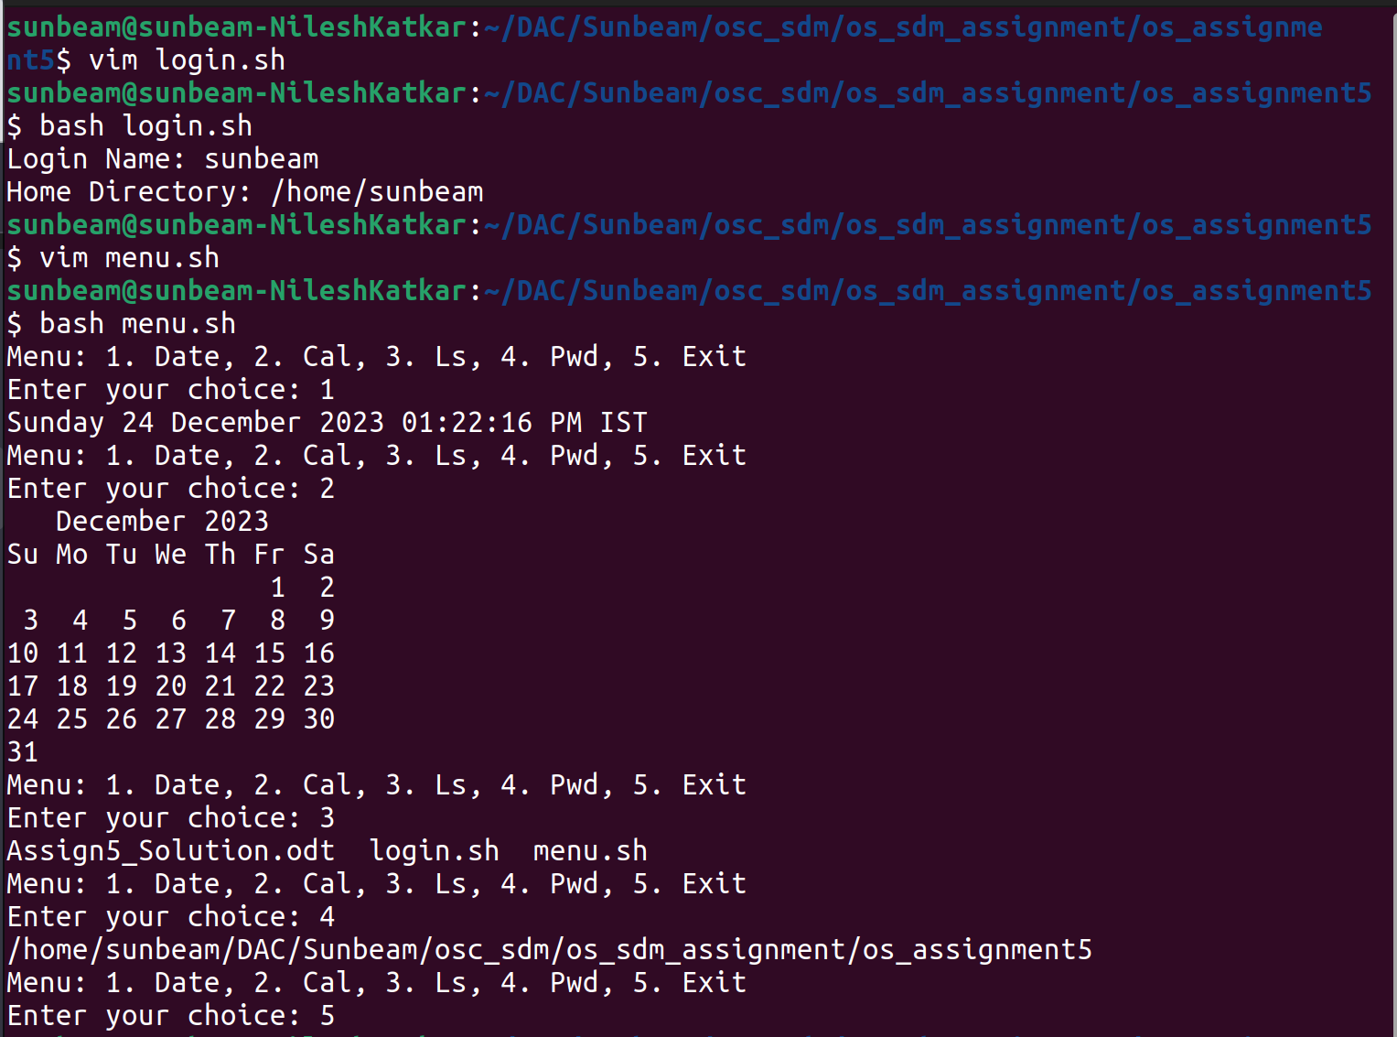
=======================================================================

3. Write a shell script to accept the name from the user and check whether user entered
name is file or directory. If name is file display its size and if it is directory display its
contents.
--------------------------------------------------------------------
#!/bin/bash
read -p "Enter a number: " num
is_prime=true
for (( i=2; i<=$num/2; i++ )); do
if [ $((num%i)) -eq 0 ]; then
is_prime=false
break
fi
done

if [ "$is_prime" = true ]; then
echo "$num is a prime number."
else
echo "$num is not a prime number."
fi
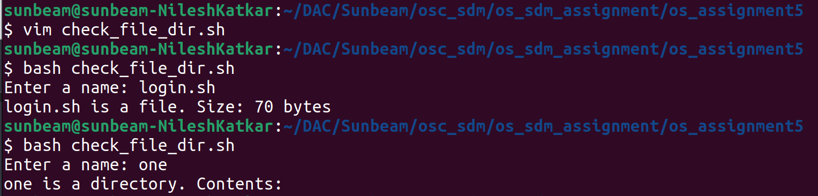

=======================================================================
4. Write a shell script to determine whether a given number is prime or not
--------------------------------------------------------------------
#!/bin/bash
read -p "Enter a number: " num
is_prime=true
for (( i=2; i<=$num/2; i++ )); do
if [ $((num%i)) -eq 0 ]; then
is_prime=false
break
fi
done

if [ "$is_prime" = true ]; then
echo "$num is a prime number."
else
echo "$num is not a prime number."
fi
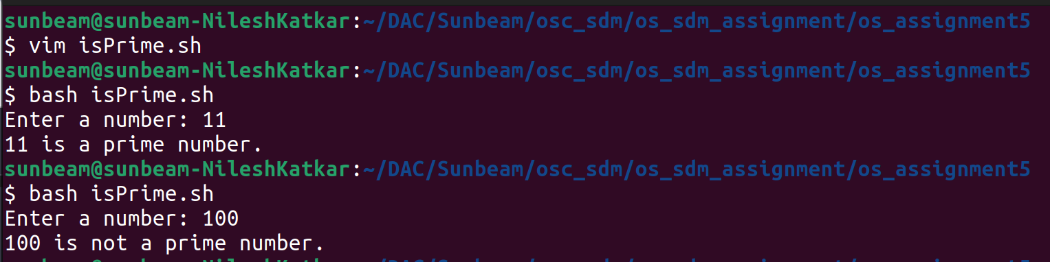
=======================================================================
5. Write a Program to find the greatest of three numbers
--------------------------------------------------------------------
#!/bin/bash
read -p "Enter three numbers: " a b c
echo "Greatest number is: $(echo "$a $b $c" | tr ' ' '\n' | sort -nr | head -n1)"
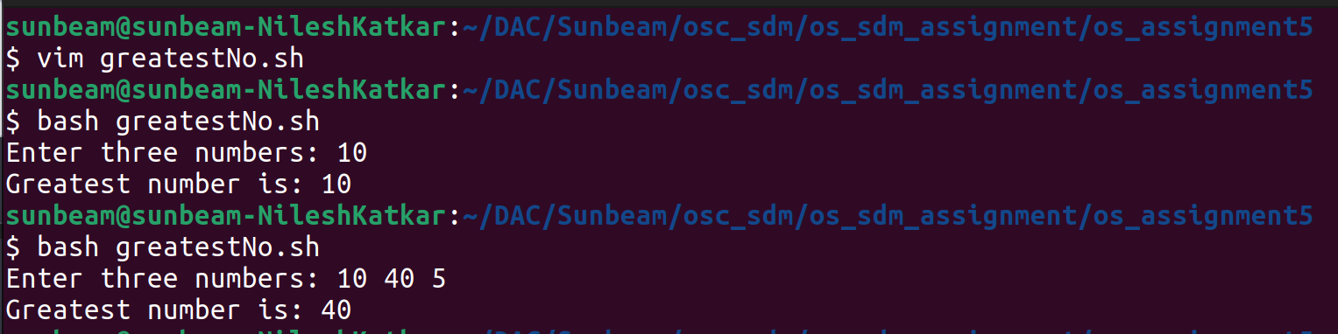
=======================================================================
6. Write a Program to find whether a given year is a leap year or not
--------------------------------------------------------------------
#!/bin/bash
read -p "Enter a year: " year
if (( year % 4 == 0 && (year % 100 != 0 || year % 400 == 0) )); then
echo "$year is a leap year."
else
echo "$year is not a leap year."
fi
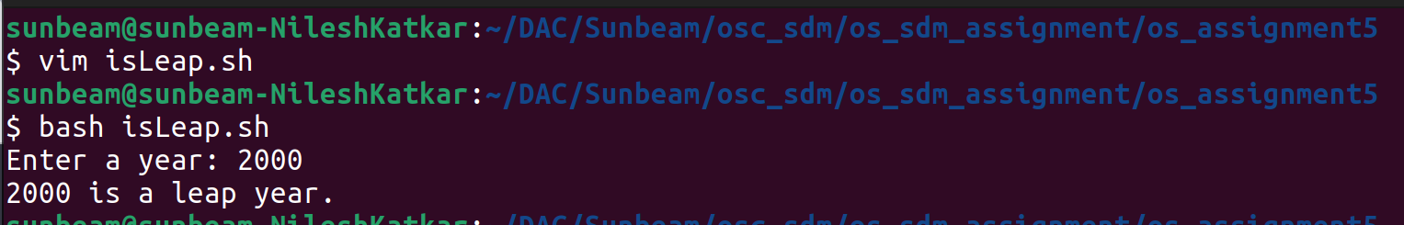
=======================================================================
7. Write a Program to find whether a given number is positive or negative
--------------------------------------------------------------------
#!/bin/bash
read -p "Enter a number: " num
if [ $num -gt 0 ]; then
echo "$num is positive."
elif [ $num -lt 0 ]; then
echo "$num is negative."
else
echo "$num is zero."
fi
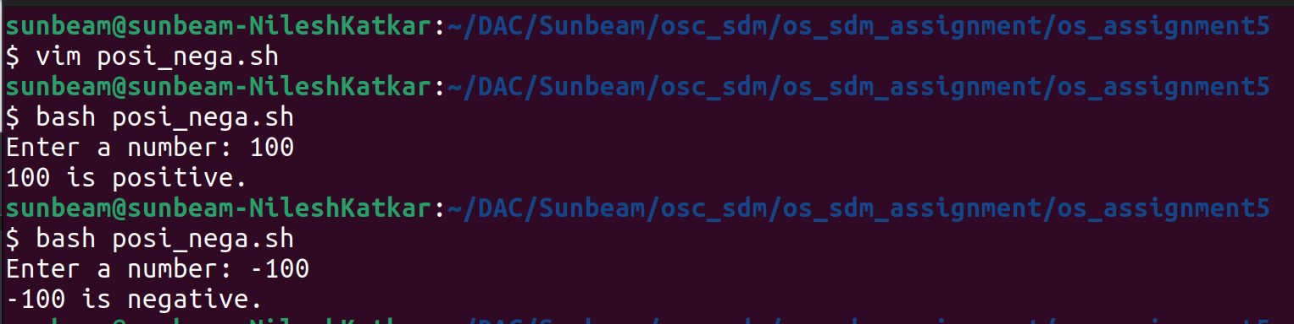
=======================================================================
8. Write a program to print the table of a given number.
--------------------------------------------------------------------
#!/bin/bash
read -p "Enter a number: " num
for i in {1..10}; do
echo "$num x $i = $((num * i))"
done

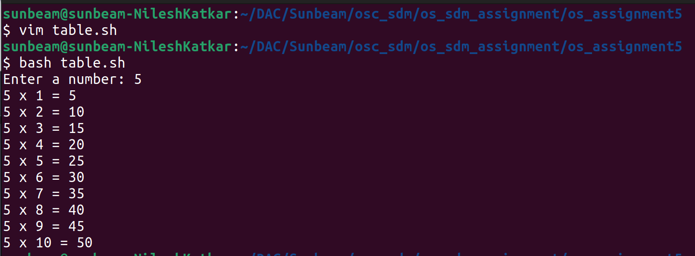
=======================================================================
9. Write a program to find the factorial of given number.
--------------------------------------------------------------------
#!/bin/bash
read -p "Enter a number: " num
factorial=1
for (( i=1; i<=$num; i++ )); do
factorial=$((factorial * i))
done
echo "Factorial of $num is: $factorial"
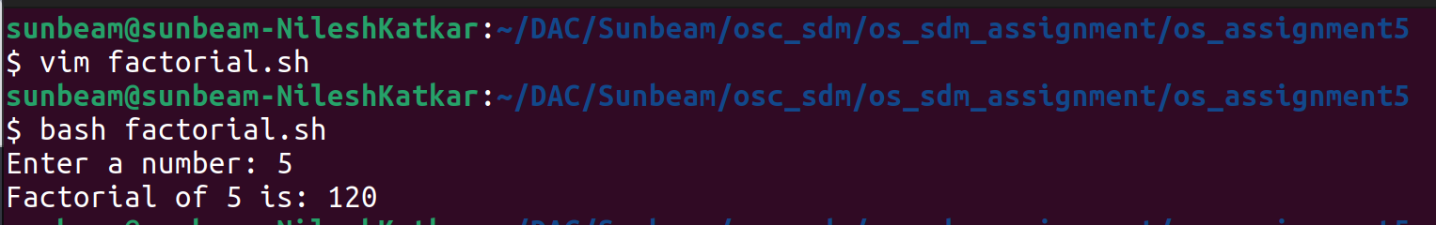

=======================================================================
10. Write a program to find given number of terms in the Fibonacci series.
--------------------------------------------------------------------
#!/bin/bash
read -p "Enter the number of terms: " n
a=0
b=1
echo -n "$a $b "
for (( i=3; i<=$n; i++ )); do
c=$((a + b))
echo -n "$c "
a=$b
b=$c
done
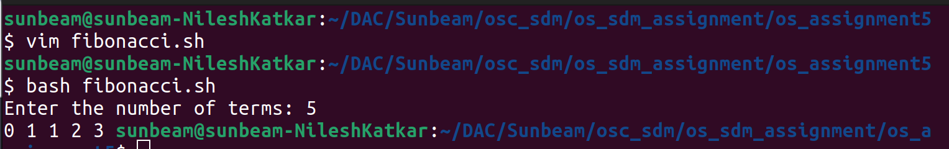
=======================================================================
11. Write a program to calculate gross salary if the DA is 40%, HRA is 20% of basic salary.
Accept basic salary form user and display gross salary (Result can be floating point
value).
--------------------------------------------------------------------
#!/bin/bash
read -p "Enter basic salary: " basic_salary
da=$((40 * basic_salary / 100))
hra=$((20 * basic_salary / 100))
gross_salary=$((basic_salary + da + hra))
echo "Gross Salary: $gross_salary"

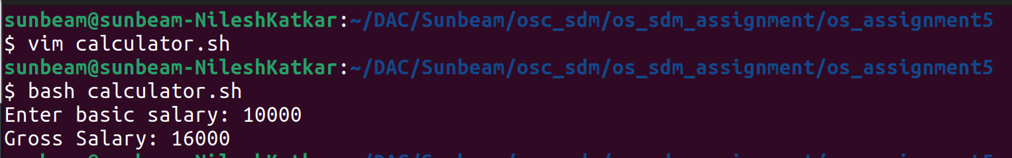

=======================================================================
12. Write a shell script to accept a filename as argument and displays the last modification
time if the file exists and a suitable message if it doesn’t exist.
--------------------------------------------------------------------
#!/bin/bash
if [ -e "$1" ]; then
echo "Last modification time of $1: $(stat -c %y "$1")"
else
echo "$1 does not exist."
fi
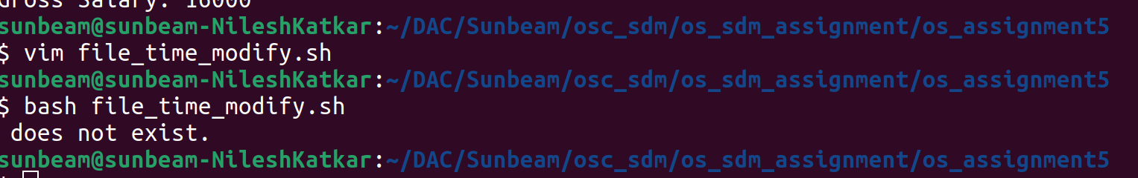
=======================================================================
13. Write a shell script to display only hidden file of current directory.
--------------------------------------------------------------------
#!/bin/bash
echo "Hidden files in the current directory:"
ls -a | grep "^\."
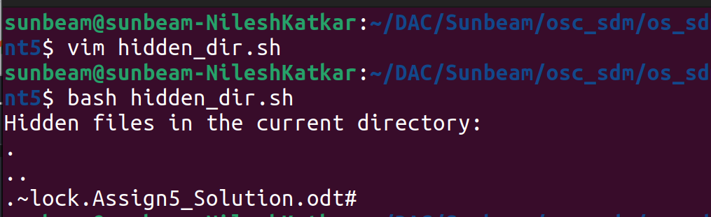
=======================================================================
14. Write a shell script to display only executable files of current directory.
--------------------------------------------------------------------
#!/bin/bash
echo "Executable files in the current directory:"
find . -maxdepth 1 -type f -executable
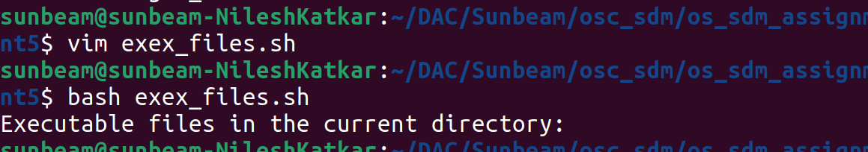
=======================================================================
15. Accept the two file names from user and append the contents in reverse case of first file
into second file.
--------------------------------------------------------------------
#!/bin/bash
read -p "Enter first file name: " file1
read -p "Enter second file name: " file2
tr '[:upper:]' '[:lower:]' < "$file1" >> "$file2"
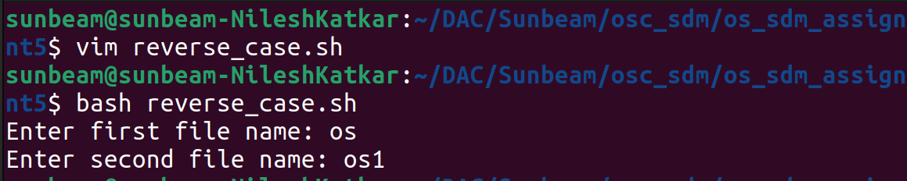

=======================================================================
16. Write a shell script to display welcome message to the user along with contents of his
home directory. Ensure that shell script will execute automatically when user login to the
shell. (Make entry of your shell script into .bashrc file into your home directory).
--------------------------------------------------------------------
source /home/sunbeam/DAC/Sunbeam/osc_sdm/os_sdm_assignment/os_assignment5/calculator.sh
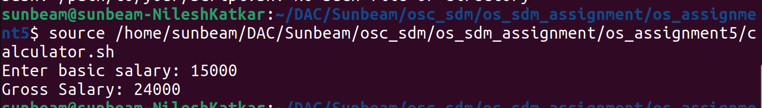

=======================================================================
17. Print the following pattern.
*
* *
* * *
* * * *
* * * * *
--------------------------------------------------------------------
#!/bin/bash
for (( i=1; i<=5; i++ )); do
for (( j=1; j<=i; j++ )); do
echo -n "* "
done
echo ""
done



