y

1.ls Display hidden files
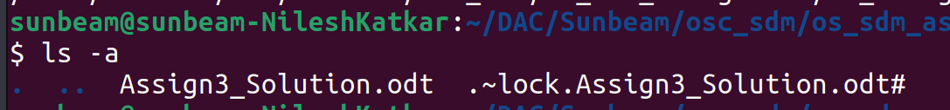
2.renameRename all *.txt files to *.htm
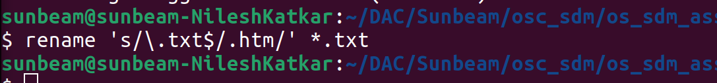
3.ln -sCreate symbolic link (shortcut) for a file
4.lnCreate hard link for a file
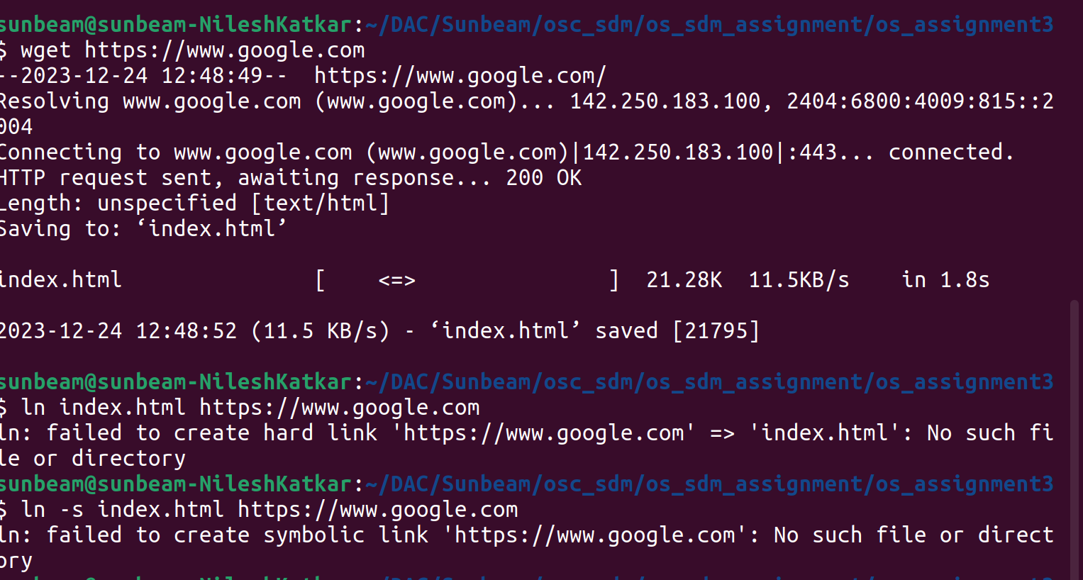

5.statDisplay time stamp of the file
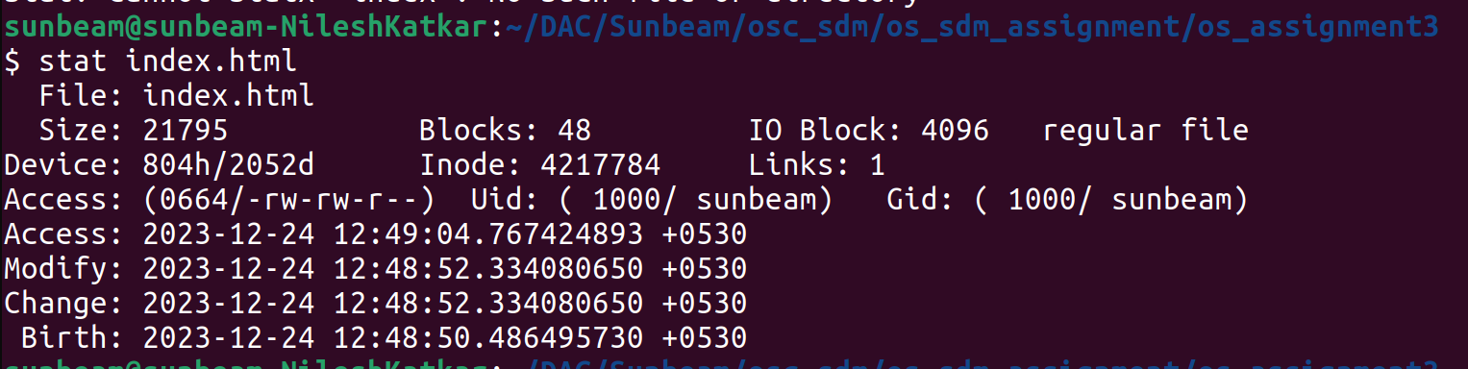

6.touchChange the time stamp of the file
7.touchCreate empty file
8.tailPrint all lines in a file from fifth line onwards

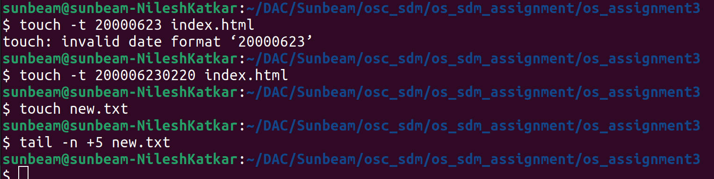
9.init 0, poweroffShutdown (Only for super-user)
sudo init 0

10.init 6, rebootReboot (Only for super-user)
sudo init 6

12.whoamiFind current user
13.ttyFind current terminal
14.who am iFind current user and terminal
15.usersFind all users logged into the system
16.whoFind all users logged in and terminals in use
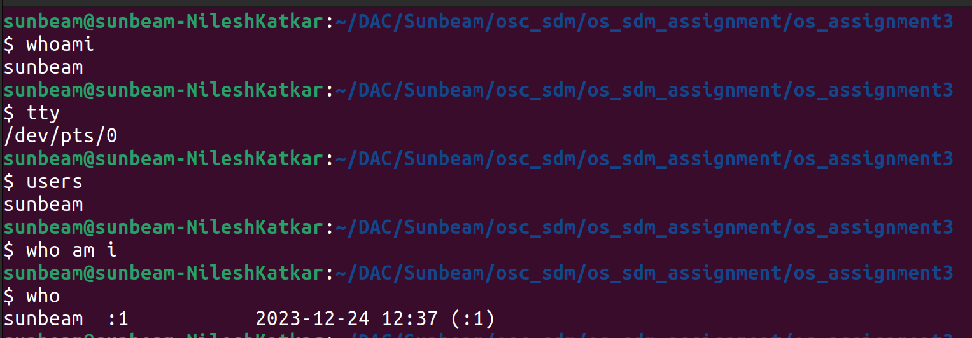
17.grep, egrep, fgrepFind a given word/pattern from the file
18.chmodMake a file as read-only
19.chmodMake a file as write, read and execute
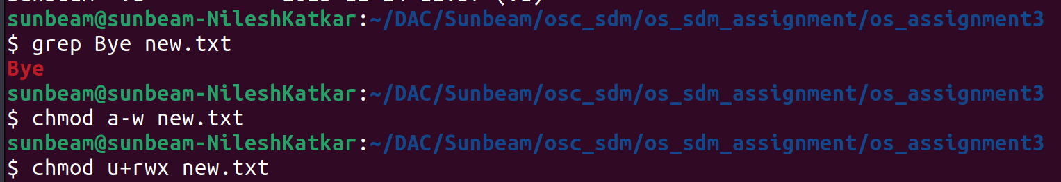
20.wc (using redirection)Take input from the file, count words and store output to other file

21.who | wc (using pipe)Count words in output of “who” command
22.head, tail (using pipe)Print lines 5 to 10 from the given file
23.sort , uniq (using pipe)Print the uniq values from the unsorted file
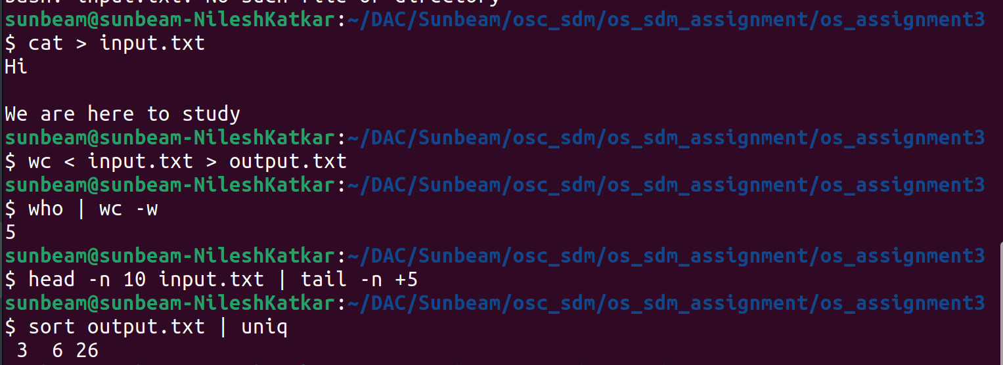
24.who, grep (using pipe)Display all users not using tty2, tty3, tty4
25.lsDisplay all files in ascending order of their file size
26.ls, grep (using pipe)Count number of files and directories from current directory
27.ls, grep (using pipe)Display only hidden files in a directory
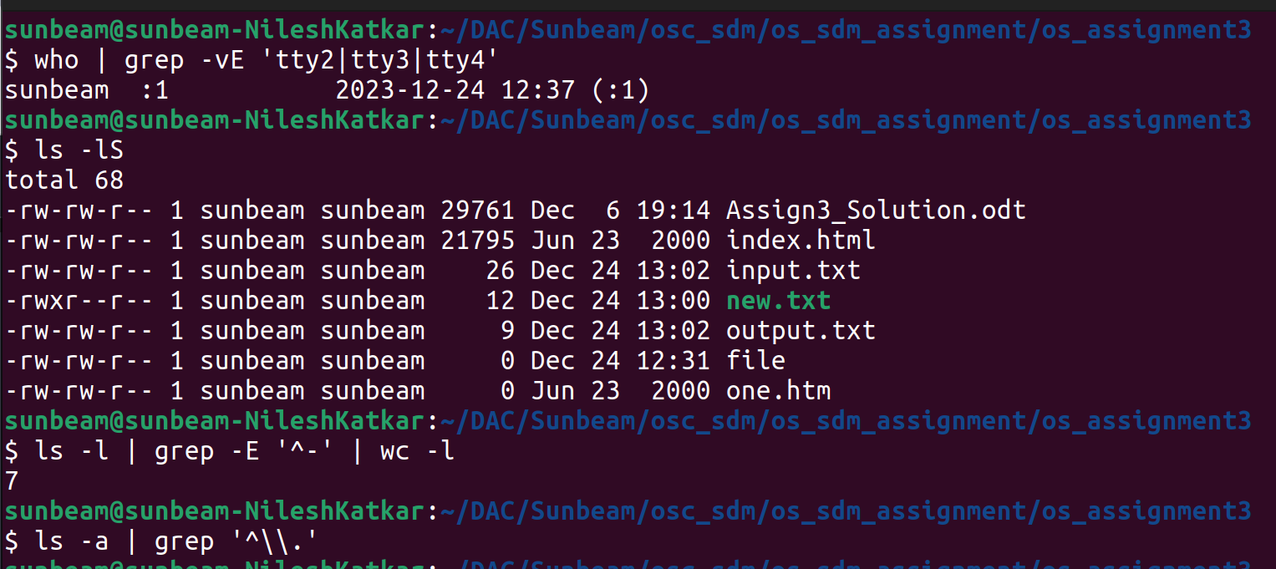
28.trConvert file contents into uppercase , also learn "-s" option of this command
29.cutSplit the file contents using delimiter and print required fields

