1. man cal Command to get help about commands

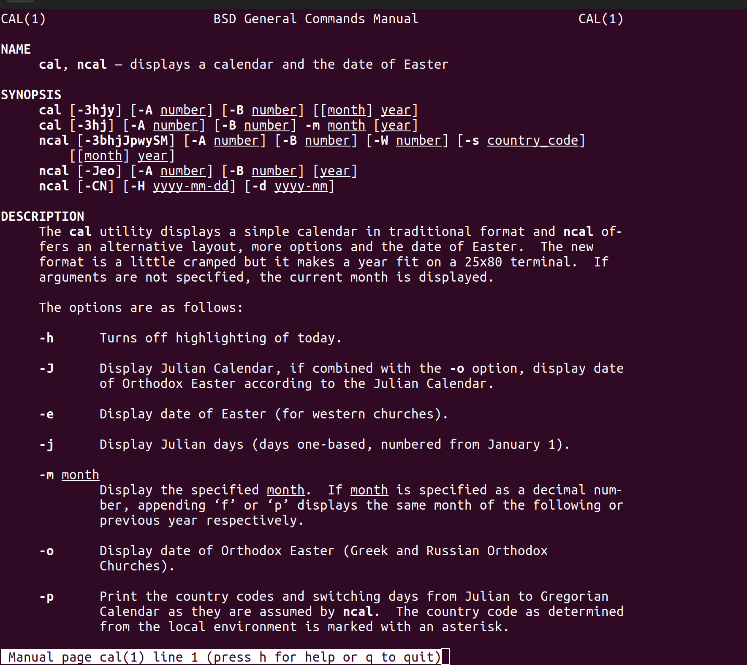

=======================================================================

2.uname Print System information
3.pwd Print current directory
4.hostname Print IP address and hostname of the machine
5.date Find today’s date
6.cal Print calendar for current year
7.ls,dir
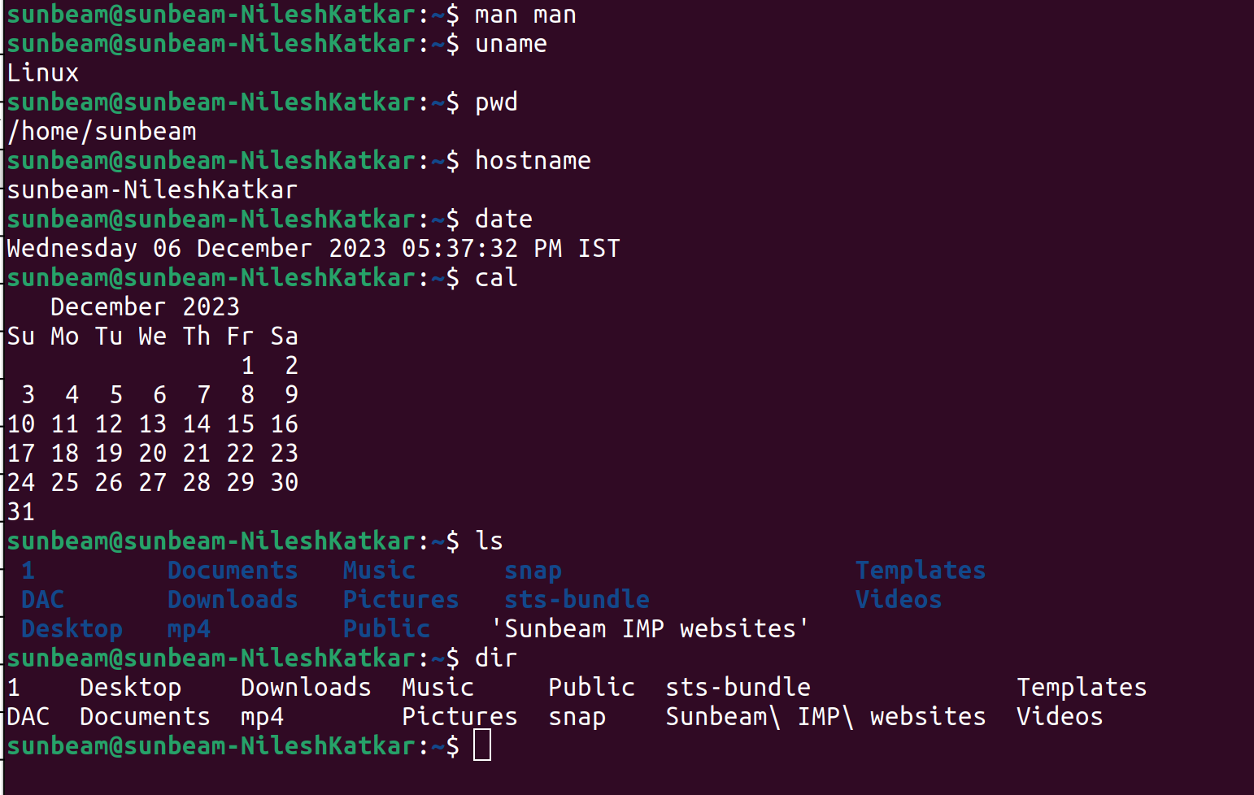
=======================================================================
8.cat Create file
9.cat >> Append some text into existing file
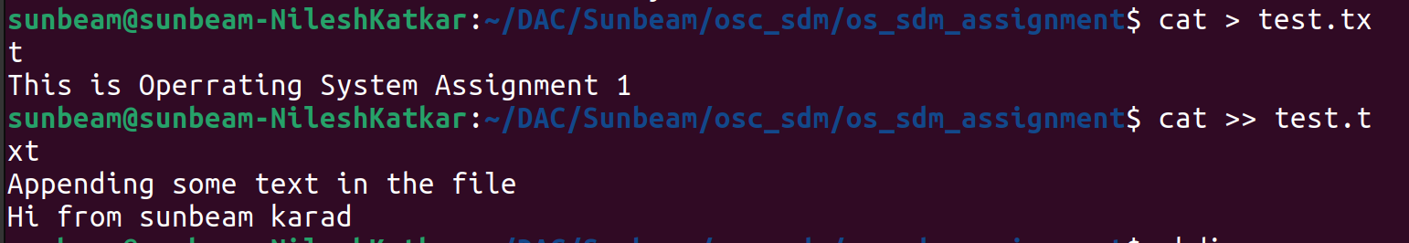
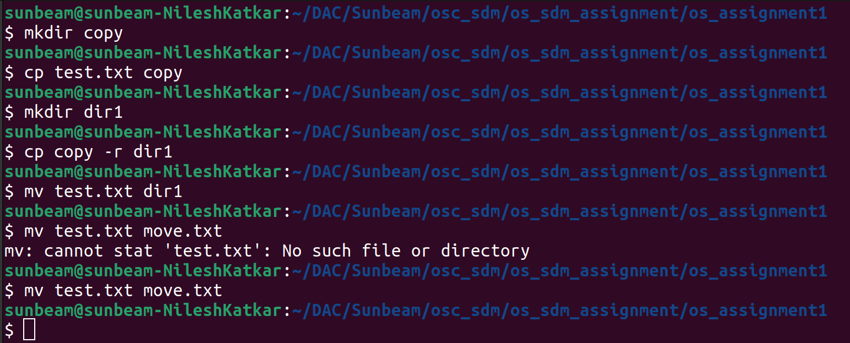
=======================================================================
10.cp Copy a file, Copy a directory
11.mv Move the files
12.mv Rename a file
15.mkdir Create directory

=======================================================================

13.tac, rev Print the file in reverse order, Reverse each line in the file
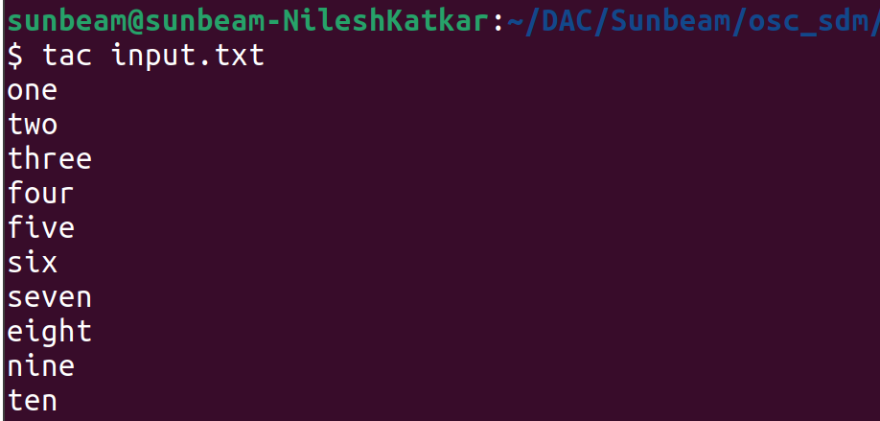

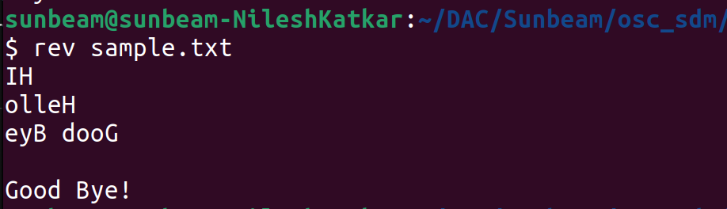

=======================================================================
14.wc Count the words, characters and lines in a file

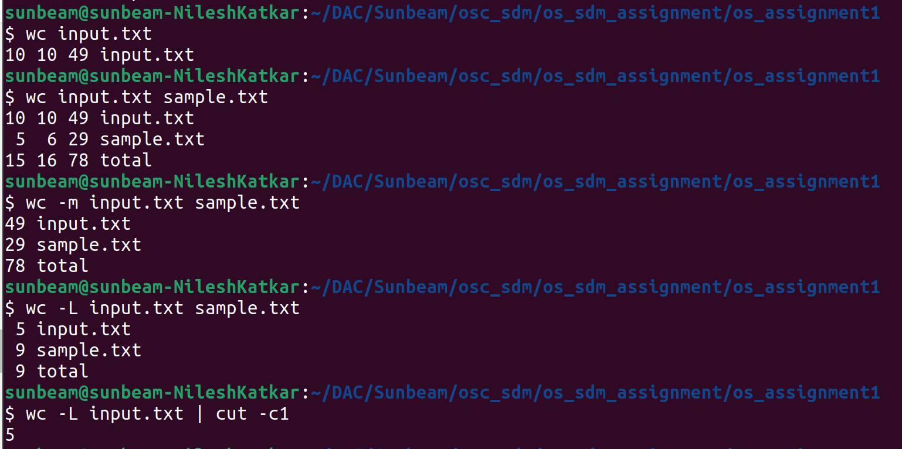
=======================================================================
16.cd Change current directory
17.rm Remove a file, remove a directory ( with -R )
18.rmdir remove empty directory

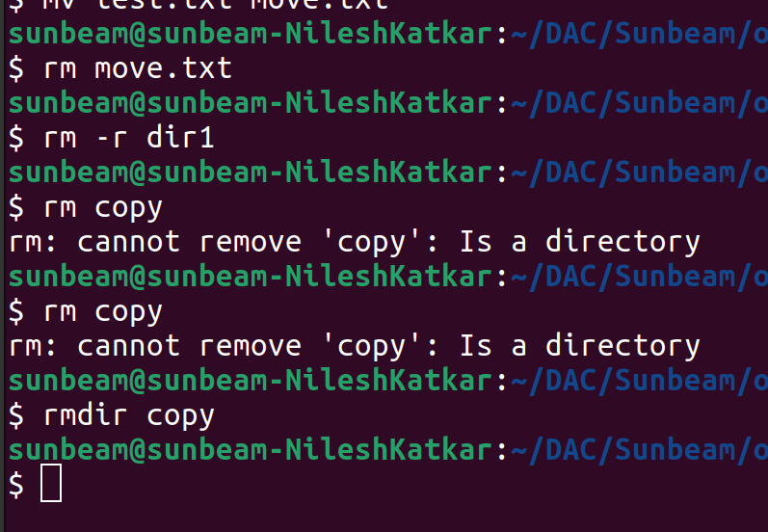
=======================================================================

19.touch change the modification time , Create Multiple empty files at once

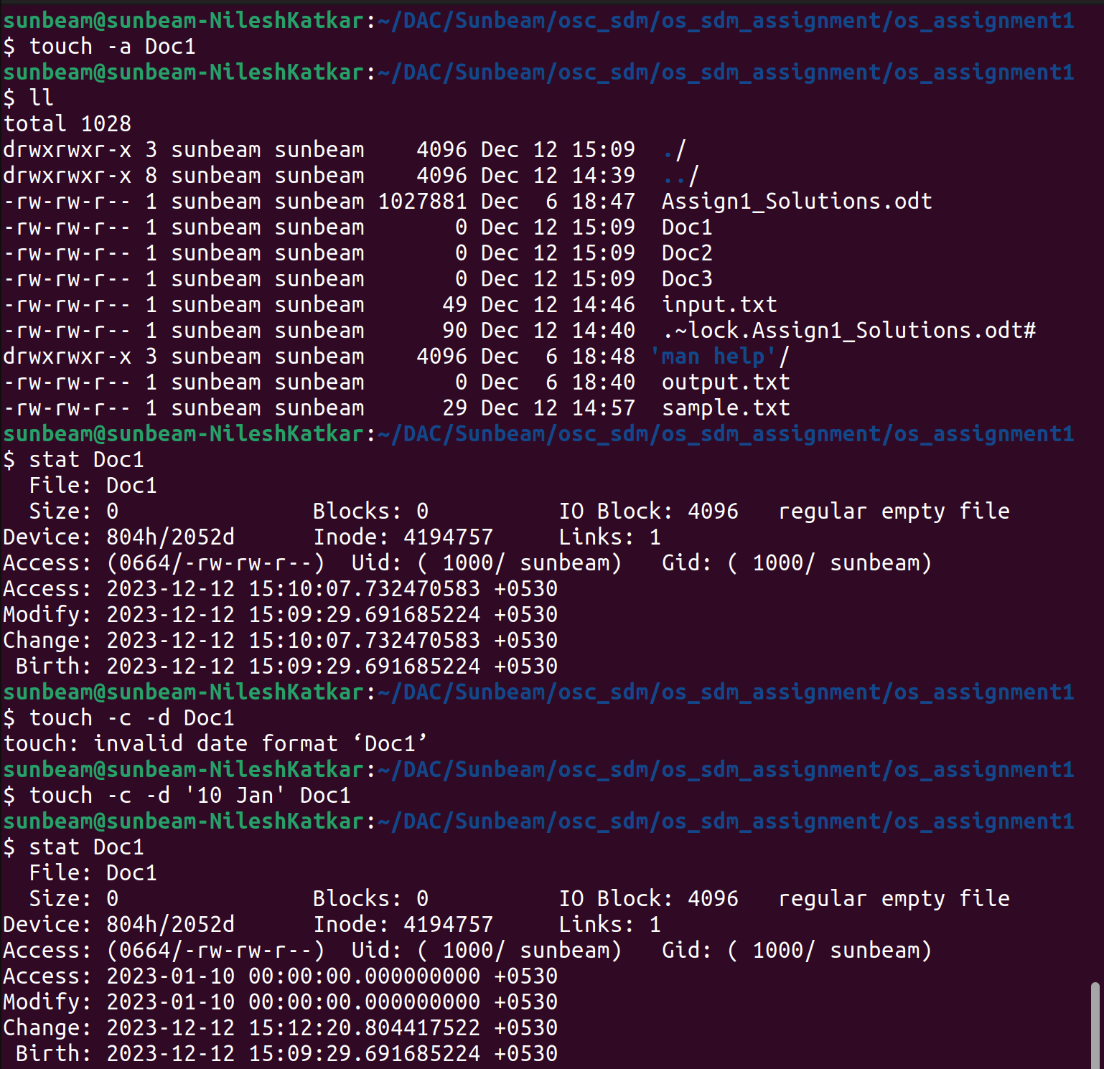
=======================================================================

20.sort Sort file.

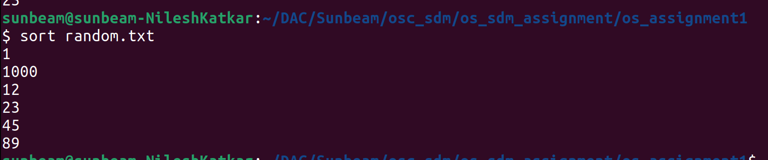
=======================================================================
21.uniq Avoid repetition in a file.

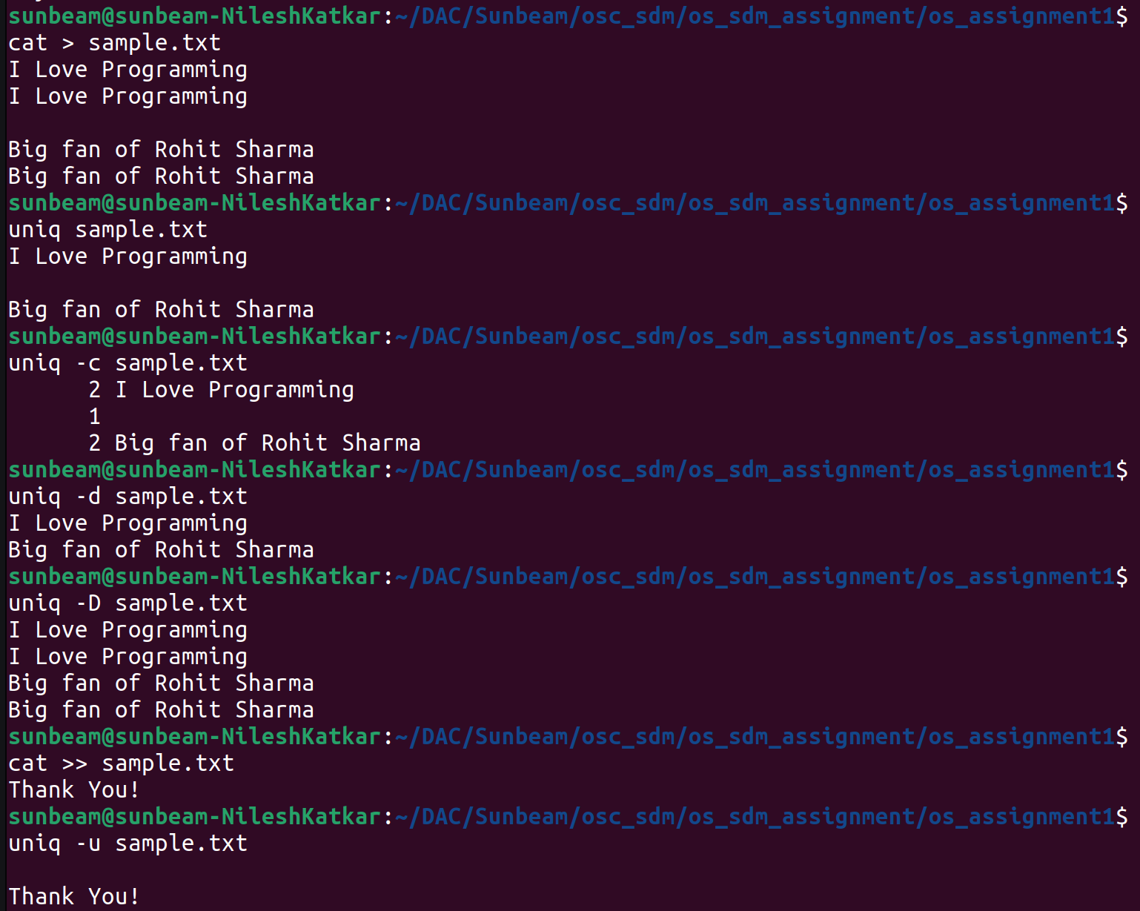
=======================================================================
22.head Print the specified number of lines from top in the file.
23.tail Print the specified number of lines from bottom in the file.

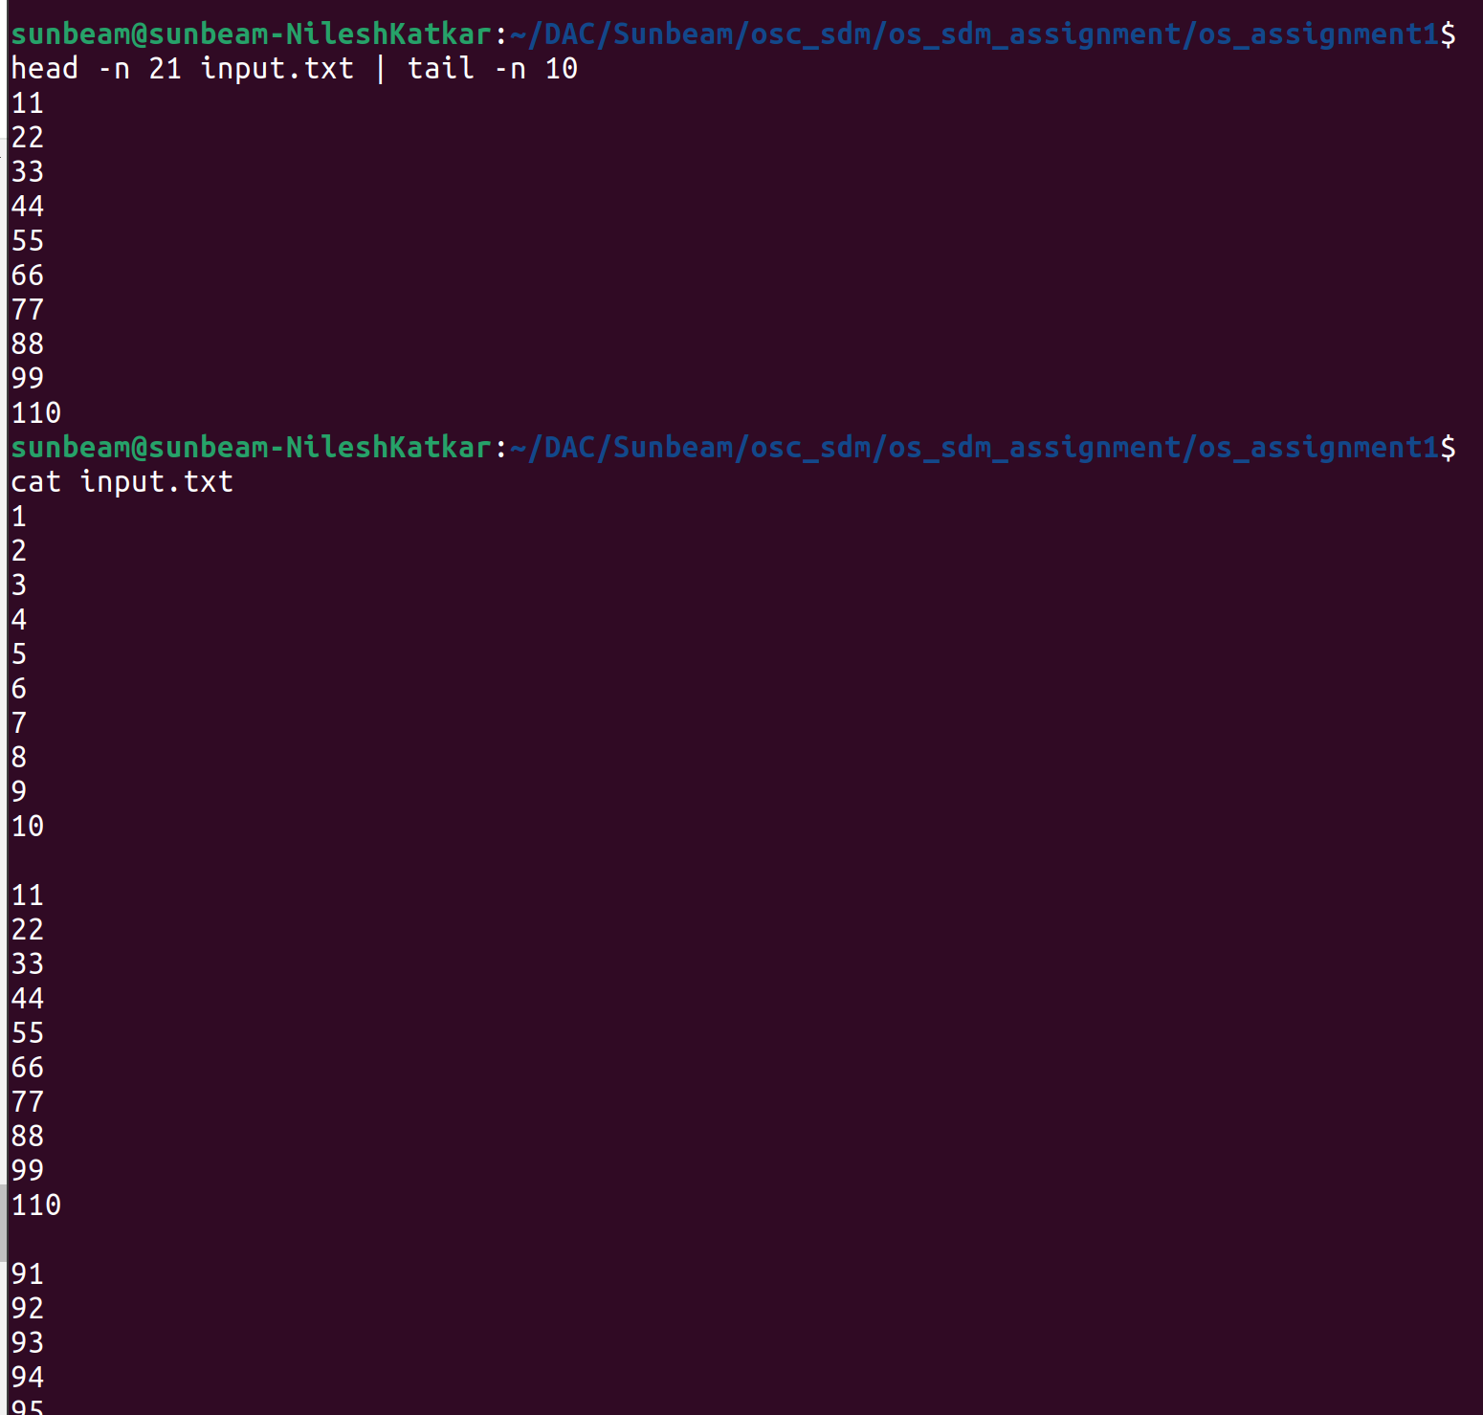

24.factor Find the factors of a number
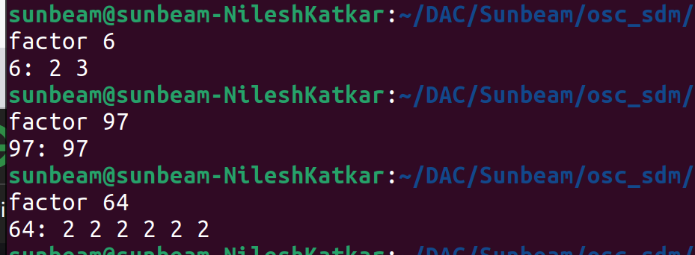
=======================================================================
25.alias Create command shortcut
26.unalias remove the command shortcut

alias [-p] [name[=value] ...] => alias command instructs shell to replace one string with another string while executing commands

alias name=”value” => creating an alias

unalias [alias name] => removing an existing alias known as unalias

alias -p => print all defined aliases is reusable format
=======================================================================
27.echo Print environment variables individually
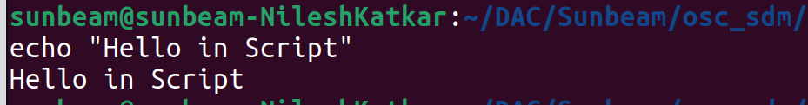
=====================================================================
28.ps Print current processes
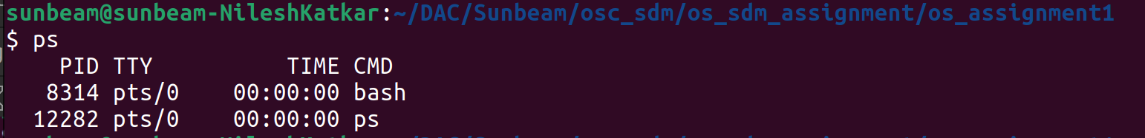
=======================================================================

29.kill Kill the process

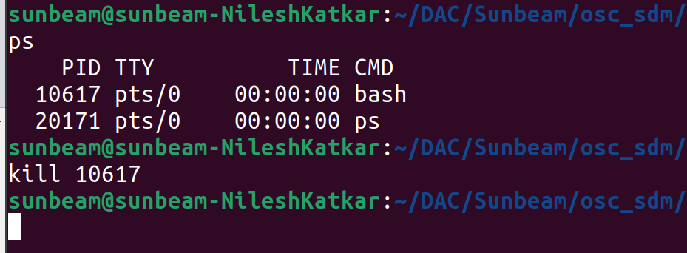
======================================================================

30.env Print environment variables




