SQL ASSIGNMENT-15

Using subqueries with DML Commands.

1.Assume there is a table called Multicust,with all of the same column definitions as Salespeople. Write a command that inserts all salespeople with more than one customer into the table.

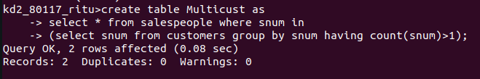
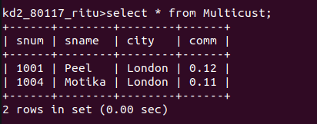

2.Write a command that deletes all customers with no current orders.

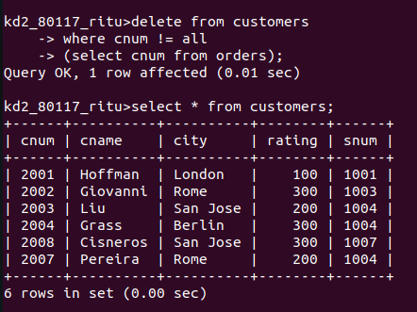

3.Write a command that increases by twenty percent the commissions of all salespeople with total orders above Rs 3000.

