Assignment-7

Q1.Write a query that counts all orders for october 3.

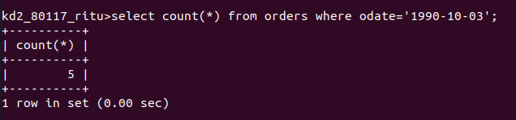

Q2.WRITE A QUERY THAT COUNTS THE NUMBER OF DIFFERENT NON-NULL CITY VALUES IN THE CUSTOMERS TABLE.

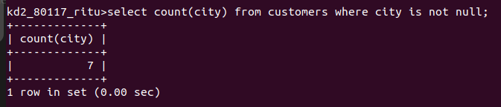

Q3.WRITE A QUERY THAT SELECTS EACH CUSTOMER’S SMALLEST ORDER.

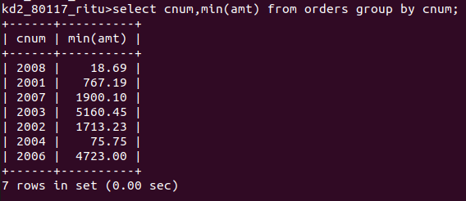

Q4.WRITE A QUERY THAT SELECTS THE FIRST CUSTOMER,ALPHABETICAL ORDER WHOSE NAME BEGINS WITH G.

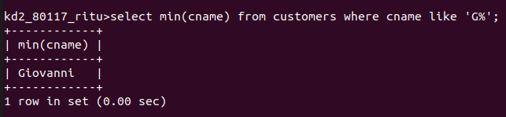

Q5WRITE A QUERY THAT SELECTS THE HIGHEST RATING IN EACH CITY

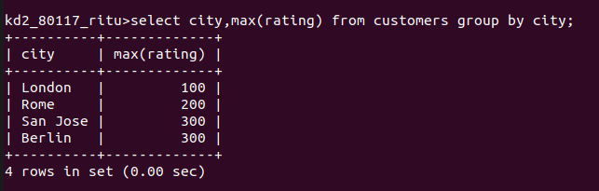

Q6.WRITE A QUERY THAT COUNTS THE NUMBER OF SALESPEOPLE REGISTERING ORDERS FOR EACH DAY.(IFA SALESPEOPLE HAS MORE THAN ONE ORDER ON A GIVENDAY,HE OR SHE SHOULD BE COUNTED ONLY ONCE)

