ASSIGNMENT – 8

Q1 Assume each salesperson has a 12% commission. Write a query on the orders table that will produce the order number , the salesperson number ,and the amount of the salesperson’s commission for that order .

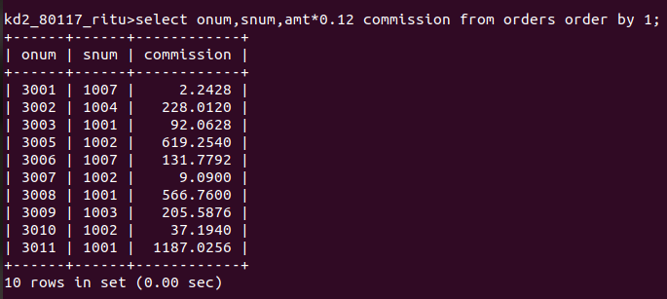

Q2write a query on the customers table that will find the highest rating in each city .put the output in this form
For the city (city) , the highest rating is :(rating).

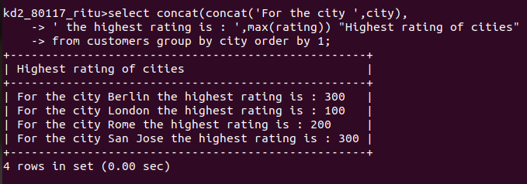

Q3. Write a query that lists customers in descending order of rating .Output the rating field firsts , followed by the customers name and number.

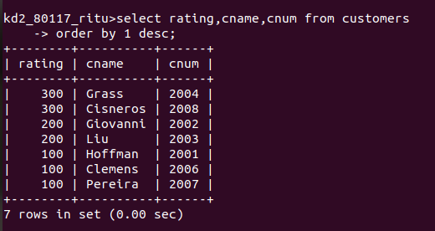

Q4. Write a query that totals the orders for each day and places the results in descending order.

