SQL Assignment – 1

Creating sample tables and inserting values.

Create the following tables with the given structures and insert sample data as specified:

A) SALESPEOPLE Table

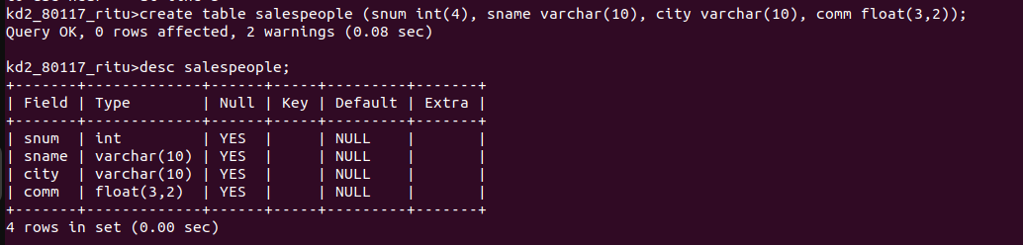
B) CUSTOMERS Table

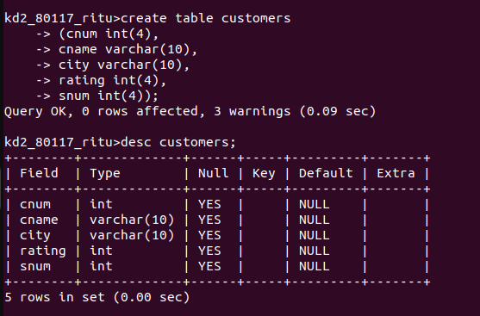

C) ORDERS Table

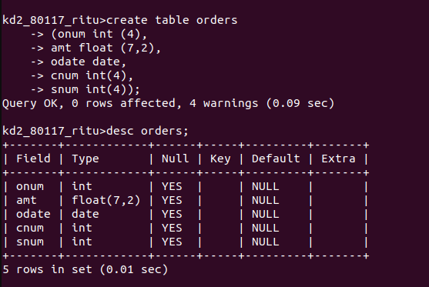

=> DATA

1) INSERTING VALUES IN SALESPEOPLE TABLE

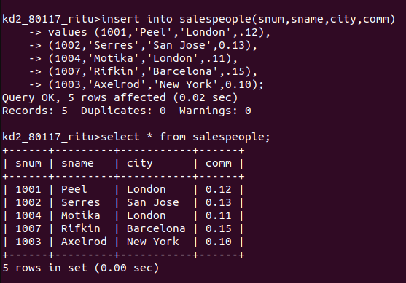

2) INSERTING VALUES IN CUSTOMERS TABLE

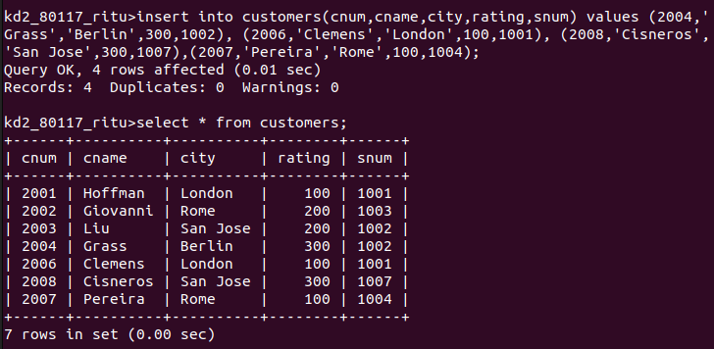

3) INSERTING VALUES IN ORDERS TABLE

