OS Assignment 1
1) man ls


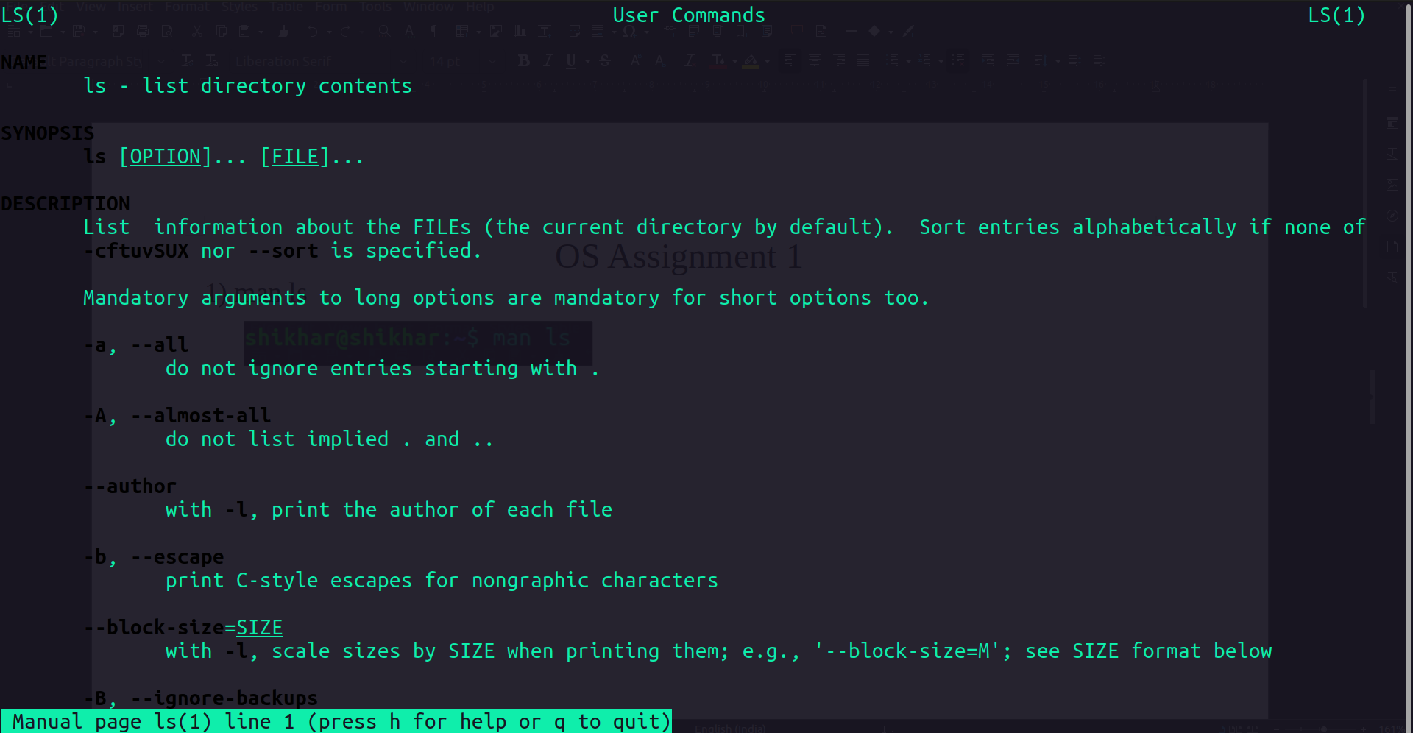
2) uname


3) pwd


4) hostname


5) date


6) cal
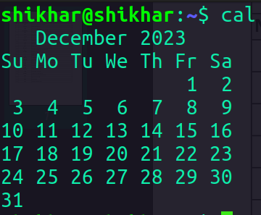

7)ls -R
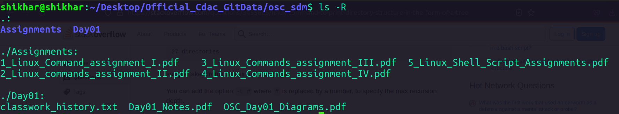
8) cat > test.txt
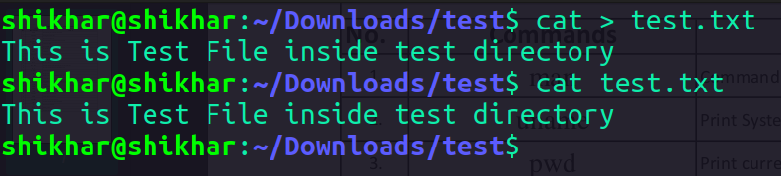

9) cat >> test.txt
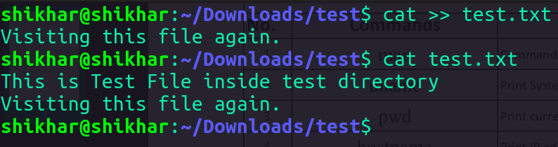

10) cp test.txt copyFile.txt
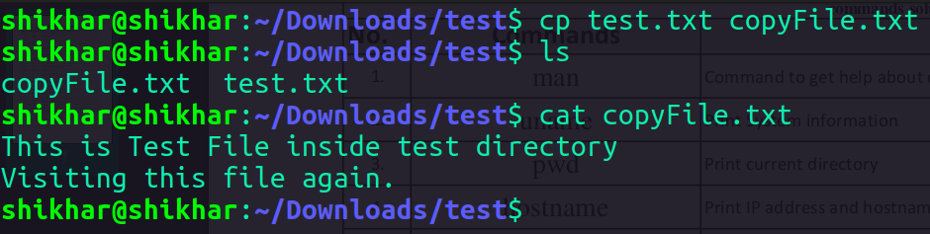

cp -r dir1 dir2
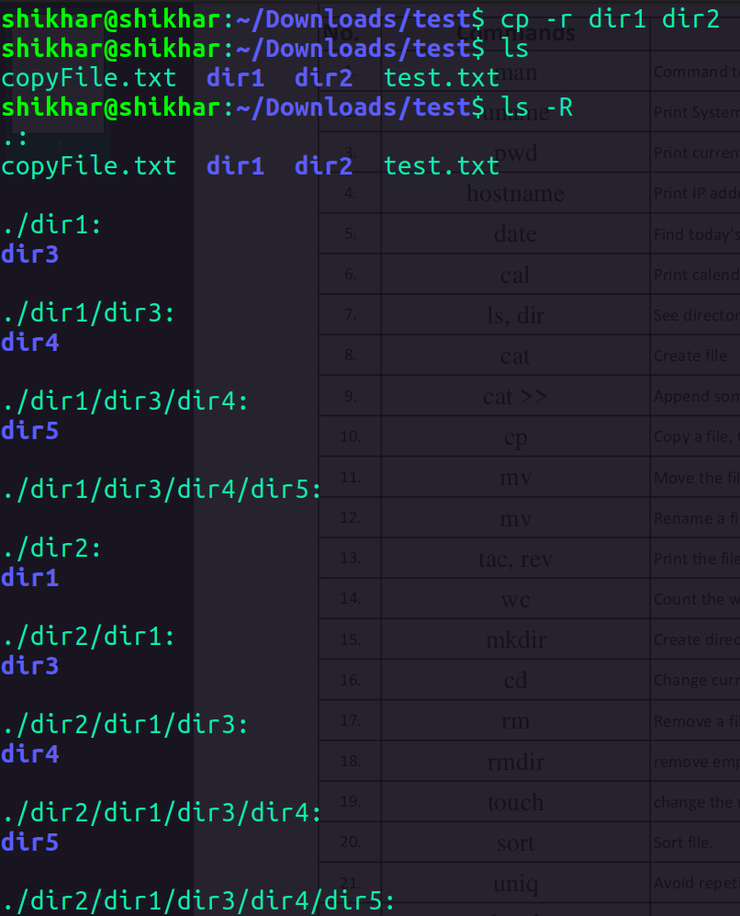

11)mv test.txt dir1 --> moves the file ‘test.txt’ into ‘dir1’ directory
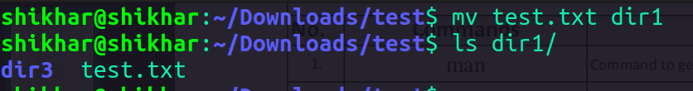

12) mv -- Rename a File
--> mv test.txt newFile.txt --> Renames the files ‘test.txt’ to ‘newFile.txt’
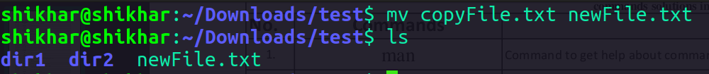
13) tac, rev
--> tac newFile.txt
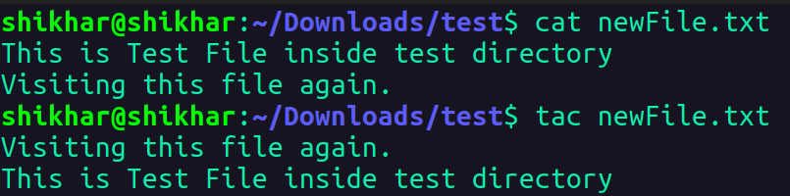

--> rev newFile.txt
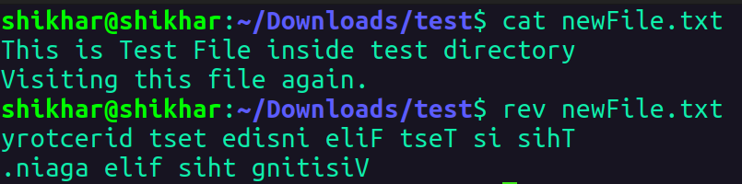

14) wc -- count the words, characters and lines in a file
--> wc newFile.txt
15) mkdir
--> mkdir -p dir1/dir3
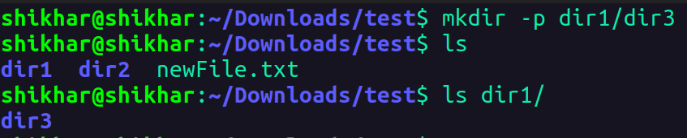

16) cd
--> cd dir1/
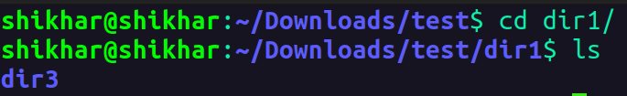

17) rm (with -r)
--> rm -r dir1/
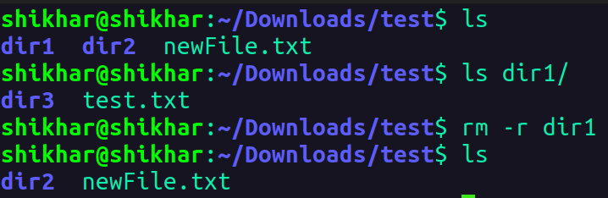

18) rmdir
--> rmdir dir3/
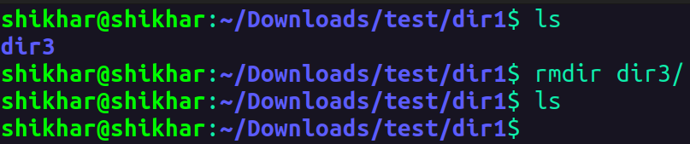

19) touch
--> touch test.txt test1.txt test2.txt test3.txt
20) sort
sort test.txt
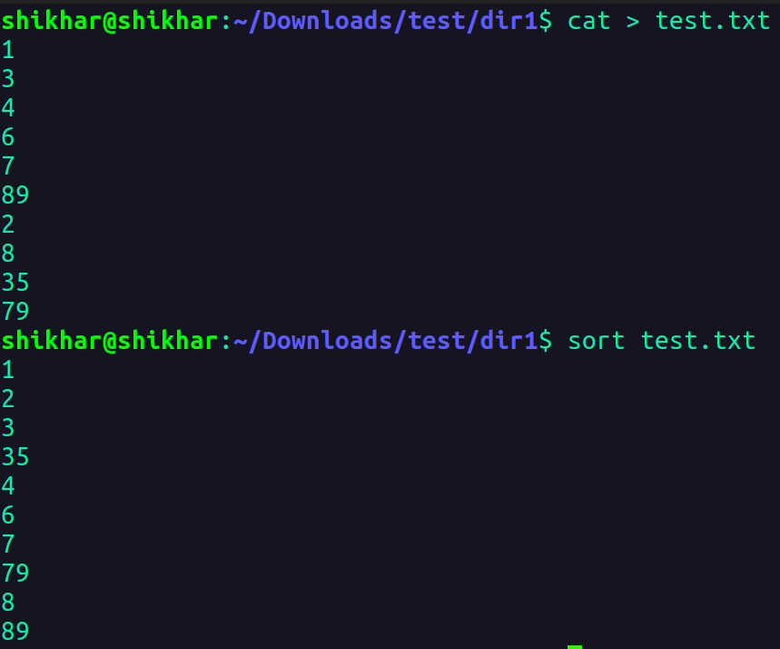

21) uniq – to avoid repetition in a file
--> sort test.txt | uniq
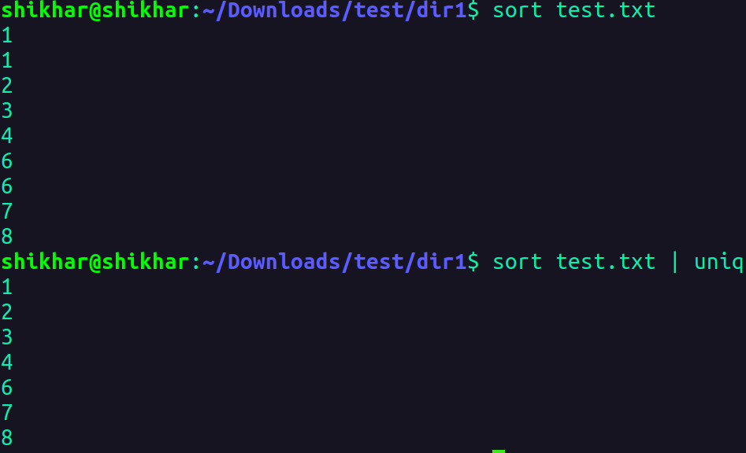

22) head
--> head -2 test.txt
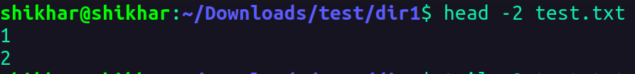
23) tail
--> tail -2 test.txt

24) factor
--> factor 24
25) alias
--> alias x=”ls”
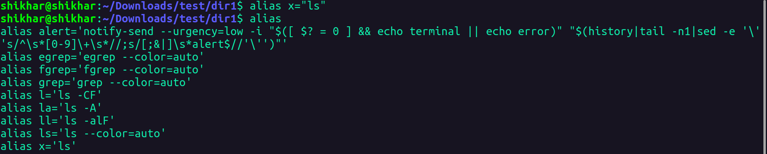

26) unalias
--> unalias x
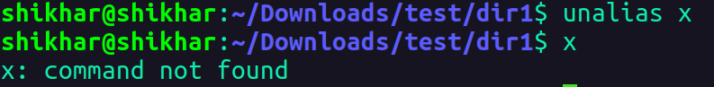
27) echo
--> echo $SHELL

28) ps
--> ps
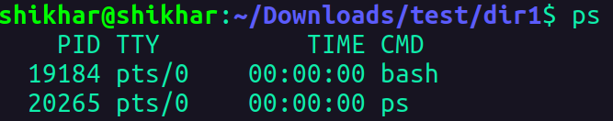

29) kill
--> pkill code
30) env
