OS Assignment 2

1) Sort by a date
ls -t
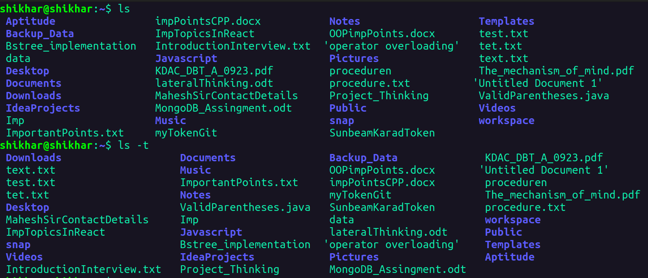
2) sort by size
--> ls -S
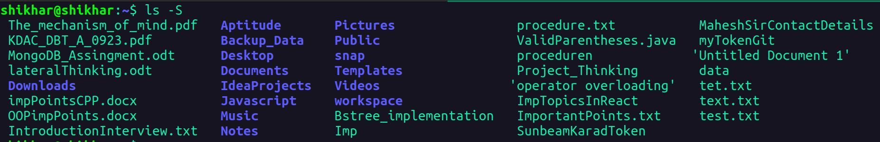
3) list files with thier inode no.
--> ls -i
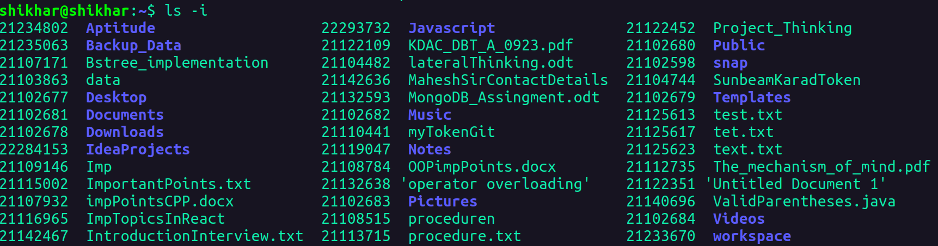
4) list the contents of the subdirectory
--> ls Aptitude/

--> ls */
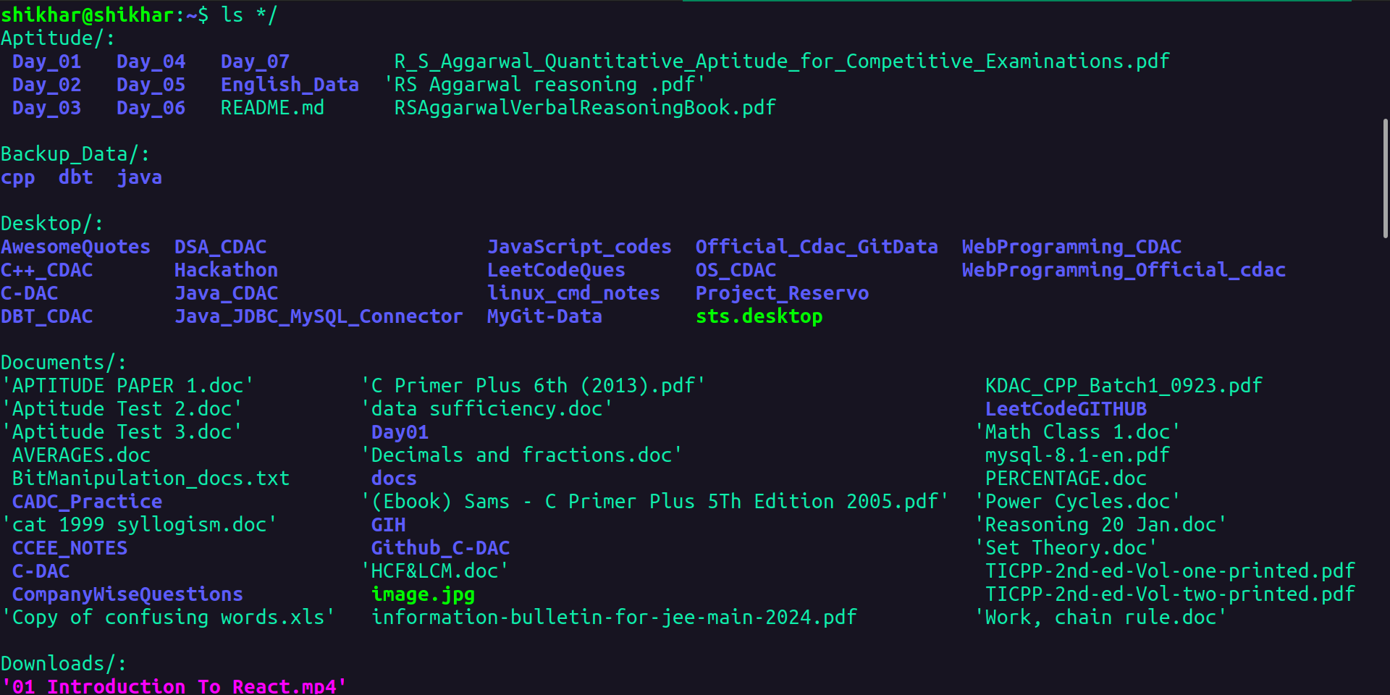
5)
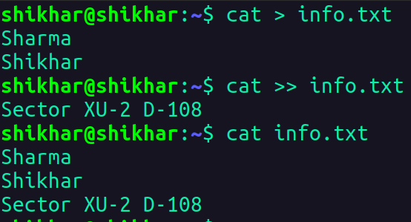

6) Change the timeStamp of a file
--> touch -t 202203160430.30 newFile.txt
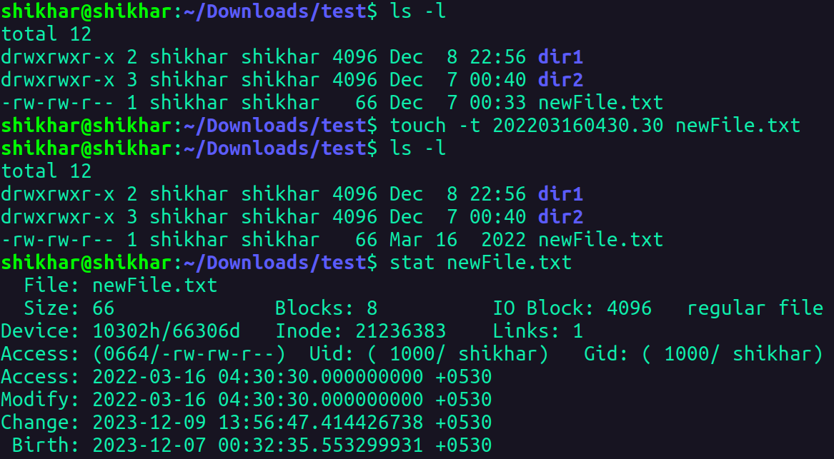

7)

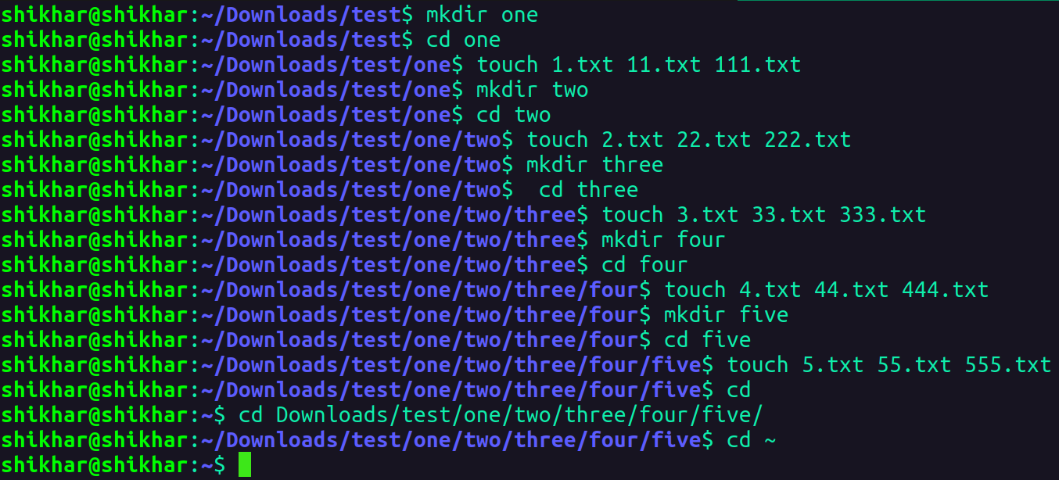
8)
i) ls Downloads/test/one/two/three/four/five/

ii) cat > Downloads/test/one/two/three/four/44.txt
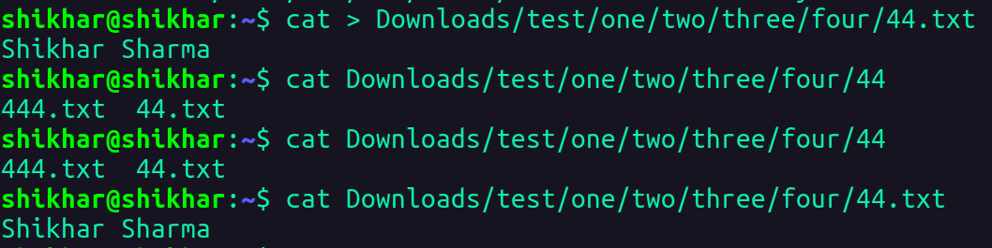
iii) rm Downloads/test/one/two/three/four/five/555.txt

iv) cd Downloads/test/one/two/three/four/five

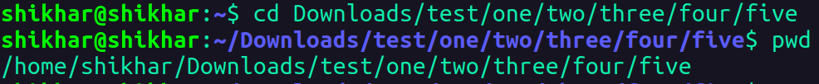
v) cat > ../../../three/3.txt
-> cat ../../../three/3.txt
vi) ls ../../../../two
vii) rm ../../../../two/222.txt
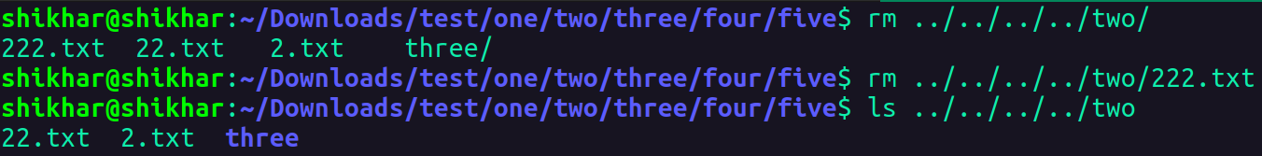
viii) cd ../../../../../one
ix) rm two/three/four/five/*
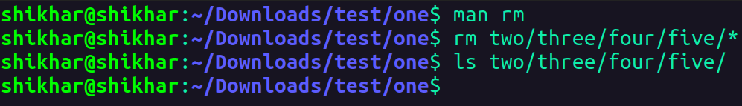
x) rmdir two/three/four/five

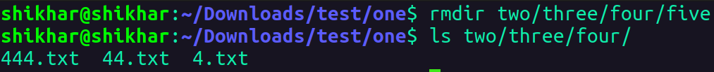
xi) rm -r two/three/four

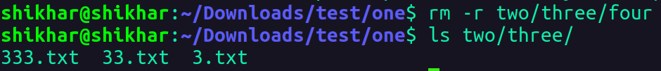
xii) cd ~
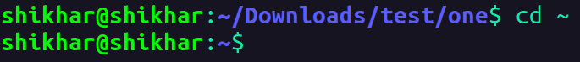

9)
