Q.1 Write a query that counts all orders for october 3.


Q.2 Write a query that counts the number of different non-null city values in the customers table.

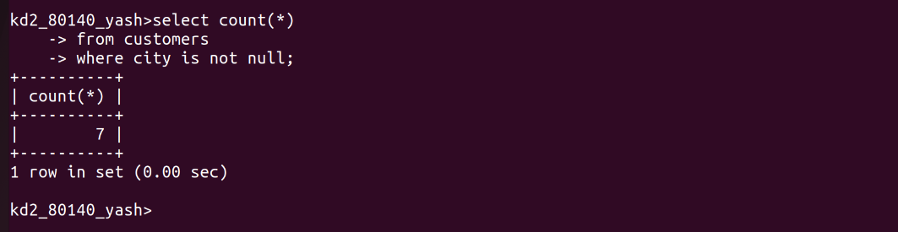

Q.3 Write a query that selects each customer’s smallest order.

Q.4 Write a query that selects the first customer in alphabetical order,whose name begins with G



Q.5 Write a query that selects the highest rating in each city


Q.6 Write a query that counts the number of salespeople registering orders from each day.



