Q.1 Assignment each salesperson has a 12% commission. Write a query on the orders table that will produce the order table that will produce the order number,the salesperson number, and the amount of the salesperson’s commission for that order.

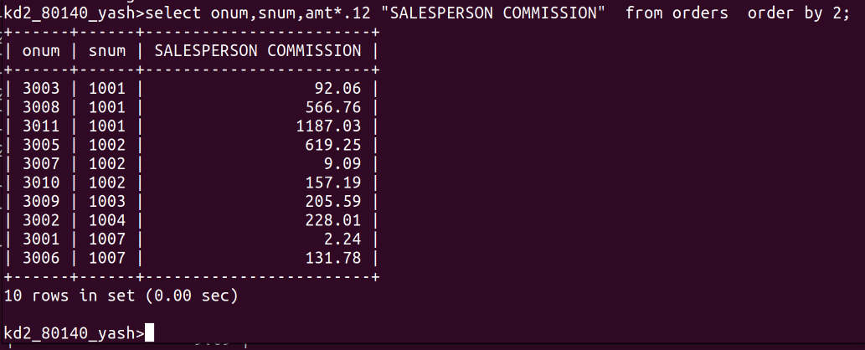

Q.2 Write a query on the customers table that will find the highest rating in each city.

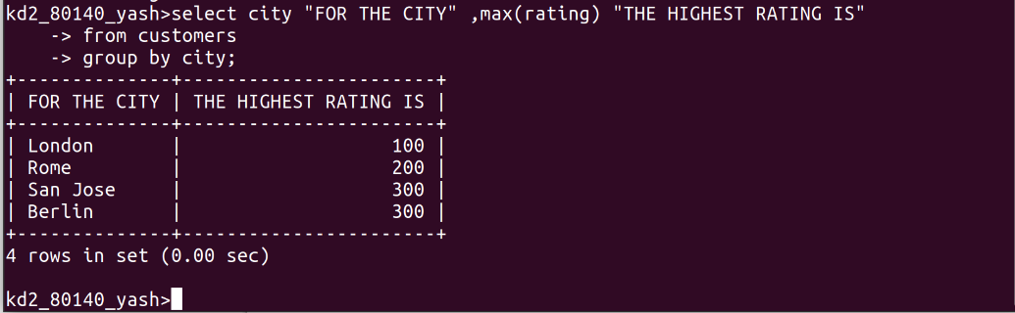

Q.3 Write a query that lists customers in descending order of rating.output the rating field first,followed by the customer’s name and number.

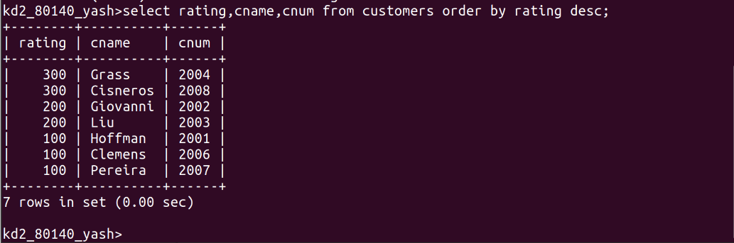
Q.4 Write a query that totals the orders for each day and places the results in descending order.

