MongoDB Assignment

Q.1 Install MongoDB database server
Answer:
$ sudo apt-get install gnupg curl
$ curl -fsSL https://pgp.mongodb.com/server-7.0.asc | \sudo gpg -o /usr/share/keyrings/mongodb-server-7.0.gpg \--dearmor

Q.2 Create a directory/folder to store MongoDB datafiles
Answer:
$ echo "deb [ arch=amd64,arm64 signed-by=/usr/share/keyrings/mongodb-server-7.0.gpg ] https://repo.mongodb.org/apt/ubuntu jammy/mongodb-org/7.0 multiverse" | sudo tee /etc/apt/sources.list.d/mongodb-org-7.0.list

Q.3 Set necessary path environment variable
Answer:
title:'MySQL programming', authors:['Jack','Jill'], likes:200Answer:
$ echo "deb [ arch=amd64,arm64 signed-by=/usr/share/keyrings/mongodb-server-7.0.gpg ] https://repo.mongodb.org/apt/ubuntu jammy/mongodb-org/7.0 multiverse" | sudo tee /etc/apt/sources.list.d/mongodb-org-7.0.list

Q.4 Startup MongoDB database
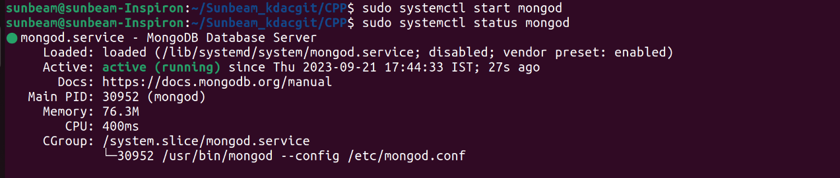

Q.5 Connect to MongoDB database through the MongoDB shell command line interface

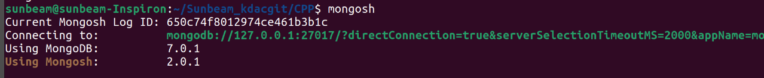

Q.6 View list of available databases

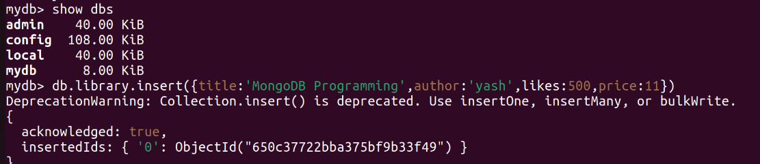
Q.7 Create a new database named CDAC and connect to it

Q.8 View list of available collections in CDAC database

Q.9 Create a new collection by the name of LIBRARY

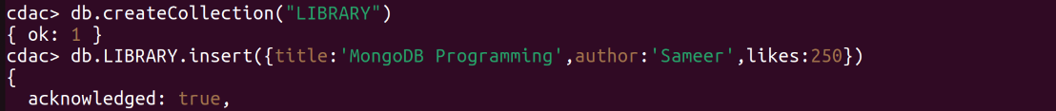

Q.10 0) Insert the following document in the LIBRARY collection:-
title:'MongoDB programming', author:'Sameer', likes:100
Answer:

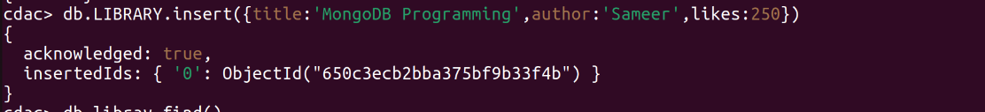
Q.11 View the recently inserted document and note the _id field
Answer:
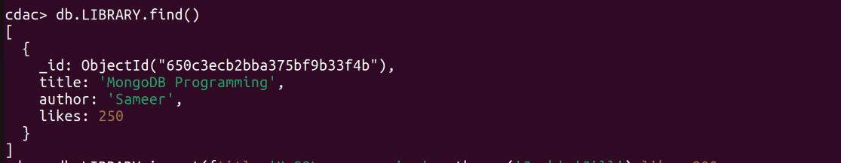
Q.12 Insert another document in the LIBRARY collection as follows:

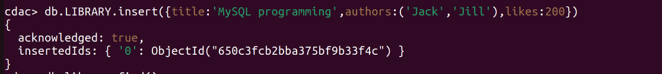
Q.13 View the inserted documents

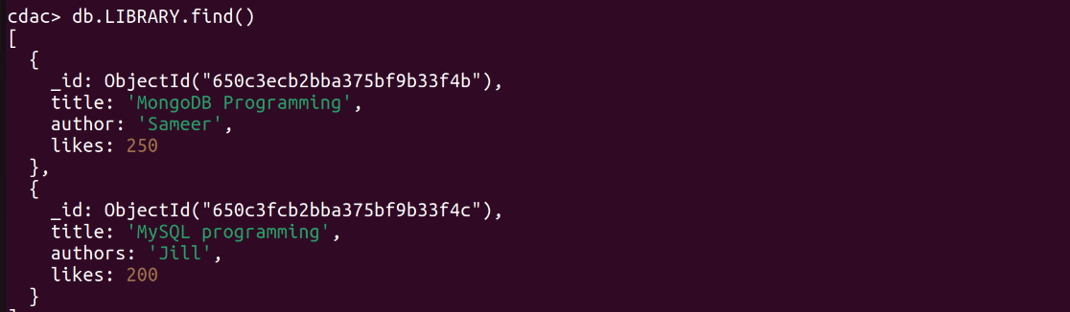

Q.14 View only the first inserted document
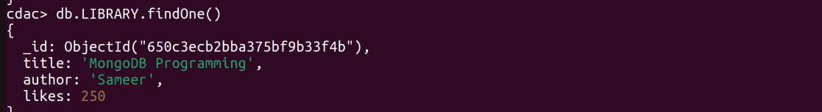
Q.15 View the documents using the pretty() method

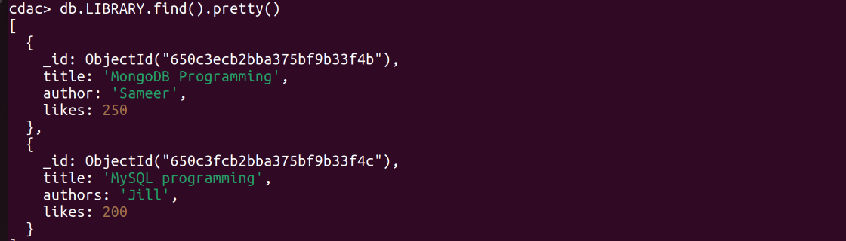

Q.16 Update the document where author name = Sameer and change it to Sameer Dehadrai

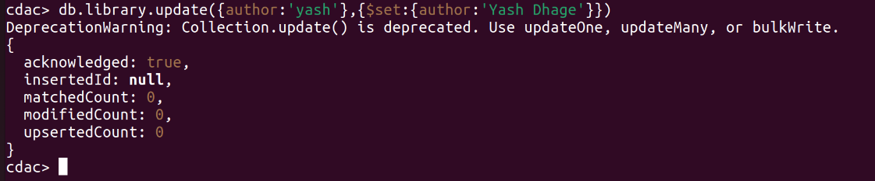
Q.17 Delete all documents that have 100 likes

Q.18 Drop the LIBRARY collection

Q.19 Drop the CDAC database

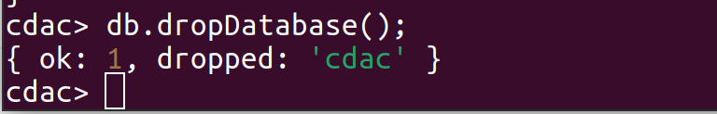
Q.20 Exit from MongoDB shell

