Q.1 Write a query that selects all customers whose ratings are equal to or greater than
ANY of Serres’.

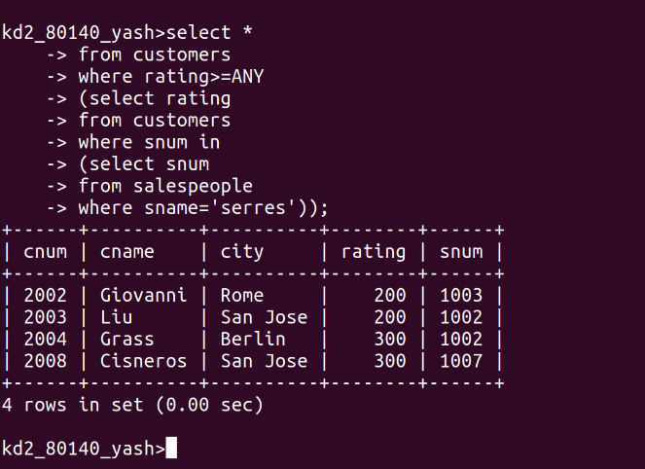
Q.2 Write a query using ANY or ALL that will find all salespeople who have no
customers located in their city.

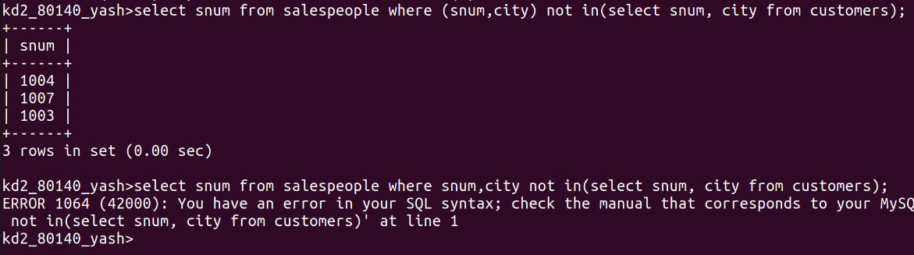
Q.3 Write a query that selects all orders for amounts greater than any for the
customers in London.

Q.4 Write the above query using MIN or MAX.

